
RECOMMENDED READING LISTS

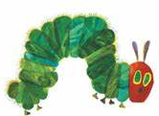
EYFS
The Very Hungry Caterpillar – Eric Carle
A Dark Dark Tale – Ruth Brown
Flotsam – David Wiesner
Tiger – Nick Butterworth
We’re Going on a Bear Hunt – Michael Rosen and Helen Oxenbury
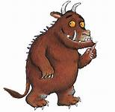
I Want My Hat Back – Jon Klassen
Each Peach Pear Plum – Janet and Allan Ahlberg
The Gruffalo and The Gruffalo’s Child – Julia Donaldson
Lost and Found – Oliver Jeffers
Up and Down – Oliver Jeffers
The Enormous Crocodile – Roald Dahl
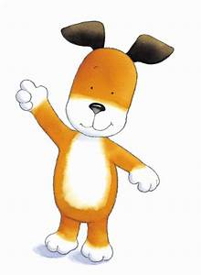
The Night Pirates – Peter Harris
Don’t Let the Pigeon Drive the Bus – Mo Willems
Where’s Spot – Eric Hill
Dear Zoo – Rod Campbell
The Jolly Postman – Janet and Allan Ahlberg
The Kipper series – Mick Inkpen, e.g. Kipper’s birthday
Meg and Mog – Helen Nicoll
Harry and his Bucketful of Dinosaurs – Ian Whybrow
Elmer – David McKee
Not Now Bernard – David McKee
Bears Don’t Eat Egg Sandwiches – Julie Falton & Rachel Suzanne
The Lion Inside – Rachel Bright & Jim Field
All Join In - Quentin Blake
The Wonder – Faye Hanson
Burglar Bill – Janet & Allan Ahlberg
Penguin – Polly Dunbar

Traditional stories
The Three Little Pigs
Goldilocks and the Three Bears
Hansel and Gretal
Little Red Riding Hood
Rapunzel
The Elves and the Shoemaker
Jack and the Beanstalk
The Gingerbread Man
Three Billy Goats Gruff

Years 1 – 2 recommended reading
Dinosaurs and All That Rubbish – Michael Foreman
War and Peas – Michael Foreman
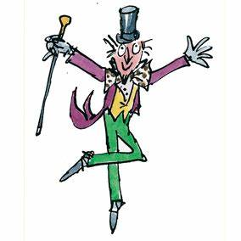
How Big is a Million? – Anna Milbourne and Serena Riglietti
The Tiger Who Came to Tea – Judith Kerr
Mog the Forgetful Cat – Judith Kerr
Where The Wild Things Are – Maurice Sendak
Angry Arthur – Hiawyn Oram and Satoshi Kitamura
Cinnamon – Neil Gaiman
That Pesky Rat – Lauren Child
Peace at Last – Jill Murphy
Dogger – Shirley Hughes
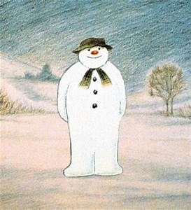
Hairy Maclary from Donaldson’s Dairy – Lynley Dodd
My Penguin Osbert – Elizabeth Cody Kimmell
The Paper Bag Princess – Robert Munsch
The Whales’ Song – Dyan Sheldon and Gary Blythe
Leon and the Place Between – Angela McAllister
The Winnie the Witch series – Valerie Thomas
The Charlie and Lola series – Lauren Child, e.g. I Will Not Ever Never Eat a Tomato
Journey – Aaron Becker

Roald Dahl
Esio Trot
The Giraffe, The Pelly and Me
Charlie and the Chocolate Factory
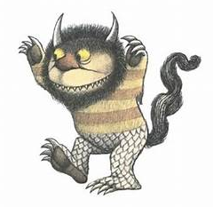
The BFG
The Magic Finger
Fantastic Mr Fox
George’s Magic Medicine

Julia Donaldson
The Snail and the Whale
Room on the Broom
A Squash and a Squeeze
Tyrannosaurus Drip
Smartest Giant in Town

Emily Gravett
Dogs
Meerkat Mail
Wolves
Again!
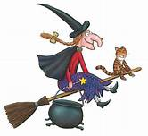
Little Mouse’s Big Books of Fears
Raymond Briggs
The Snowman
Father Christmas
Fungus the Bogeyman
Ug: Boy Genius of the Stone Age
Books parents can read aloud
The Owl Who Was Afraid of the Dark – Jill Tomlinson
The Christmasaurus – Tom Fletcher
A Necklace of Raindrops – Joan Aiken
The Kingdom Under the Sea – Joan Aiken

Years 3 – 4 recommended reading
Picture books for older readers
The Dark – Lemony Snickett and Jon Klass
Black Dog – Levi Pinfold
Those Shoes – Maribeth Boelts
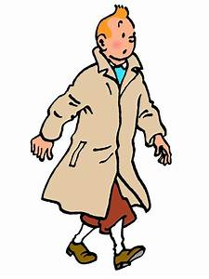
Rosie Revere, Engineer – Andrea Beaty
Ada Twist, Scientist – Andrea Beaty
The Fantastic Flying Books of Mr Morris Lessmore – W.E. Joyce
The Mysteries of Harris Burdick – Chris van Allsburg
Comics / graphic novels
The Asterix series – René Goscinny and Albert Uderezo, e.g. Asterix the Gaul
The Adventures of Tintin series – Hergé, e.g. Explorers on the Moon
Stormbreaker – Anthony Horowitz
Artemis Fowl – Eoin Colfer
Poetry / short stories
Please Mrs Butler – Allan Ahlberg
Revolting Rhymes – Roald Dahl
Dirty Beasts – Roald Dahl
Sea Prayer – Khaled Hosseini
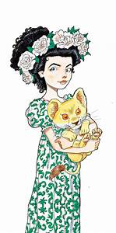
The Mrs Pepperpot short stories – Alf Prøysen
Just So Stories – Rudyard Kipling
The Witch’s Vacuum Cleaner short story collection – Terry Pratchett
Dragon’s at Crumbling Castle short story collection – Terry Pratchett
Short chapter books
The Great Piratical Rumbustification – Margaret Mahy
Fortunately, the Milk – Neil Gaiman
The Saga of Erik the Viking – Terry Jones
The Legend of Spud Murphy – Eoin Colfer
The Worst Witch series – Jill Murphy
The Raven Boy and Elf Girl series – Marcus Sedgewick, e.g. Fright Forest
The Raven Mysteries – Marcus Sedgewick, e.g. Flood and Fang
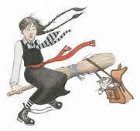
The Something Wickedly Weird series by Chris Mould, e.g. The Wooden Mile
The Ottoline series by Chris Riddell
The Goth Girl series – Chris Riddell
The Captain Underpants series – Dav Pilkey
The Mr Gum series – Andy Stanton, e.g. You’re a Bad Man, Mr Gum!
The Mr Majeika series – Humphrey Carpenter
The Moomin series – Tove Jansson
Longer chapter books
Charlotte’s Web – E.B. White
The Tale of Despereaux – Kate DiCamillo
The Miraculous Journey of Edward Tulane – Kate DiCamillo
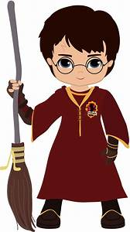
The Boy, the Bird and the Coffin Maker – Matilda Woods
Journey to Jo’burg – Beverley Naidoo
Millions – Frank Cottrell Boyce
The Wild Robot – Peter Brown
The Hamish and the World Stoppers series – Danny Wallace
The Fizzlebert Stump series – A.F. Harrold
The Gregor the Overlander series – Suzanne Collins
The Shapeshifter series – Ali Sparkes, e.g. Finding the Fox
A Series of Unfortunate Events – Lemony Snickett, e.g. The Bad Beginning
How to Train Your Dragon series – Cressida Cowell
The Spiderwick Chronicles series – Tony DiTerlizzi and Holly Black, e.g. The Field Guide
The Tales from the Five Kingdoms series – Vivian French, e.g. The Robe of Skulls
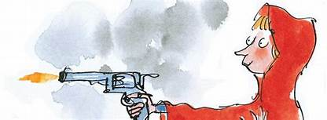
Authors
Michael Morpurgo and Dick King Smith for books about animals
Roald Dahl for books as dark as they are funny and imaginative
David Walliams for general silliness
Jacqueline Wilson for books about ordinary kids
J.K. Rowling for the Harry Potter universe
Years 5 – 6 recommended reading
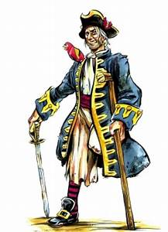
Modern issues
The Other Side of Truth – Beverley Naidoo
The London Eye Mystery – Siobhan Dowd
Wonder – R.J. Palacio
Boy 87 – Ele Fountain
Kick – Mitch Johnson
Refugee Boy – Benjamin Zephaniah
Kiss the Dust – Elizabeth Laird
Trash – Andy Mulligan
Fantasy
The House with Chicken Legs- Sophie Anderson
The Graveyard Book – Neil Gaiman
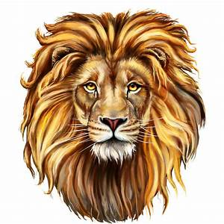
Un Lun Dun – China Mieville
The Carpet People – Terry Pratchett
I Was a Rat! – Philip Pullman
Clockwork – Philip Pullman
The Scarecrow and His Servant – Philip Pullman
Howl’s Moving Castle – Diana Wynne Jones
The Artemis Fowl series – Eoin Colfer
The Last Wild series – Piers Torday
His Dark Materials trilogy – Philip Pullman, e.g. Northern Lights
The Silver series – Cliff McNish, e.g. The Silver Child
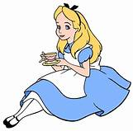
The Doomspell trilogy – Cliff McNish
The Hunger Games series by Suzanne Collins
The Cogheart series – Peter Bunzl
The Mortal Engines series – Philip Reeve
The Bromeliad series – Terry Pratchett, e.g. Truckers
The Edge Chronicles – Paul Stewart and Chris Riddell, e.g. The Curse of the Gloamglozer
The Alex Rider and The Diamond Brothers series – Anthony Horowitz, e.g. Stormbreaker and The Falcon’s Malteser
Children of the Red King – Jenny Nimmo, e.g. Midnight for Charlie Bone
The Maze Runner series – James Dashner
The Gone series – Michael Grant
Historical setting
I am David – Anne Holm
The Silver Sword – Ian Serraillier
The Secret of the Blue Glass – Tomiko Inui
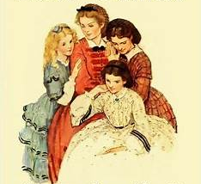
The Once series by Morris Gleitzman
The Little House series – Laura Ingalls Wilder, e.g. Little House on the Prairie
Roll of Thunder, Hear My Cry – Mildred D. Taylor
Coram Boy – Jamila Gavin
John Diamond – Leon Garfield
Arthur: The Seeing Stone – Kevin Crossley-Holland
The Roman Mysteries – Caroline Lawrence, e.g. Thieves of Ostia
Secrets of a Sun King – Emma Carroll
Letters from a Lighthouse – Emma Carroll
Classics
The Railway Children – E. Nesbit
Black Beauty – Anna Sewell
The Secret Garden – Frances Hodgson Burnett
Heidi – Johanna Spyri
Treasure Island – Robert Louis Stevenson
Twenty Thousand Leagues Under the Sea – Jules Verne
Journey to the Centre of the Earth – Jules Verne
The Hound of the Baskervilles – Arthur Conan Doyle
Tom’s Midnight Garden – Philippa Pearce
The Sword in the Stone – T.H. White

Little Women – Louisa May Alcott
Alice’s Adventures in Wonderland – Lewis Carroll
The Wonderful Wizard of Oz – L. Frank Baum
The Chronicles of Narnia series – C.S. Lewis, e.g. The Lion, the Witch and the Wardrobe
Notable Authors
Rick Riordan for mythical adventures
Chris D’Lacey for dragon adventures
Malorie Blackman for serious, issues-based books
R.L. Stine for children’s horror

