Medium Term Planning
Year 2 Autumn Term Recovery Curriculum

Inspire Curriculum | Core Text  Hook | Diversity, Community and Global Project Outcome for the Term
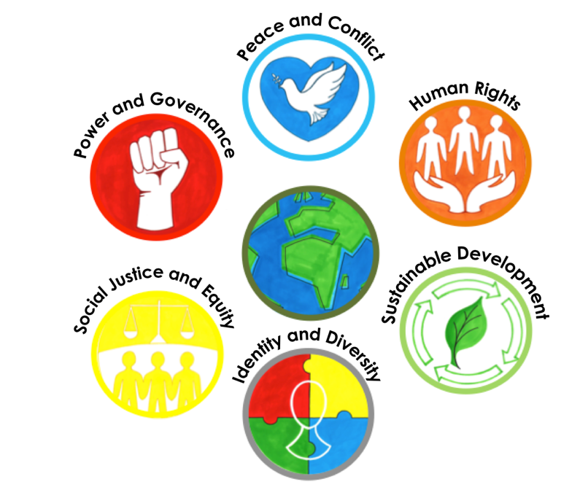 | 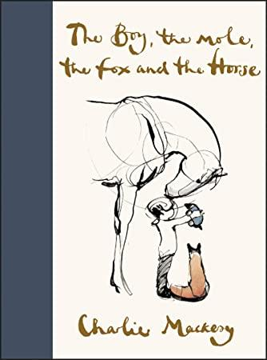  The Boy, the Mole, the Fox and the Horse by Charlie Mackesy  Hook: Cake, children to bake/decorate/eat cake and discuss the quote from the core text – If at first you don’t succeed, have some cake | Project outcome- Museum of Happiness  Include art linked to Zones of Regulation.  Notes – poetry about hopes and dreams for the future.  -Words about hope.  Speech bubbles  Zones of regulation recap from Summer especially for the children who missed it.
 | Art Outcomes  Display Ideas | Trips/Visitors
Using the artwork from the core text, children will recreate an image using mixed media. They will also create pencil/charcoal sketches.
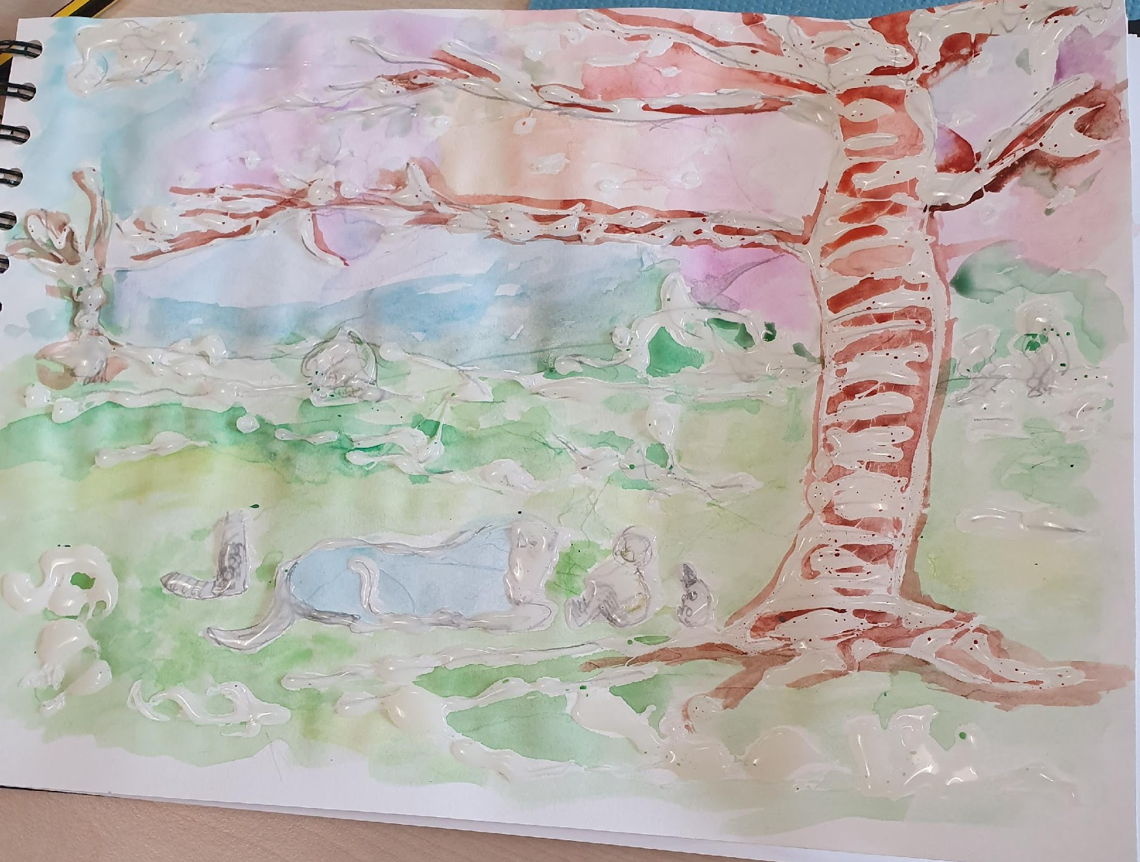

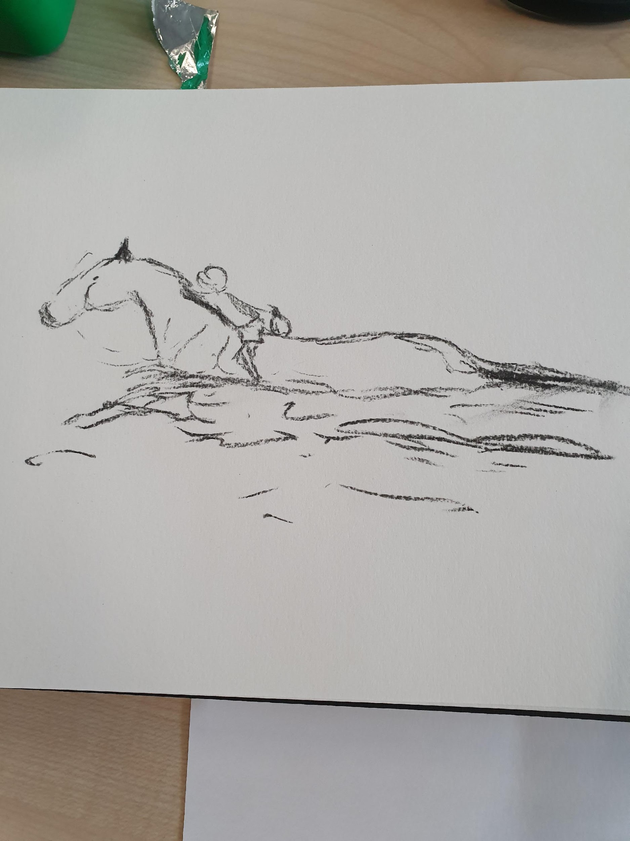
Knowledge and Understanding | Skills | Attitudes
Identity and Diversity  - Uniqueness and the value of every person  - Similarities and differences between self and others  - similarities and differences between peoples in local setting and also in wider contexts  - what contributes to self-identity and belonging | Empathy  - show awareness of, and concern for, people’s feelings  - show interest in, and concern for, others outside immediate circle and in contexts different to own  Self-awareness and reflection  - recognise effects of own behaviour on others and use this to help make choices  - identify matters that are important to self and others  Communication  - participate in discussions about issues that affect self, others and the wider world  - state opinions and start to give reasons for these  - listen carefully to others  Ability to manage complexity and uncertainty  - describe feelings about changes in own life and locality | Sense of identity  - sense of belonging and valuing of relationships with others  - awareness of, and pride in, own individuality  Respect for people and human rights  - respect for other people’s feelings and ideas  Commitment to participation and inclusion  - willingness to participate in activities both inside and outside of the classroom  - belief that that everyone should be included and able to participate

Exploring
Deepening
Planning
Delivering
Evaluating

 | Diversity, Community and Global Project Learning Journey
Week 1  7th September | ** Provide a brief description of the different learning activities in the Diversity, community and global learning project which will be covered each week. Include art within this section as you build up to your art outcome.  All of the RSE will be linked to emotions and colour. Additionally, mindfulfness activities will be used to help the children identify what is happening in the present moment.  Mindfulness is a way of paying attention to the present moment, using techniques like meditation, breathing and yoga. It helps us become more aware of our thoughts and feelings so that instead of being overwhelmed by them, we’re better able to manage them.  A separate document of mindful activities will be given to you so choices can be made regarding mindfulness activities. Some suggestions will be made, adapt according to the children’s needs.  Throughout our learning journey we are going to explore emotions and feelings. We are going to identify our hopes and dreams for the future and we will share these with each other as well as sharing with people in our local community. At the end of this term we are going to participate in a Museum of Hope which is our project outcome. This is where we will share our childrens journey of hopes and dreams for the future. This year we have experienced changes never seen before, e.g. like when we didn’t have to come to school due to COVID19 and when we were told about our new teachers in a different way. At our school we met our new teacher by watching a video (State how each school did this). We are going to think about what we would like our future to be like and what our hopes are, we will share our visions when we write a poem that we will recite and record.  NB. Take photos of the learning journey which will be used to evaluate the project in the last week.  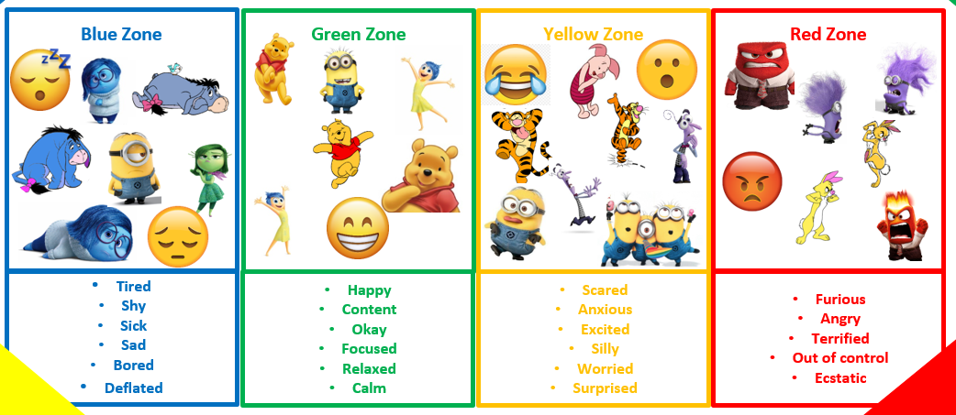  RSE – Museum of Hope  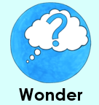  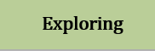  Lesson 1: LI: to explore and identify changes  Vocabulary: change, worry, emotions, positive, mindset  Mindfulness activity – Be Happy. Start with one person then go around the room, every child says one thing that makes them feel happy. E.g. Chocolate makes me feel happy because I like how it tastes on my tongue. One person speaks at a time. This will make the children feel calm and relaxed ready for their learning.  Activity – Through discussion, identify changes that the children have noticed. E.g. new class, new teacher, new year group, coming back to school after the summer holidays, some may not have been at school since before Easter.  Children to write questions on a post it note sharing any concerns they have about the changes.  I do: Model some questions for the children.  Q. What will we be doing? Why do we have a different teacher? Why haven’t we been to school for ages? Where have you been?  Why are we having different playtimes? Am I going to see my friends from other classes? Etc.  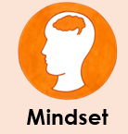  (As a class go through some of the post it notes, discussing them altogether. Do this daily, so everybody has shared their voice)  Through discussion draw out the positives about the new routines and changes.  Identify how the children are feeling, explaining that it’s okay and normal to feel nervous when we experience new things but to link it to Growth Mindset about challenging ourselves and overcoming new problems by making them into a positive routine. Identifying how we respond to these changes in a positive, encouraging way.  In books, children record some of their questions.  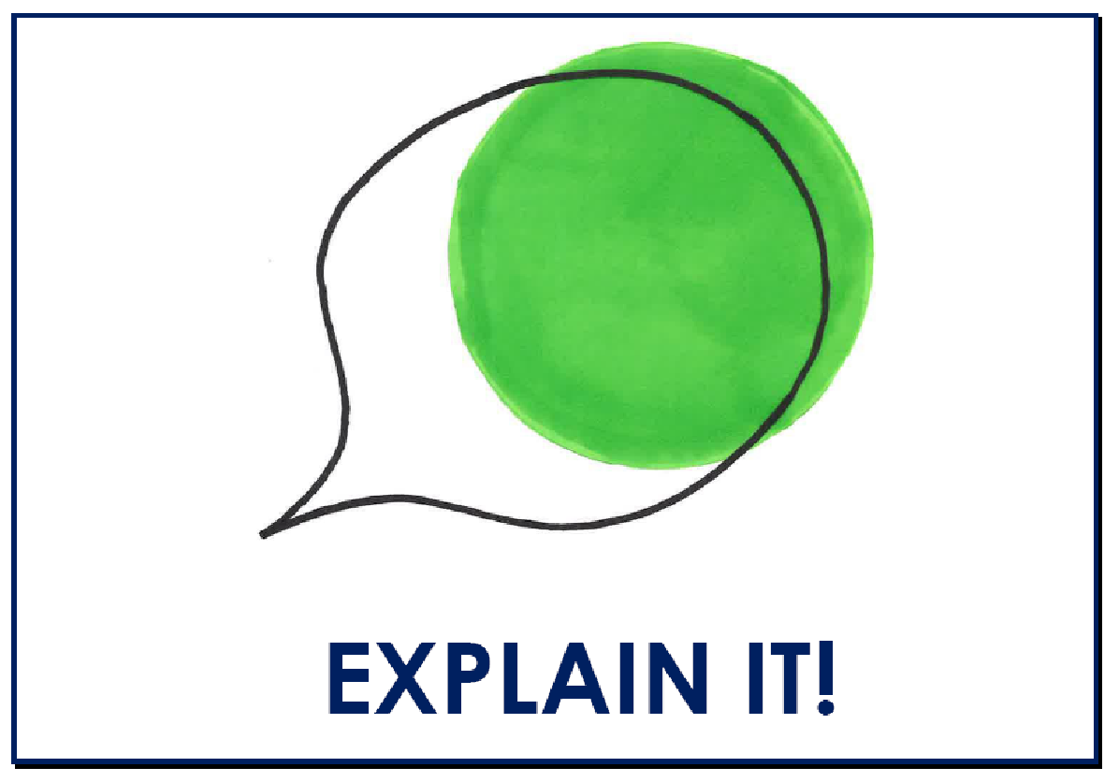  Reflection: After identifying the changes, how positive do you feel?  I feel positive because …  After identifying the changes I feel … because …  Lesson 2: LI: to identify and explore emotions  Vocabulary: scared, content, out of control, terrified, tired  Mindfulness activity – Pass the compliment. Showing kindness is also part of mindfulness. Start with one person and go around the room. Pay the person next to you a compliment, everybody is to pay and receive a compliment.  Discuss emotions and how they can be linked to different colours, explain all the different emotions linked to colours on the chart. Identify the emotions the characters are displaying and discuss why they may be showing these emotions. (Take pictures of the children as the discussions happen)  Watch some clips of Inside out (the times are stated below) [p] https://www.youtube.com/watch?v=8Cn1pYnAZSE  The clips will help the children relate to the emotions. As you have started to read the core text, identify when you think the characters (The Boy, the Mole, the Fox and the Horse) have felt these emotions. Share with the children that emotions can change throughout the day and that it is normal to have different feelings. Answer the questions using the sentence stem provided. Discuss with your shoulder partners and share with the class.  Watch 0 – 0.29 secs – What do you think the emotion is? What makes you think this?  I think the emotion is … because …  When the character behaved like …, it made me think he was … because …  Which character might have felt this emotion when they first met the boy?  I think the … felt like this when it met the boy because …  I disagree with … because …  Further to … point, I would like to add that …  Watch 2.28 – 2.41 What makes you the think clip is showing how upset the character is? What do the body movements show you? Explain using your reasoning skills.  The part that shows where the character is upset is … because …  When the … does … he shows…because … (E.g. When the red angry man starts waving his arms around he shows he is angry because he is using a threatening behaviour to others.)  Watch 4.52 – 5.06 What emotion is being shown? What body movements and facial expressions are being shown? Can a person show emotion without speaking or making a sound? Explain why you think this.  The emotion being shown is … because …  The body movements … show … because …  The facial movements shown are … this makes me think … because …  I agree with … because …  I disagree with … because …  Reflection in books: What emotions have you displayed today? Explain your thoughts using your reasoning skills.  I have felt … because …  This emotion is linked to the colour … and I felt this way because …
Week 2  14th September | Lesson 1: LI: to explore emotions  Context: The Boy, the mole, the Fox and the Horse  Vocabulary: fearful, overwhelmed, ecstatic, concerned, dumbfounded  Mindfulness activity – pass the smile. In your circle or at the tables, start with one person who can pass the smile to another person. Continue until everyone has received and shared a smile, including the adults. Ask the children how they feel when someone smiles at them. To continue this, you could always pass a grumpy face and see how long it takes before it becomes laughter and smiles.  We are going to explore emotions by listening to our core text. Throughout the story, stop the video link and ask questions. Children to share their responses with their partner, then with the rest of the class. Use the new vocabulary and add to your word wall, explain the meanings for each word.  This link is of The boy, the Mole, the Fox and the Horse being read by Tim Uffindell. He uses different voices for each character. You may also choose to read the book instead of listening to the video.  https://www.youtube.com/watch?v=81b4i9jQhck  Listen to the story, stopping and asking questions that are relevant to your children.  E.g. Has there ever been a time when you have felt like the boy? Link it to the colours.  Model:’ I was so happy when I knew I was coming back to school because it meant I would see everybody. This emotion is linked to the green colour.’  When have you felt angry and scared like the fox when he was trapped? You might not have been trapped, but you could have experienced the same emotions. Even though he was angry, he may have been feeling a bit scared. He might have been feeling as if it was out of his control so he was getting agitated. Therefore, he was in 2 colours. Use some of the vocabulary to explain.  In books children can use an emotion bar to identify how they are feeling at this moment in time. Children can circle the emotion and explain how they are feeling. They can compare it to how they felt earlier in the day.  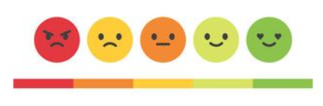  At this moment in time I am feeling … because …  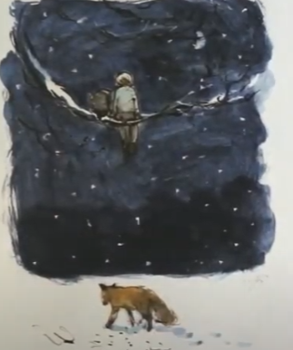  Another activity:  If you were sitting in the tree with the mole, what emotion would you feel? Explain using your reasoning skills.  If I was sitting in the tree with the mole, I would feel … because …  (e.g. If I was sitting in the tree with the mole, I would feel a bit fearful  because I would be worried I might fall out of the tree and hurt  myself. Also, there is a scary fox and I would feel a bit concerned  because he might try to eat me.)  Let the children explore and identify things that may make their emotion change into a different colour, and why they might experience more than one emotion at one time.  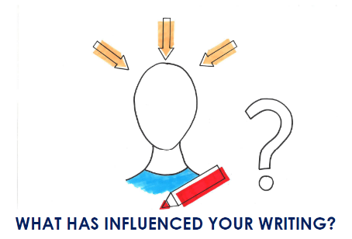  Reflection: When have you felt more than one emotion at one time?  I felt more than one emotion at once when I … because …  I made a link to … and I felt more than one emotion because …  (I made a link to when it was my birthday and I felt more than one  emotion because I was told I couldn’t have a party. I was upset until my friends arrived and shouted out ‘surprise’.)  Lesson 2: LI: to explore emotions in music    Vocabulary: communication, confidence, opinions, feelings.  Mindfulness activity – Petal breathing. Listen to the piece of music and put one hand on top of the other (both palms facing upwards). As you take a slow breath in, close your fingers as if they are the petals on a flower closing. On the slow out breath, gradually open your finger. You may start quicker, but as you become more focussed and relaxed, the breaths become longer as you slow down.  Petal breathing music: https://www.youtube.com/watch?v=4uNaYZ759Dc  Today we are going to Identify emotions through listening to music. The video clip has a book linked to Jack and the beanstalk, but we are not using Jack and the Beanstalk. Link all of the questions to The Boy, the Mole, the Fox and the Horse.  Then we are going to listen to music and identify how we feel. After, we are going to think about where the music fits best when we think about our core text The Boy, the Mole, the Fox and the Horse.  We are going to use the character skill of Relationships and the children will have the drive of Communication where they will Listen to others and respond appropriately, additionally they will Speak confidently when sharing their ideas, opinions and feelings with others. Only play the sections listed below.  https://www.youtube.com/watch?v=ptK3fzSlcfc  Instructions:  Listen to the music.0.00 – 0.34 and pause. How does the music make you feel? Thinking time. Children to think then share their thoughts with their shoulder partner.  The music makes me feel … because …  Carry on playing until o.43.  Where do you think this piece of music fits into The Boy, the Mole, the Fox and the Horse? Explain your thoughts with your shoulder partner using the sentences stems below.  Start music from 0.54 – 1.19 How does the music make you feel? Thinking time. Children to think then share their thoughts with their shoulder partner. Then share with the class.  Where do you think this piece of music fits into The Boy, the Mole, the Fox and the Horse? Explain your thoughts with your shoulder partner using the sentences stems below.  Start music from 1.38 – 2.02 How does the music make you feel? Thinking time. Children to think then share their thoughts with their shoulder partner. Then share with the class.  Where do you think this piece of music fits into The Boy, the Mole, the Fox and the Horse? Explain your thoughts with your shoulder partner using the sentences stems below. Then share with the class.  Start music from 2.21 – 2.46 How does the music make you feel? Thinking time. Children to think then share their thoughts with their shoulder partner.  Where do you think this piece of music fits into The Boy, the Mole, the Fox and the Horse? Explain your thoughts with your shoulder partner using the sentences stems below. Then share with the class.  Start music from 3.05 – to the end. How does the music make you feel? Thinking time. Children to think then share their thoughts with their shoulder partner.  Where do you think this piece of music fits into The Boy, the Mole, the Fox and the Horse? Explain your thoughts with your shoulder partner using the sentences stems below. Then share with the class.  In books, insert the image and identify which piece of music you think will fit with the following images and explain your thoughts.  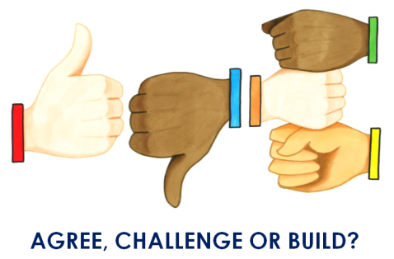  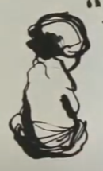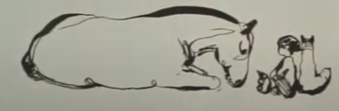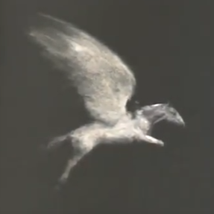  Through oracy, use the agree build challenge prompts to extend vocabulary and debates.  Sentence stems: I strongly believe … I agree with … I’m afraid I disagree because … That may be true but … However, …  Explain ideas using: For example, … In addition, … Clearly …  If the children need to clarify: What I really mean is …  Reflection: Justify your point of view using the agree, challenge or build prompts.  Sentence stems: I strongly believe … I agree with … I’m afraid I disagree because … That may be true but … However, …  Explain ideas using: For example, … In addition, … Clearly …  If the children need to clarify: What I really mean is …
Week 3  21st September |   Lesson 1: LI: to interpret music through visual art  Vocabulary: music, visual art, emotions, moods, feelings  Mindfulness activity – Finger breathing. Listen to a relaxing piece of music and you open one hand and spread out your fingers. With the other hand, as you breathe in, use your pointer finger and gradually glide it around the outside of your spread out hand. When you breathe out, glide your pointer finger down the other side of the spread out hand. Continue to do each finger slowly as you breath in and out.  Today we are going to interpret how we feel about different types of music through visual art. Children will use the character skill of Wonder and use their Critical Thinking skills to make connections to their prior knowledge  What do you think this means? Think about the language used, music and visual art. Visual is what we can see. Add the words to your word wall for children to relate to later.  Children will need cartridge paper and coloured pencils. The children will listen to the music and then choose a colour to do a line drawing on their paper. Use only one colour and one sheet of paper for each piece of music.  https://www.harmony.gov.au/get-involved/schools/lesson-plans/lesson-plan-musical-moods/#:~:text=%20Lesson%20plan%20-%20musical%20moods%20%201,represent%20musical%20qualities%20through%20visual%20art.%20More%20  Fast music https://www.youtube.com/watch?v=2QKuxt_QKts Listen from 3.10 6 minutes  Medium/cautious https://www.youtube.com/watch?v=D7vrXDiKbEU  https://www.youtube.com/watch?v=NvZtkt9973A  Change the music, now interpret what you can hear. As you listen, don’t forget to draw your lines in the right colour according to the emotion you feel.  (If the outcomes look really good, see if they can be joined together to make a collaborative piece. Identify if all the colours need to go together linked to emotions)  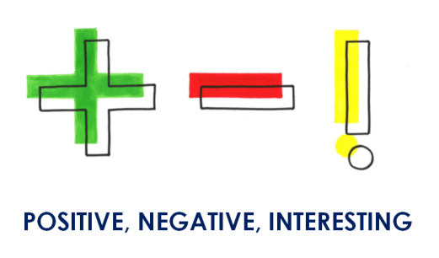  Reflection: Which music did you prefer and why?  Did you have positive or negative thoughts and what part of the music did you find interesting?  I preferred the … because  The … music made me feel …  The positive thoughts I had were … but I felt negative when … (The positive thoughts I had were when I felt more relaxed and the music I heard made me feel calm, but I felt negative, angry thoughts when the beat changed and became quicker making the music sound angry.)  I thought … was the most interesting part because …
Week 4  28th September | Lesson 1: LI: to explore our hopes and dreams  Vocabulary: aspirations, ambition, yearning, future  Mindfulness activity – Mindful body posing.  Superman: stand with your feet apart and place your arms on your hips with your fist clenched. You can then move your arms as if you are flying like Superman and stretch your body, making you as tall as possible. Do this in silence. When I say change, choose a different pose whether it’s a superhero, princess, animal etc.  As a class, discuss what our hopes are for the future. For next week, next year, 5 years from now etc. Think of the emotions you will feel when you have hope. Share your thoughts using the rally robin (take it in turns).  I do: Model- My hopes for the future are that the whole world will be at peace with no arguing and that we can reduce plastic waste so we can save the animals in the sea.  We do: Identify as many words that you can which mean hope to you - love, interest, pride, inspiration, awe, gratitude etc. Share the words with your shoulder partner. Record all the words on a mind map that you can think of that depict hope. (Wish, dream, yearn, long for, ambition, want, trust, hopefulness, believe.)  There are many words that mean hope to me, they are …, …, …, and …  You do: Discuss - What do you yearn for, what are your ambitions and what do you aspire to be? Then record them in your book in speech bubbles..  I want to be … because …  A dream I have for the future is … so I …  I aspire to be … so I … (E.g. I aspire to be like Roald Dahl so I can write amazing, funny books that children would like to read.)  What do you think the boy in the core texts dreams are? Do you think the boy in the story has the same dreams as you? Explain your thoughts to your partner. After sharing your thoughts, record your sentence.  I think the boy’s dreams are … because …  I think the boy has the … (same/different) thoughts because …  What do you think the boys hopes might be? Why?  I think the boys hopes might be …because …  Reflection: Compare your hopes and dreams to how you think the boy feels.  One similarity is …  One difference is …  _____ and ______ hopes and dreams are alike/ different because …  Another way I think my hopes and dreams are similar/ different to the boy is … and …
Week 5  5th October |   Lesson 1: To create poetry  Context: The Door  Vocabulary: imagination, change, power, dreams, hopes  Mindfulness activity – belly breathe. Put your hands on your stomach and breathe in and out. Feel your hands move on your stomach as you breathe. You can do this to music and explain to the children that when they feel themselves breathe, it can help relax them especially if they are feeling agitated. Explain that these mindfulness activities can be used anywhere, even if they are at home.  This half term we have been exploring and identifying emotions. To help us do this, we have explored our feelings and emotions, and we have matched colours to emotions. We have thought about our hopes and dreams for the future as well as thinking about our aspirations. Our project outcome will be ‘A museum of Hope’ where we will share our hopes and dreams for the future with others. These hopes and dreams in the form of poetry will be shared within our school community as well as … (Foxfield- our local nursing home). We have different art outcomes which we will also be putting into our museum. We are hoping our families will be able to see our Museum, but if they can’t, then we will film it and share it that way.  We are going to make some changes to a poem and make it our own so we can share it within our local community and send videos of us reciting our poems to people we care about and also to those who have helped people we care about.  Read the poem. How does it make you feel? How do you think it will make others feel within our community?  https://www.scottishpoetrylibrary.org.uk/poem/door/  The Door by Miroslav Holub  Go and open the door.  Maybe outside there’s  a tree, or a wood,  a garden,  or a magic city.  Go and open the door.  Maybe a dog’s rummaging.  Maybe you’ll see a face,  or an eye,  or the picture  of a picture.  Go and open the door.  If there’s a fog  it will clear.  Go and open the door.  Even if there’s only  the darkness ticking,  even if there’s only  the hollow wind,  even if  nothing  is there,  go and open the door.  At least  there’ll be  a draught.  Read the first stanza. What does it mean to you? The poem means …  We are going to change some of the words in the poem to what our hopes and dreams are.  Go and open the door.  Maybe outside there’s … (Change) a tree, or a wood, a garden, or a magic city.  What could it be changed to? Children think of some ideas. Model some ideas. Identify the children’s hopes and dreams and use them to create a happy poem that makes people feel good. (e.g. dreamer, beautiful flower, princess, no plastic waste, no war, kindness, friendliness, a Lamborghini, a huge elephant plodding, a giraffe swaying, etc.)  Go and open the door,  Maybe outside there’s  A dreamer, or a peacekeeper,  a stunning, purple flower,  or a beautiful princess.  Go and open the door.  Maybe my fabulous mum is laughing?  Maybe a face might be staring.  Maybe I’ll see a beautiful smile,  Or an elephant walking slowly,  Or a tree swaying  In the whistling wind  Go and open the door.  If there’s a wind  it will blow.  Go and open the door.  Even if there’s only  the sound of birds tweeting,  even if there’s only  the wind howling,  even if nothing is there,  go and open the door.  At least  there’ll be us.  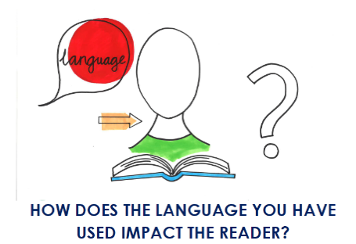  Reflection: How do you think your writing has influenced the reader?  Sentence stems:  When I used … I wanted the reader to …  I wanted my writing to be … so I used …
Week 6  12th October | Lesson 1: to recite poetry using expression  Vocabulary: clear, posture, expression, tone  Mindfulness activity – Mindful body posing.  Superman: stand with your feet apart and place your arms on your hips with your fist clenched. You can then move your arms as if you are flying like Superman and stretch your body, making you as tall as possible. Do this in silence. When I say change, choose a different pose whether it’s a superhero, princess, animal, muscleman, proud person  This half term we have been exploring and identifying emotions. To help us do this, we have explored our feelings and emotions, and we have matched colours to emotions. We have thought about our hopes and dreams for the future as well as thinking about our aspirations. Our project outcome will be ‘A museum of Hope’ where we will share our hopes and dreams for the future with others. These hopes and dreams in the form of poetry will be shared within our school community as well as … (Foxfield- our local nursing home). We have different art outcomes which we will also be putting into our museum. We are hoping our families will be able to see our Museum, but if they can’t, then we will film it and share it that way.  Today we are going to recite and record our poetry. While some are reciting, others are to practice reading their poem. Some children may read a line each and combine the sentences together, whereas others will recite their own poem.  When reciting, identify when to take a breath, identify how to hold your body posture and think about your tone of voice.  Film each other reciting the poem.  I do: Model how to read the poem using expression, tone and posture.  We do: Explain to your shoulder partner how you are going to recite your poem. Read each other the first stanza using your ideas of how to recite a poem. Peer assess each other, identifying what went well and next steps.  You do: Recite your poems to each other and film each other using an iPad/camera.  This will be shared within the community and the Museum of Hope exhibition. (share with nursing homes, NHS, local community groups)    Reflection: What emotions did you feel when you recited your poem? Explain your thoughts using your reasoning skills and the character skill of integrity and pride by recognising and celebrating your own achievements.  I felt proud and … when I … because …
Week 7  19th October |   Lesson: LI: to share our hopes and dreams  Context: Museum of hope  Celebrate and share all of your successes in the museum of hope (in line with how your school is celebrating it).  Ideas: Gallery of all the year groups learning including art, RSE journey, and English. Photographs of the journey can also be shared showing how the children have developed during the recovery curriculum. Videos of the children reciting their poetry. Videos of the children doin their mindfulness activities. Speech bubbles of the children’s hopes and dreams.    LI: to evaluate and reflect on our learning journey  Context: Museum of Hope  Vocabulary: reflect, favourite, sequence, chronological  Think about how the journey has made the children feel.  Are you excited about what the future may bring? (Discussion)  I am excited because …  Recap the journey using photos that you have taken, children to sequence the photos in their books, children to recall what emotions they felt for each photo.  Children to discuss what they enjoyed about the learning journey, including the museum of hope.  I do: Model -  E.g. I really enjoyed learning about emotions and feelings, and how the colours matched particular emotions because it helped me to understand the difference in how I feel compared to how others feel. I liked how we listened to the music and identified how it made me feel. It surprised me that not everybody felt the same way, this helped me to understand how unique we all are.  My favourite part while learning about emotions was when we matched emotions to music because it made me think about why music can affect how I feel and why I like certain types of music.  We do: Children to share their thoughts and experiences with each other using Kagan talking chips. (Talking Chips - Have a pencil each, put your pencil down when you share your thoughts and ideas, this way we know everyone has had a go in your team. Decide how this will work in your classroom)  You do: Reflect on the journey explaining your thoughts using your reasoning skills.  I enjoyed … because …  My favourite part was … because …  Next time I would do … differently because …  Next time I would do … the same because …

English Learning Journey

Week 1  7th September | Week 2  14th September | Week 3  21st September | Week 4  28th September | Week 5  5th October | Week 6  12th October | Week 7  19th October
*Ensure spelling focus is included during weekly modelled writes  Spelling focus:  Common exception words  Door, floor, poor, because, hour  (KPI: Spell most common exception words)  Grammar focus:  1.J spelt as ge at end  2.J spelt as dge at end  3.J spelt as j or g beginning  4.S sound spelt c before e, I and y  Capital letters and full stops | *Ensure spelling focus is included during weekly modelled writes  Spelling focus:  Common exception words  Find, kind, mind, behind, child  (KPI: Spell most common exception words  Grammar focus:  1.N spelt as kn and gn  2.r spelt wr at beginning  3l spelt le  4. l spelt el  5. l spelt al  Punctuation: capital letters and full stops | *Ensure spelling focus is included during weekly modelled writes  Spelling focus:  Common exception words  Climb, wild, children, beautiful, pretty  (KPI: Spell most common exception words  Grammar focus:  Punctuation- question marks and capital letters | *Ensure spelling focus is included during weekly modelled writes  Spelling focus:  Common exception words  christmasa even, every, everybody, sure  (KPI: Spell most common exception words  Grammar focus:  Commas in a list | *Ensure spelling focus is included during weekly modelled writes  Spelling focus:  Common exception words  Most, only, both, clothes, sugar  (KPI: Spell most common exception words  Grammar focus:  Apostrophes for missing letters | *Ensure spelling focus is included during weekly modelled writes  Spelling focus:  Common exception words  Old, cold, gold, hold, fold  (KPI: Spell most common exception words  Grammar focus:  Apostrophes for possession | *Ensure spelling focus is included during weekly modelled writes  Spelling focus:  Common exception words  Great, break, steak, eye, water  (KPI: Spell most common exception words  Grammar focus:  Recap  1.capital letters and full stops  2.Question marks  3.commas in a list  4.Apostrophes for missing letters  5.Apostrophes for possession
Monday:  HOOK  LI: to consider the meaning of a text  Activity: Children to put ingredients together to make cakes/ decorate cakes/eat and enjoy a range of cakes.  Display the quote “if at first you don’t succeed, have some cake”  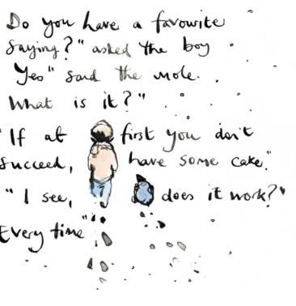  Whilst enjoying the cakes children to consider, How did the cakes make you feel?  Share the quote, what do we think this quote means?  Children to orally discuss.  Make links with the character skill of wonder    Tuesday:  LI: to justify an opinion  Activity:  Children to further discuss the quote:  Reflecting on what the quote means.  Children to record ideas in their books.  What quote would you say? How would you finish your quote?  If at first you don’t succeed …  Reflection: Can you think of a time you have ever felt like you didn’t succeed? What made you feel better?  Wednesday:  LI: to identify the characteristics of a fixed and growth mindset  Activity:  Children to receive envelopes with fixed mindset quotes on them, with pictures showing a scenario, in Kagan teams children need to rewrite fixed mindset quotes to growth mindset quotes – articulating the importance of positive thinking.  Make links with the character skill of mindset  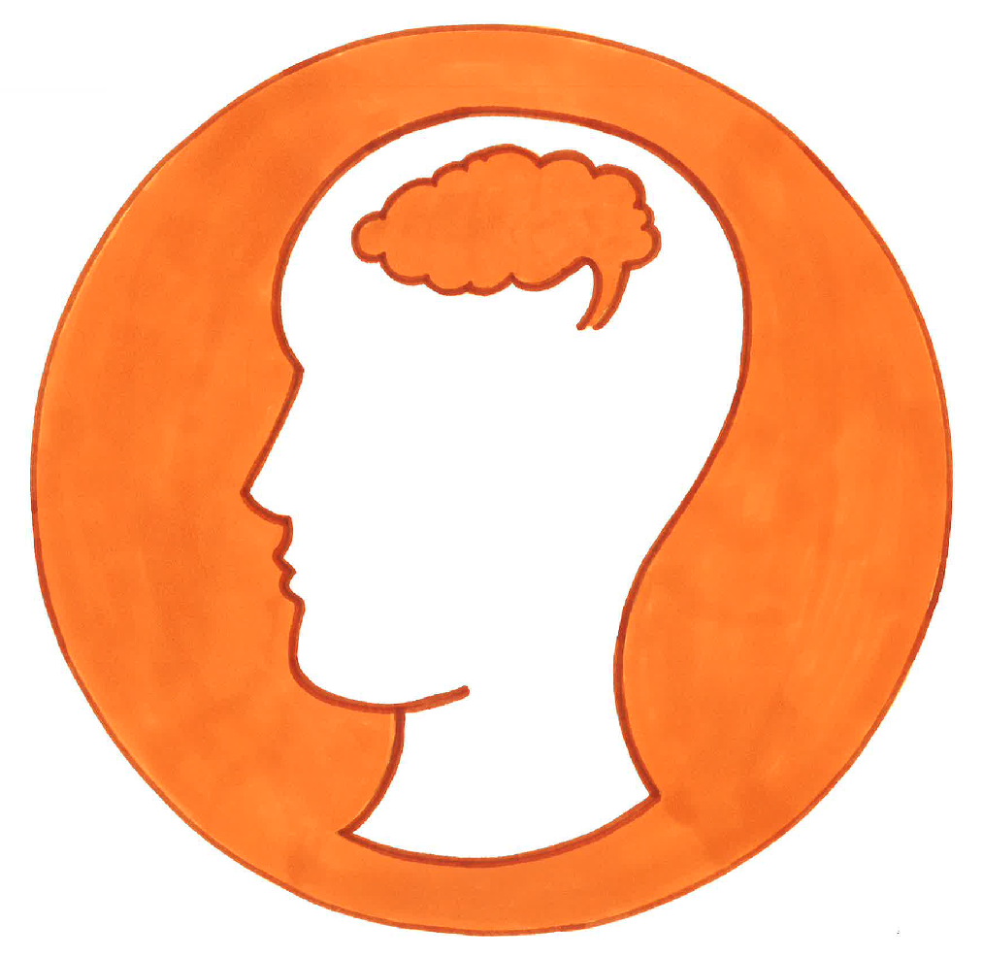  Thursday:  LI: to form and justify an opinion  Activity:  Children to be given quotes from the book, children to discuss what they think the quotes mean and do a diamond ranking activity.  Diamond ranking: The method involves a set of nine quotes/ images. Children working in pairs or threes, place them onto a piece of paper in a diamond shape, ranking them by position so that the preferred picture/ quote is at the top and the most disliked is at the bottom.  Children to focus on their oracy skills, articulating which they prefer and why and which they preferred the least and why.  Children to have the chance to hear the rankings and justification of others and can change their mind.  Opportunity for Agree, Challenge Build prompt.  Friday:  LI: to record an opinion and justify  Activity:  Children to record their opinion from the day before.  Which was their favourite quote and why? | Monday:  LI: to make predictions about a text using evidence  Activity:  Children to be given text from the core text, children to use these to further make predications about the core text, using evidence from the text.  I predict that… because it says …  Tuesday:  LI: to make predictions about an image using evidence  Activity:  Children to be given pictures from the core text, children to make predications of the core text based on evidence from the images.  I predict that … because …  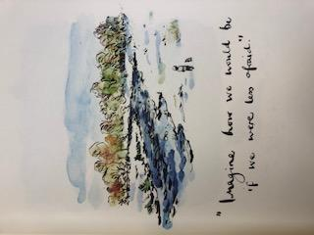  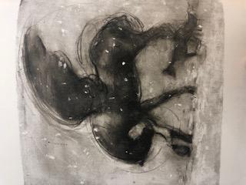  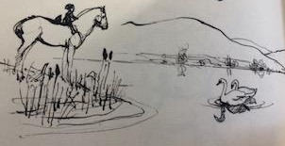  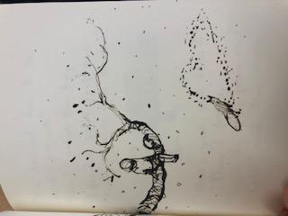  Wednesday:  LI: to create a narrative  Activity:  Look at the phrases and pictures from the book – order them and create your own story.  Will it be a happy ending?  What will happen?  Are there any words you need clarifying?  Thursday:  LI: to evaluate accuracy of a prediction  Activity:  Read the story to the children – was your prediction correct?  Reflection:  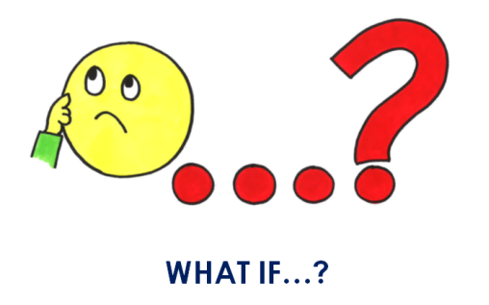  What if the mole was scared of the fox and didn’t help him out of the snare?  What if the boy never met the mole?  What if horse never showed his friends he could fly?  What would the impact be on the story?  Friday:  LI: to reflect on the themes of a text  Activity:  How did the story make you feel. Have you ever felt like this before – recount  Depth opportunity – making connections.  Make links with the character skill integrity   | Monday:  LI: to use a drama technique to explore a character  Activity:  Children to use the drama technique Role on the wall to demonstrate their understanding of the horse character.  Role on the Wall is a strategy that invites students to infer meaning about a character and to visually map the relationship between characteristics (emotions) and actions (behaviors) onto a simple outline of a human figure. By inviting students to analyze context clues, the group collectively explores and constructs a more complex understanding of the character’s motivation.  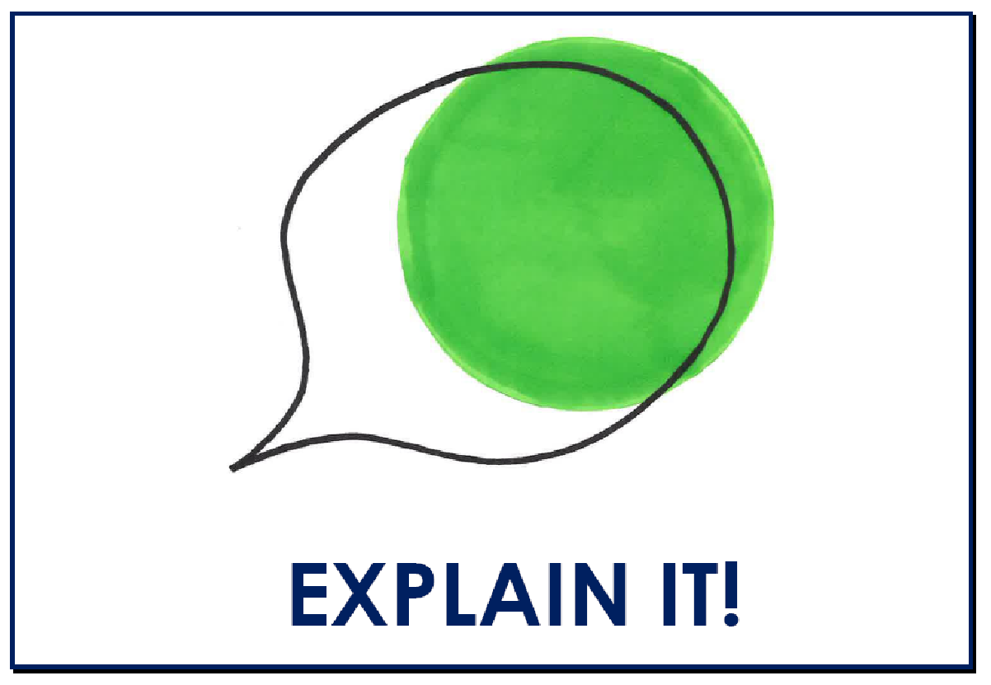  Tuesday  LI: To create descriptive sentences  Activity:  Children to use the knowledge and understanding from the previous lesson to create descriptive sentences. Consider using expanded noun phrases/ noun phrases and the power of three.  Describe the HORSE  Wednesday:  LI: to use a drama technique to explore a character  Activity:  Children to use the drama technique Role on the wall to demonstrate their understanding of the fox character.  Thursday  LI: To create descriptive sentences  Activity:  Children to use the knowledge and understanding from the previous lesson to create descriptive sentences. Consider using expanded noun phrases/ noun phrases and the power of three.  Describe the FOX  Friday:  LI: to compare and contrast  Activity:  Children to compare the horse and the fox using ‘but’.  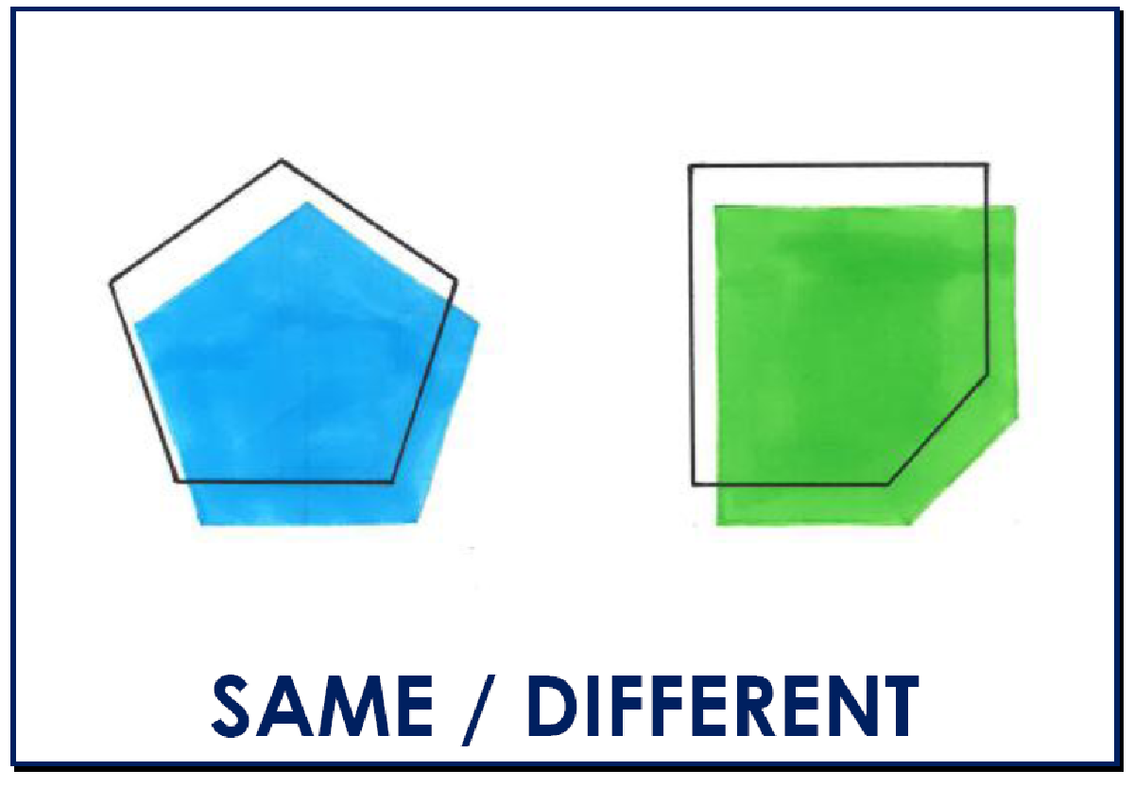  KPI: Show some accurate use of –er –est where no change is needed in the spelling of root words for example: helping, helped, helper (Y1 KPI)  The horse was kinder than the fox because the fox wanted to eat the mole.  The fox was the quietest because he felt he had nothing interesting to say.  - Reread writing and make appropriate revisions so that the word choices are effective (Y1 GD KPI)  INCIDENTAL WRITE | Monday:  LI: to use drama to explore emotions  Activity:  Children create freeze frames of their event-tap on shoulder-use vocab and explain how they are feeling in that moment-reflection at end  Make links to the character skill of relationship    Tuesday:  LI: to identify adverbs  Activity: Children to have a range of objects on their table, children to explore these objects, what can each one do? How did you move it?  Children feedback to the class teacher who then creates a mindmap of all of the adverbs that have been used so far today. Children then gain a greater understanding of what an adverb is and begin to add more adverbs. Teacher to ask can you use that in a sentence? What does this word mean?  Wednesday:  LI: to generate adverbs  Activity: Role play as the different characters thinking about - ly suffixes to describe how the characters are moving  Four corners – KAGAN  KPI: Show some accurate use of –ing –where no change is needed in the spelling of root words (Y1 KPI)  Slowly walking, Carefully crawling,  Gracefully flying  Thursday:  LI: To identify the present and past tense  Activity: Recap role play as the different characters thinking about - ly suffixes to describe how the characters are moving.  Then sit children at their tables and asked them to consider the way they moved.  Slowly walking  Slowly walked  Children to identify past and present tense, though a sorting activity for We do.  Then to write sentences to show knowledge of past tense.  KPI: Show some accurate use of –ed –where no change is needed in the spelling of root words (Y1 KPI)  Slowly walked  Carefully crawled  Gracefully flying  Friday:  LI: to sequence images  Activity: Children to sequence pictures – and add relevant  Suffixes to each picture as a KAGAN 4  Context page. | Monday:  LI: to sequence images  Activity: Children to sequence pictures – and describe what is happening in each pictures – emphasis on using suffixes, third person and past tense.  IN BOOKS  Tuesday:  LI: to compare and contrast narratives  Activity: good model and bad model of the narrative – children to choose which is better and why.  Features to include; third person, characters, setting description, interesting vocabulary, beginning, dilemma, solution, adverbs, noun phrases, emotions  Context Lesson  Wednesday:  LI: to identify and unpick features of a narrative  Activity: Share the modeled write with the children, what is the purpose, features, language choices  Big on tables and list of what to look for.  Features to identify; third person, characters, setting description, interesting vocabulary, beginning, dilemma, solution, adverbs, noun phrases, emotions  Make links to the character skill of relationship  Thursday:  LI: to retell a narrative  Activity: retell using a story map.  Friday:  LI: to plan a narrative  Activity: innovate a story map | Monday:  LI: to rehearse a narrative  Activity: verbally tell the story to friends – promoting oracy and talk for writing  Tuesday:  LI: to write a third person narrative –  Write the beginning part of the narrative.  Plenary: Refer back to what makes good, and create a checklist of what this section should include. Children then use this to edit their beginning.  Wednesday:  LI: to write a third person narrative – short date in the margin to continue  Write the middle of their narrative. Consider the WMG and ensure there is a checklist of things for children to include.  Thursday:  LI: to edit and uplevel  Children to read their writing and check there is cohesion between the beginning and middle.  Identify the features that should be included and children to read through to edit and up level.  No LI in book.  Friday:  LI: LI: to write a third person narrative – short date in the margin to continue  Write the end of their narrative. Consider the WMG and ensure there is a checklist of things for children to include. | LI: to edit and uplevel –  Children to consider what makes good and identify where these features are identified within the story.  Children to check for cohesion, and ensure features are included.  Opportunity for green box response also.  KPI - Reread writing and make appropriate revisions so that the word choices are effective (Y1 GD KPI)  Publish  Publish  Self assess  Peer assess

Maths Learning Journey
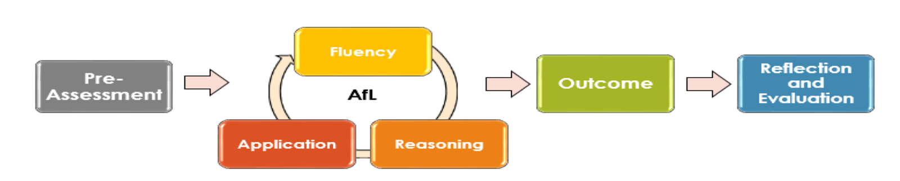

 | Week 1  7th September | Week 2  14th September | Week 3  21st September | Week 4  28th September | Week 5  5th October | Week 6  12th October | Week 7  19th October
 | Arithmetic session: Whole class  assessment time. Show question and solve independently. Quiz style with children. | Arithmetic session: Whole class  assessment time. Show question and solve independently. Quiz style with children. | Arithmetic session: Whole class  Number bonds within 5. Addition and subtraction. | Arithmetic session: Whole class  Number bonds within 5. Addition and subtraction. | Arithmetic session: Whole class  One more one less of numbers to 100. | Arithmetic session: Whole class  Sequence numbers to 100. Partition within this. | Arithmetic session: Whole class  More than less than numbers to 100. Using symbols.
 | Mental oral starters:  Use this time for baseline assessments. One question per day. | Mental oral starters:  Use this time for baseline assessments. One question per day. | Mental oral starters:  Counting to 100 forwards and backwards. | Mental oral starters:  Counting to 100 forwards and backwards. | Mental oral starters:  Counting in 2s, 5s and 10s. | Mental oral starters:  Number bonds to 10 | Mental oral starters::  Number bonds to 10
 | Pre-assessment  LI: to recognise numbers up to 50  Hook/assessment lesson. Number games, bingo etc. Counting forwards and backwards from 0-50. Number square. Context lesson.  (Y1 KPI) Count to 50 forwards and backwards, beginning with 0 or 1, or from any number  Fluency  LI: To sequence numbers from 0 – 50  Number tracks  Variation of ways alongside more counting games focus particularly on crossing tens boundaries and saying 14 and 40 differently etc Children to complete varied fluency number tracks.  (Y1 KPI) Count, read and write numbers to 20 - 50 in numerals.  Fluency  LI: To represent the place value of numbers to 50  NCETM materials 1.9 teaching point 2 & 5  use numicon or diennes to build 2 digit numbers up to 100 – use sentence Stem outloud ‘This is 56 because it has 5 tens and 6 ones’ (context)  Reasoning  LI: To represent the place value of numbers to 50  Starter- revise how to partition numbers.  Chn to choose number cards between 1-100 and have to represent with diennes. Use start with the answer stcker and give them the diennes representation and they have to work out what the number is. Or draw it along with varied white rose questions   I have represented the number 30. Do you agree?  (Y1 KPI) Identify and represent numbers using diennes, pictorial representations including the number line, and use the language of: equal to, greater than less than up to 50.  LI: To find one more and one less of a number to 50  Numbers up to 50 – use of hundred squares to support – particular attention to crossing 10s. Oracy – use of sentence stems to describe using tens and ones.  (Y1 KPI) Given a number, identify one more or one less up to 50. | Fluency  LI: To recognize numbers up to 100  Counting games forwards and backwards to 100. Kagan groups, create the number square to 100. Children to giant number squares and arrange the numbers of the number square in teams.   Reasoning  LI: To sequence numbers from 0 – 100  Number tracks  Variation of ways alongside more counting games focus particularly on crossing tens boundaries and saying 19 and 90 differently etc Children to complete varied fluency number tracks.  (Y1 KPI) Count to and across 100, forwards and backwards, beginning with 0 or 1, or from any given number.  Fluency  LI: To read and write numbers 0-100 in numerals and in words  Matching numerals to words and visual representations in kagan groups. (Out of books)  LI: To Read and write numbers 0-100 in numerals and in words  Record the digit and word alongside the visual representation in books. Self mark opportunity. Train children up.  (Y2 KPI) Read and write numbers 50-100 in numerals and in words  Application  LI: To represent the place value of numbers to 100  NCETM materials  NCETM materials 1.9 teaching point 2 & 5  use numicon or diennes to build 2 digit numbers up to 100 – use sentence Stem outloud ‘This is 56 because it has 5 tens and 6 ones’. Then in books using stickers e.g. error spotter, start with answer. Reasoning focus. (Y1 KPI /Y2 KPI) Identify, represent and estimate(y2) numbers using objects and pictorial representations including the number line, | LI: To understand that numbers have a place on a numberline.  NCETM 1.9 teaching point 3. 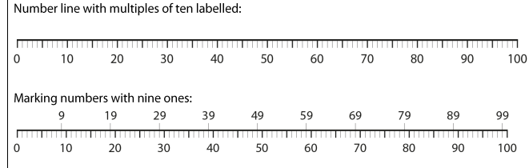  Going a bit deeper than just number tracks and use string beads like in NCTEM materials (context)  LI: To find one more and one less of a number to 100  Children use number line knowledge and place value knowledge to find one more and one less of numbers to 100.  (Y1 KPI) Given a number, identify one more and one less.  LI: To compare numbers to 100 (fluency)  Children to use language of equal to, more than, less than to compare numbers. In books. Varied fluency images, words, numberals etc. Explain it stickers using tens and ones.  (Y2 KPI) Recognise the place value of numbers up to 100 x 2 Looking at tens and ones and using language  compare and order numbers from 50 to 100; use and =>< signs)  Reasoning/  Application:  LI: To compare numbers to 100  NCETM materials 1.9 all of teaching point 4 –  Chn to be given range of odd one out questions and explain it sticker. They can group the numbers by tens, ones, size, odd or even but need to justify it.  Outcome  LI: To problem solve using place value  Children problem solve using tens and ones. E.g. number has 4 tens and 6 ones. Number has more tens than.. but less that…Each answer ‘unlocks’ an ingredient to make simple biscuits/cakes for mole from the book.   (Y2 KPI) Use place value and number facts to solve problems | Pre-assessment  Fluency  LI: To partition 2 digit numbers in different ways  Pre assessment: Same different sticker. Representations of numbers partitioned differently. PD materials 1.14 teaching point 4  Children to have unifix cubes in sticks of ten and separate ones. Pick a digit card and create. Then break up the ten sticks to show how it can be represented in different ways. Context. (Y2 KPI) 2 digit numbers can be partitioned in different ways  Application  LI: To partition 2 digit numbers in different ways  PD materials 1.14 teaching point 4  Children to have unifix cubes in sticks of ten and separate ones. Pick a digit card and create. Then break up the ten sticks to show how it can be represented in different ways. In books  LI: To count in multiples of 2, 5 and 10.  Children to use numicon to count in 2s, 5s and tens. They can put their objects into groups of e.g. ten then start to learn their ten times table by matching the number of objects with the numbers on their 100 square.  What do you notice about all the numbers in the 10 times table?  What’s the same, what’s different? 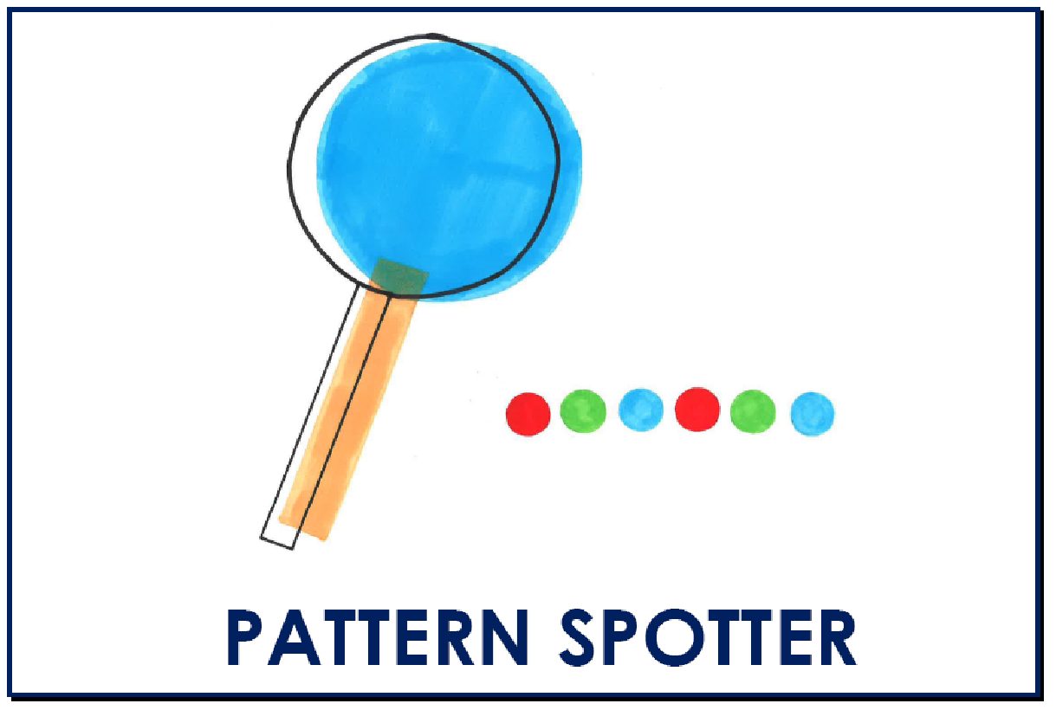  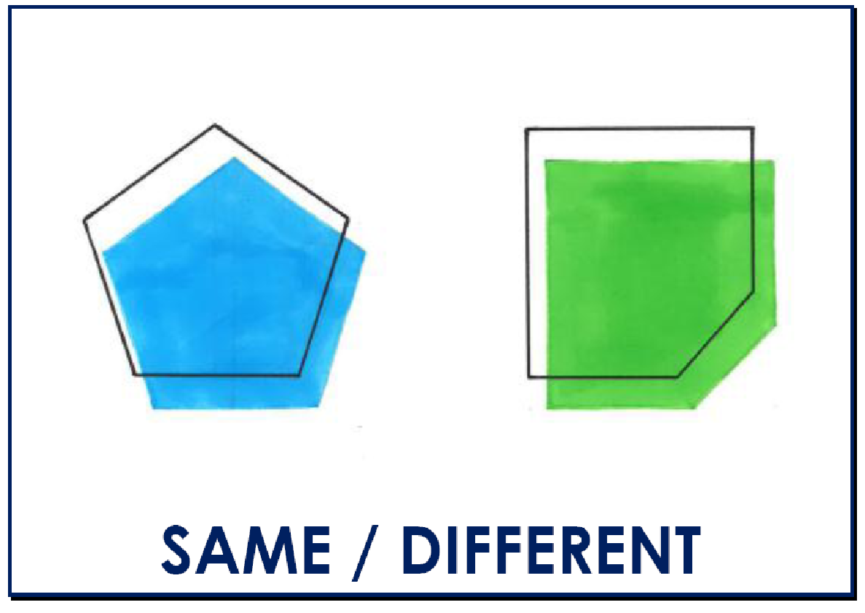  (Y1 KPI)Count in multiples of 2 5 and 10 first and get this solid from zero forwards and backwards  Fluency  LI: To count in multiples of 2, 5 and 10.  In books. Finding the total amount of varied fluency pics counting in 2s, 5s and 10s.  LI: To count in steps of ten from any given number  PD Materials 1.14 teaching point 1  Children to pick a digit card and create using numicon/dienes. What happens when I add a ten? Use number square alongside. Children to add ten to numbers. Pattern spotter stickers for reflection. What do you notice? Taking ten away too.  (Y2 KPI – counting in steps of ten from any given number forwards and backwards) | LI: To count in steps of ten from any given number  PD Materials 1.14 teaching point 1  Number tracks in books. Counting in jumps of ten.  Fluency  LI: To count in steps of 3  PD Materials 1.14 teaching point 1  Rolling numbers to 3. Children to count in threes using concrete numicon. Post it noting the amount above. Oral practice.  (Y2 KPI)Count in steps of 3 from zero and steps of 10s from any number, forward and backward.  Reasoning  LI: To count in steps of 3  In books counting in threes to find the total. Varied fluency.  (Y2 KPI)Count in steps of 3 from zero and steps of 10s from any number, forward and backward.  Fluency  LI: To investigate number bonds to 10  Children to work systematically to find the number bonds to ten using a ten frame. In books. Record the number sentence. Pattern spotter sticker for swapping parts to make the whole.  (Y1 KPI) Recap number bonds within and including10 heavily  LI: To find the missing number in number bonds within ten   Children to find missing number with part whole model.  (Y1 KPI) Recap number bonds within and including10 | Reasoning  LI: To explore related number facts using our number bonds  Children to explore the relationship from number bonds to 10 to 100. What patterns do you notice? What have you found out? Out of books.  (Y1 KPI) Recap number bonds within and including10 heavily  Reasoning  LI: Related number facts to 100  If I know… then I also know… In books. Reasoning. (Y2 KPI) Use related number facts to 100  Application  LI: To bridge ten when using addition  (NCETM Bridging 10 addition from year 2 PD Materials 1.11 teaching point 5  Children to move away from counting on and use bridging to perform mental maths. E.g. 7+5. Use 3 to make ten and 2 left. Circle by 10 strategy  white rose page 21:  https://whiterosemaths.com/wp-content/uploads/2019/01/Year-1-2018-19-Spring-Term-Block-1-FINAL.pdf  .  6 + 7 = partition one of the numbers to make 10. Really need to know number bonds to 10. Reinforce not counting to find the answer but more so I have 10 and 3 I know that’s 13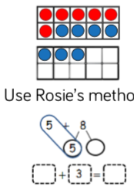  (Y1 KPI) Recap adding through 10 utilising a 20 frame adding within 20 using those partitioning skills  LI: To add by making 10  Use ten frames alongside to help support but record in books with using partitioning to make ten to add.  Reinforce not counting on to find the answer but recognising it within the 20 frame  LI: To subtract through 10  Use of a 20 frame to subtract numbers within 20 that cross the 10s boundaries. White rose page 25. Eg  12 - 5 =  Step 1: Partition 5 into 2 and 3 so I can subtract 12 -2 = 10  Then step 2 subtract 10 - 3 = 7  Alongside 20 frames. Try to recognising number in 10 frame left rather than count how many left  context  NCETM Bridging 10 subtraction from year 2 PD Materials 1.11 teaching point 6 (Y1 KPI) Recap subtracting through 10 utilising a 20 frame within 20 and using partitioning skills | Application  LI: To subtract through 10  in books this time but still using support of 20 frame on tables for those children that need the support.  LI: Investigate number bonds to 20  Pattern spotter lesson. Children to use numicon to find the bonds and record on whiteboards. Compare with number bonds to 10. What do you notice? Kagan.  (Y2 KPI) Recall and use addition and subtraction facts to 20 fluently,  LI: Number bonds to 20  Varied fluency in books e.g. part whole model. Finding the missing number for the number bonds to 20.  (Y2 KPI) Recall and use addition and subtraction facts to 20 fluently,  LI: Number bonds to 20  Writing the addition and subtraction facts alongside the part whole models.  (Y2 KPI) Recall and use addition and subtraction facts to 20 fluently,  Outcome  Friday: Choose either outcome lesson or space for misconception lesson  LI: To apply my addition and subtraction knowledge  Shop lesson. Children have different recipe cards for simple smoothies. Children to cost up and add together the ingredients from the set menu. Subtract to remove a rogue ingredient e.g. marmite. Teacher can then blend the smoothies together.

Wider Curriculum

 | Week 1  7th September | Week 2  14th September | Week 3  21st September | Week 4  28th September | Week 5  5th October | Week 6  12th October | Week 7  19th October
Whole Class Reading | Strategy focus:  Predicting – children to look at the front cover and blurb and discuss what they think the book is going to be about. Chn to explain their predictions .  Genre focus:  Fiction – The Red Tree Shaun Tan  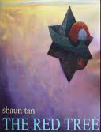  Links to RSE and emotions | Strategy focus:  Inferring  Children to infer how the character is feeling throughout the story and discuss how they know.  Genre focus:  Fiction – The Red Tree Shaun Tan  Links to RSE and emotions  KPI - With support make inferences based on what is being said and done (Y1 GD KPI) | Strategy focus:  Asking questions.  Children to write questions about what they want to find out about.  Genre focus:  Fiction – The day the crayon’s quit  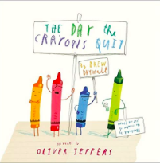 | Strategy focus:  Inferring  Children to infer how the character is feeling throughout the story and discuss how they know.  Genre focus:  Fiction – The day the crayon’s quit  Links to RSE and emotions  KPI - With support make inferences based on what is being said and done (Y1 GD KPI) | Strategy focus:  Clarifying  Children to use a glossary to understand the meaning of words in context in a fact file.  Genre focus:  Fiction – The heart and the bottle – Oliver Jeffers  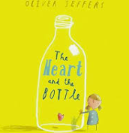  KPI - With support, children are motivated to discuss new vocabulary and they can make plausible links to words they know (Y1 KPI | Strategy focus:  Making connections – children to connect the book to a time they have  Genre focus:  Fiction – The heart and the bottle – Oliver Jeffers | Strategy focus:  Evaluate the language choices of the book. The repetition of ‘All are welcome here’ (equality) -connecting this to our curriculum learning  Genre focus:  Fiction – The heart and the bottle – Oliver Jeffers  KPI - With prompting, is beginning to discuss the author’s vocabulary choices ‘Why do you think he used…?’ (Y1 GD KPI)
Art/DT | LI: to create an observational drawing  Context: Shading  5 minutes - I do: explore different ways to shade. Hatching and cross hatching.  Model how to use both, doing one at a time.  You do: Children to identify how to shade using both techniques.  I do: Scrunch up a piece of paper on the table and model how to draw the negative space (line around the edge)  You do: Children to draw the negative space (outside line, not adding detail).  I do: model how to add detail using shading.  You do: Children to add more detail using shading techniques. | LI: to create a mood board based on an inspirational artist  Context : Pablo Picasso (line drawings)  (Character skill of Wonder – Curiosity and questioning)  Look at images that Picasso has created  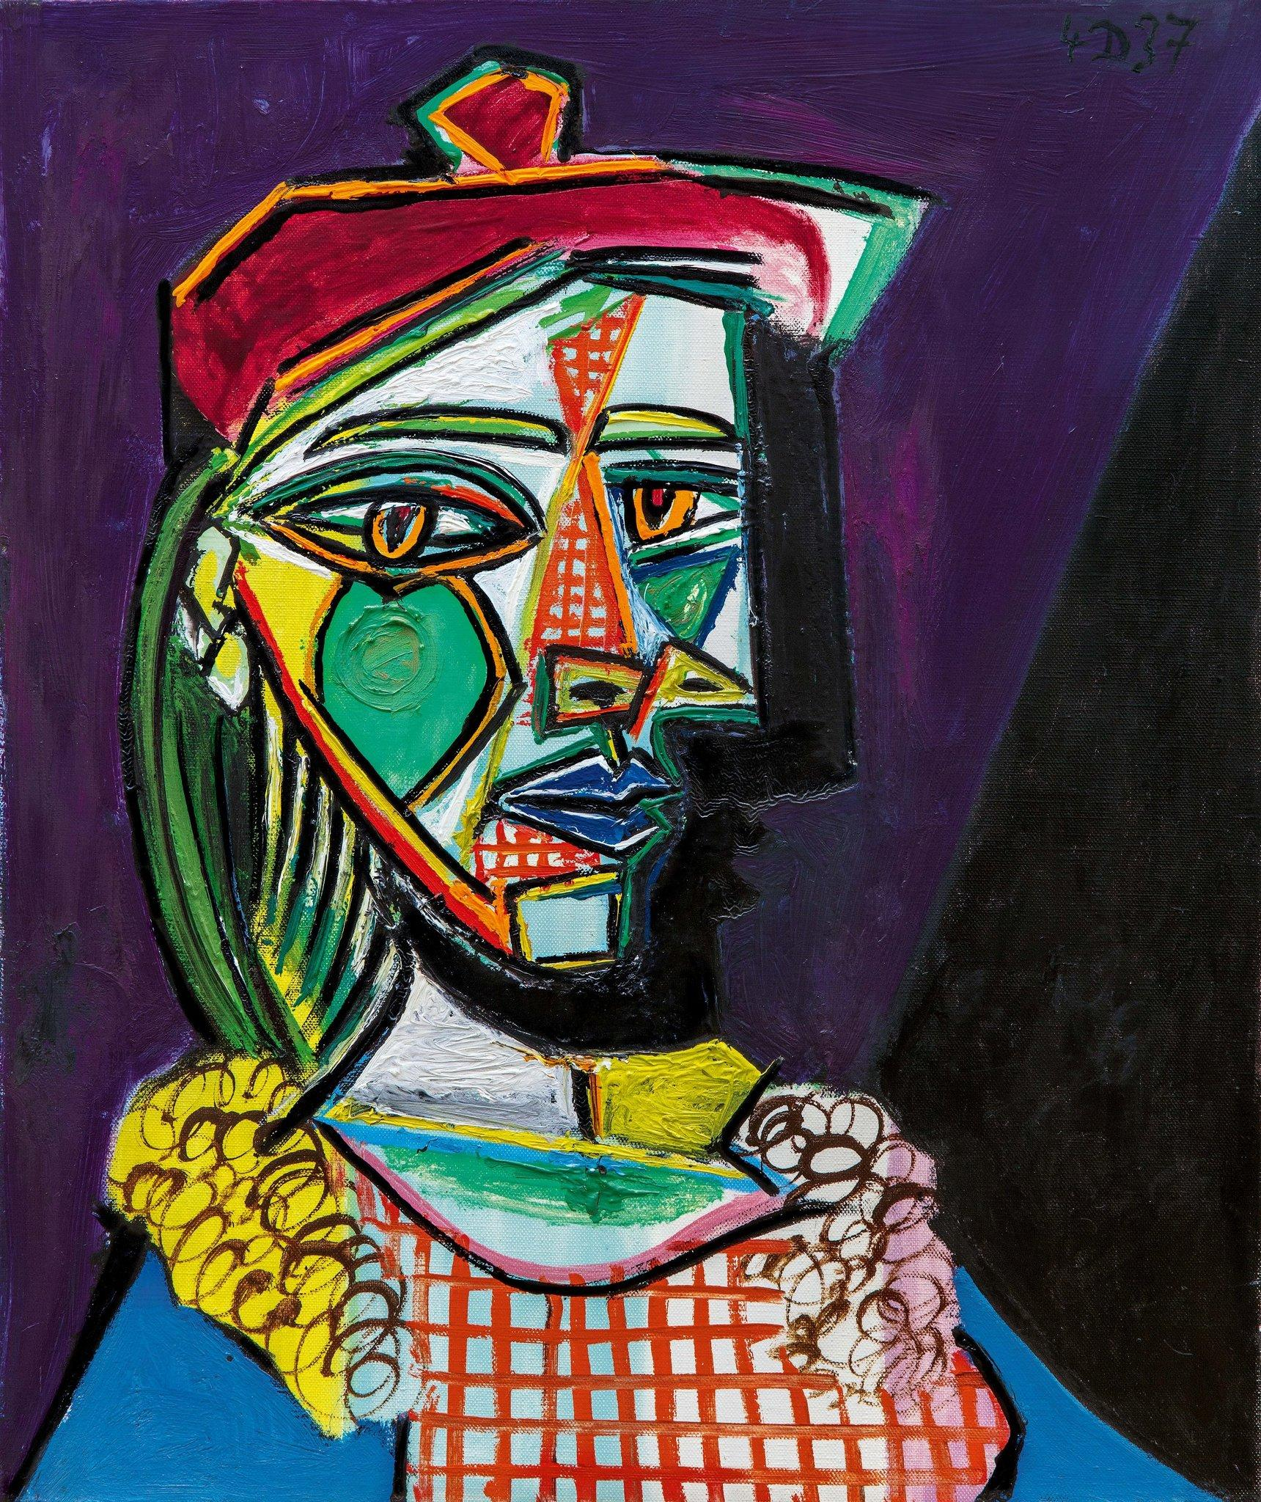  What does he draw?  Why do you think he did faces like this? (Think Emotions linked to colour)  Identify the colours he uses.  What emotion/ emotions do you think he felt while he painted this image? Share with your partner using the Kagan strategy rally robin (taking it in turns to talk their shoulder partner).  Create your mood board, annotate by adding your questions and your thoughts.  Annotate your notes and ideas why he used those particular colours. Think about what emotions he may have been feeling when he created his art. | LI: to create in the style of an artist  Context: Pablo Picasso - line drawings  Look at some continuous line drawings of Picasso’s animals.  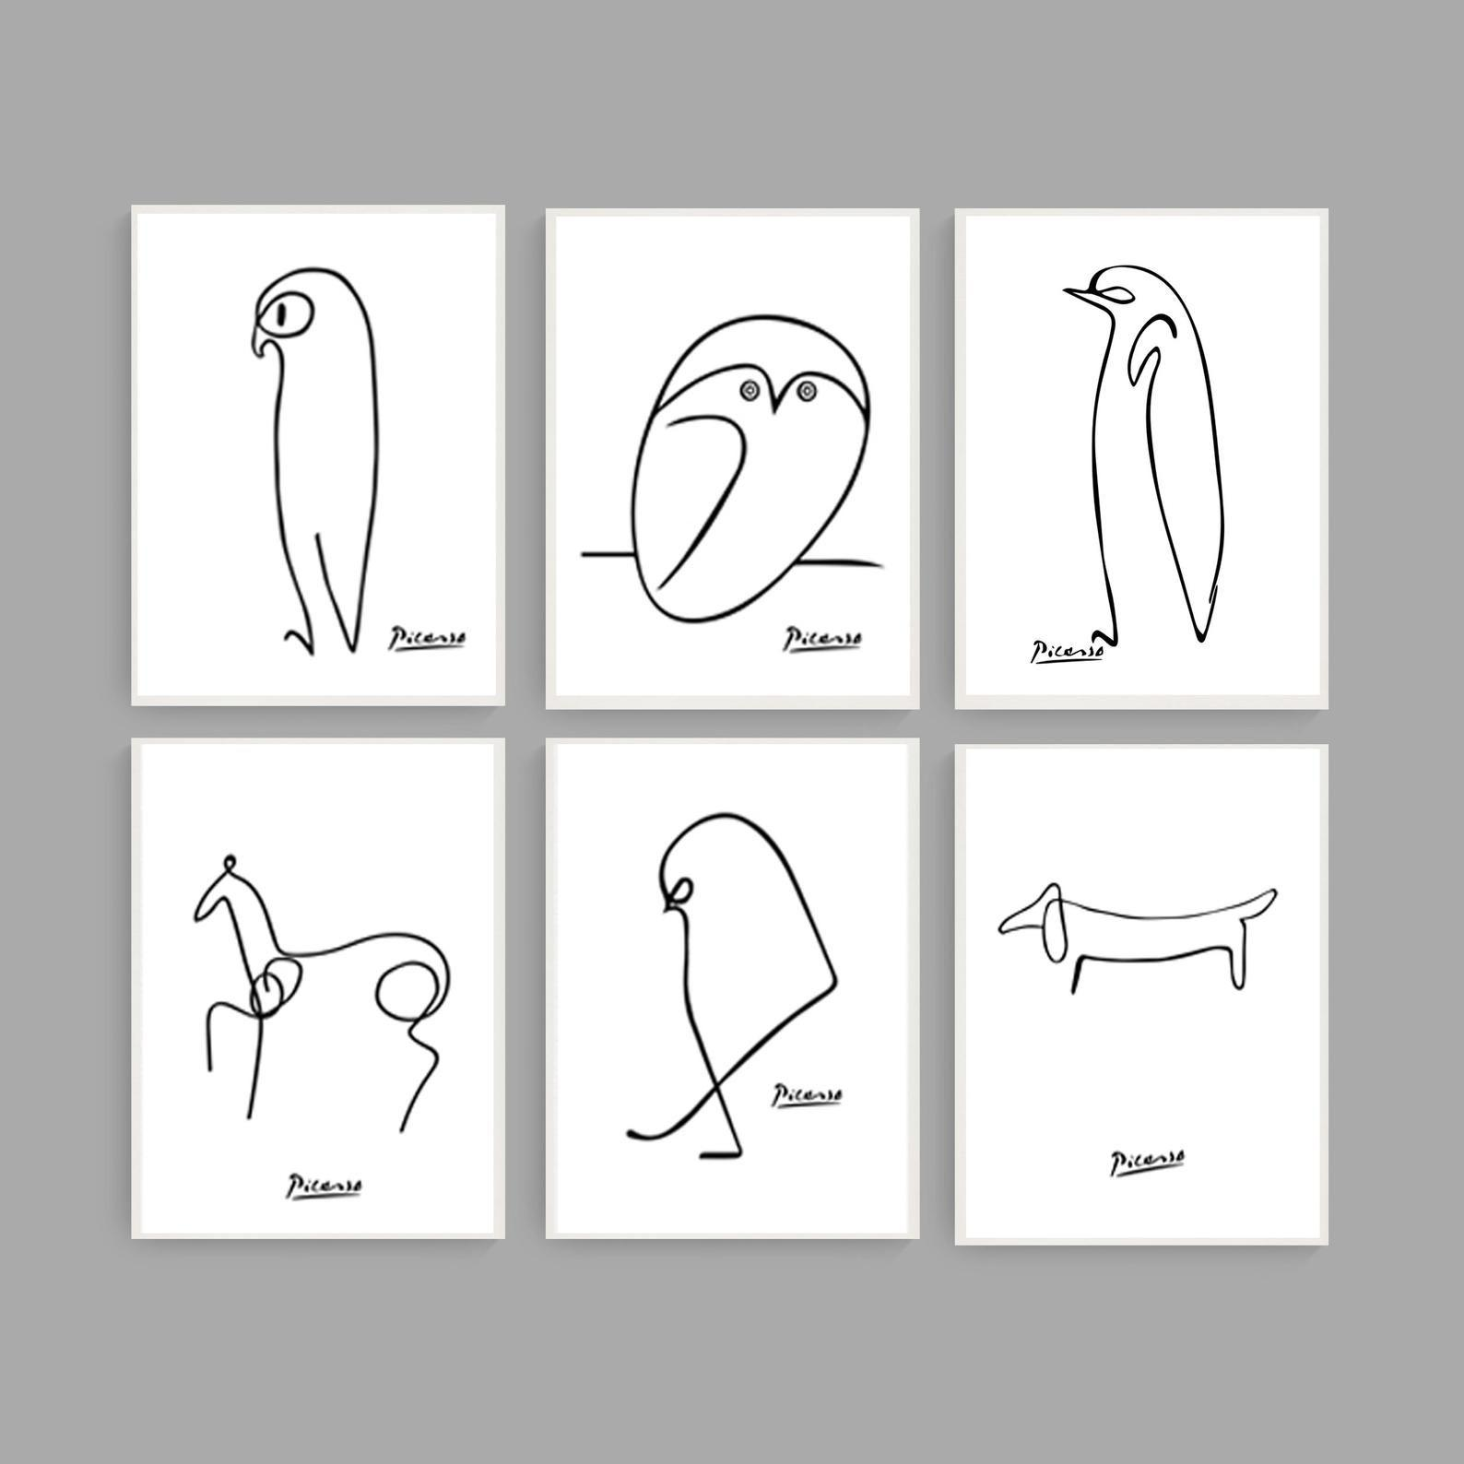  Discuss what they see. Compare them to the paintings from last week.  How are they different?  Why might he have drawn continuous line animals (1 line only without taking his pencil off the paper)  What emotion might Picasso have felt when he drew them compared to when he painted the faces? Could he have  been bored, happy, miserable etc?  Explain and justify your thoughts  Using the Agree, build, challenge prompts within your class.  I do: Model how to draw a continuous line drawing with a pencil.  We do: share with your shoulder partner what I did. (e.g. did I lift my pencil, did I colour it in etc?)  You do: Children draw their continuous line drawing using a pencil.  Use different media to draw the line drawing. Use charcoal, a paint brush with paint, ink etc. | LI: to create observational art  Context: The boy, the Mole, the Fox and the Horse  Look at the images in the book and let the children choose one to copy and make their own.  You do: Discuss what you can see, decide what you like and what you don’t like. Think about how the characters are feeling. Why do you they feel like that?  Share your thoughts using round robin/rally robin (depending on seating)  Finalise ideas and work on final piece  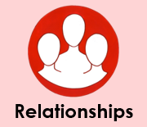  I do: Model how to sketch using the continuous line drawing like Picasso and using short strokes like Charlie Mackesy(core text)  You do:  Sketch your drawing using either the technique of a continuous line or smaller strokes, or both. Children to decide.  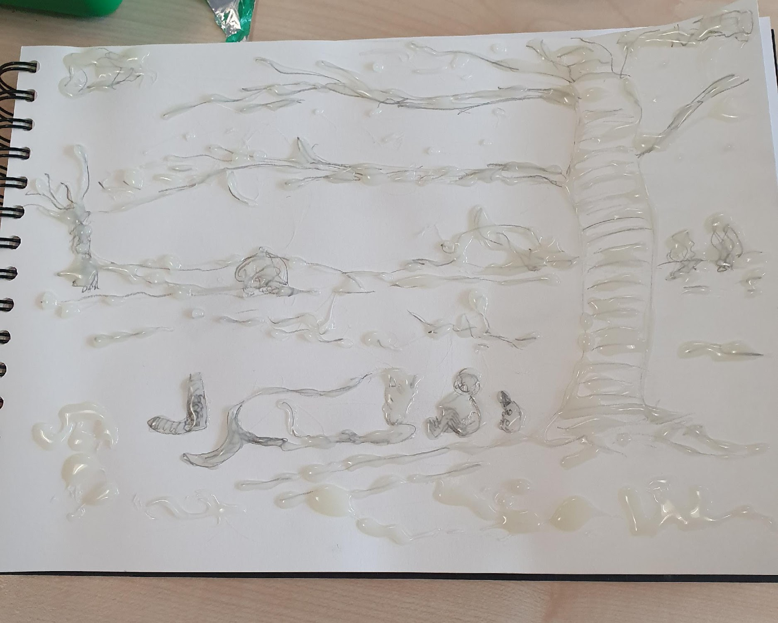 | LI: to create and explore texture through experimentation  Work on final piece.  Inform the children we are going to add some texture to our drawing which will need time to dry.  Ensure sketch is complete.  I do: Model how to drizzle a mix of PVA and black acrylic paint (choose the colour wisely)  Using a brush, drizzle the mixture over the pencil work. It doesn’t matter if a mistake is made. A lumpy line will form and dry.  Also model how to do the same thing with a glue gun (remember health and safety with heat)  We do: Children to discuss with their partner what they would like to use and why. Round robin.  You do: children to drizzle paint with pva over their pencil lines.  Leave to dry.  Discuss how they felt when they did this. Were they nervous about making a mistake?  How can they be positive about their mistakes? Can we learn from our mistakes?  (Mindset -Be adaptable and reflective- refer to character skills)  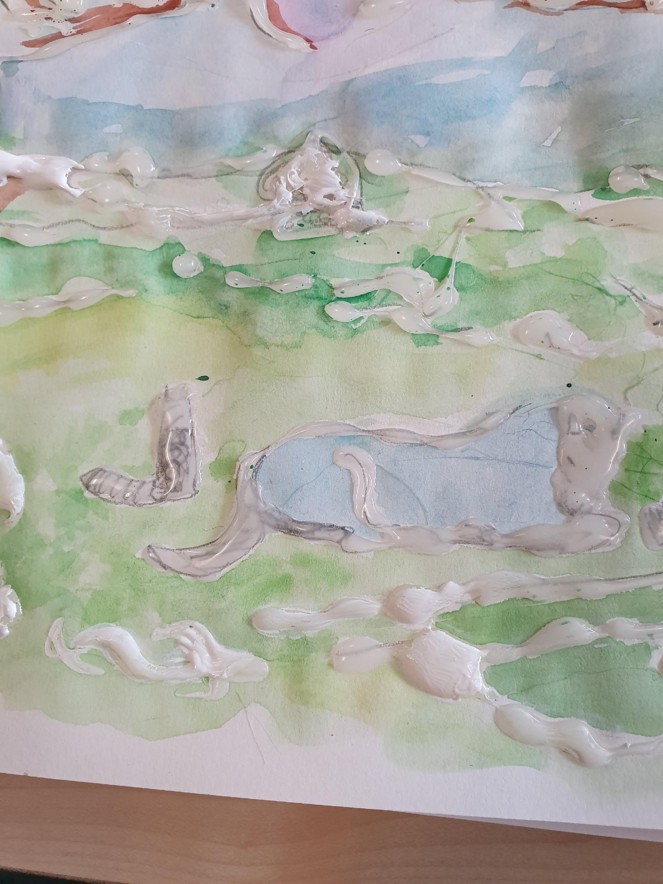 | Context: Watercolour  Work on final piece. Explain to the children that today you will identify and add the colours. Using colours matched to specific emotions. The colour will be added depending on what emotion they think is being portrayed in the drawing. Explain there is no right or wrong, it is what the children decide.  I do: Model how to use watercolour by adding water to alter the colour (more than one colour can be used). Model we don’t go over the same piece again and again as it damages the surface.  We do: Children tell their partner what colours they would like to use explaining why.  You do: Children to use watercolour to add emotions.More than one colour can be used.  Create  Work on final piece  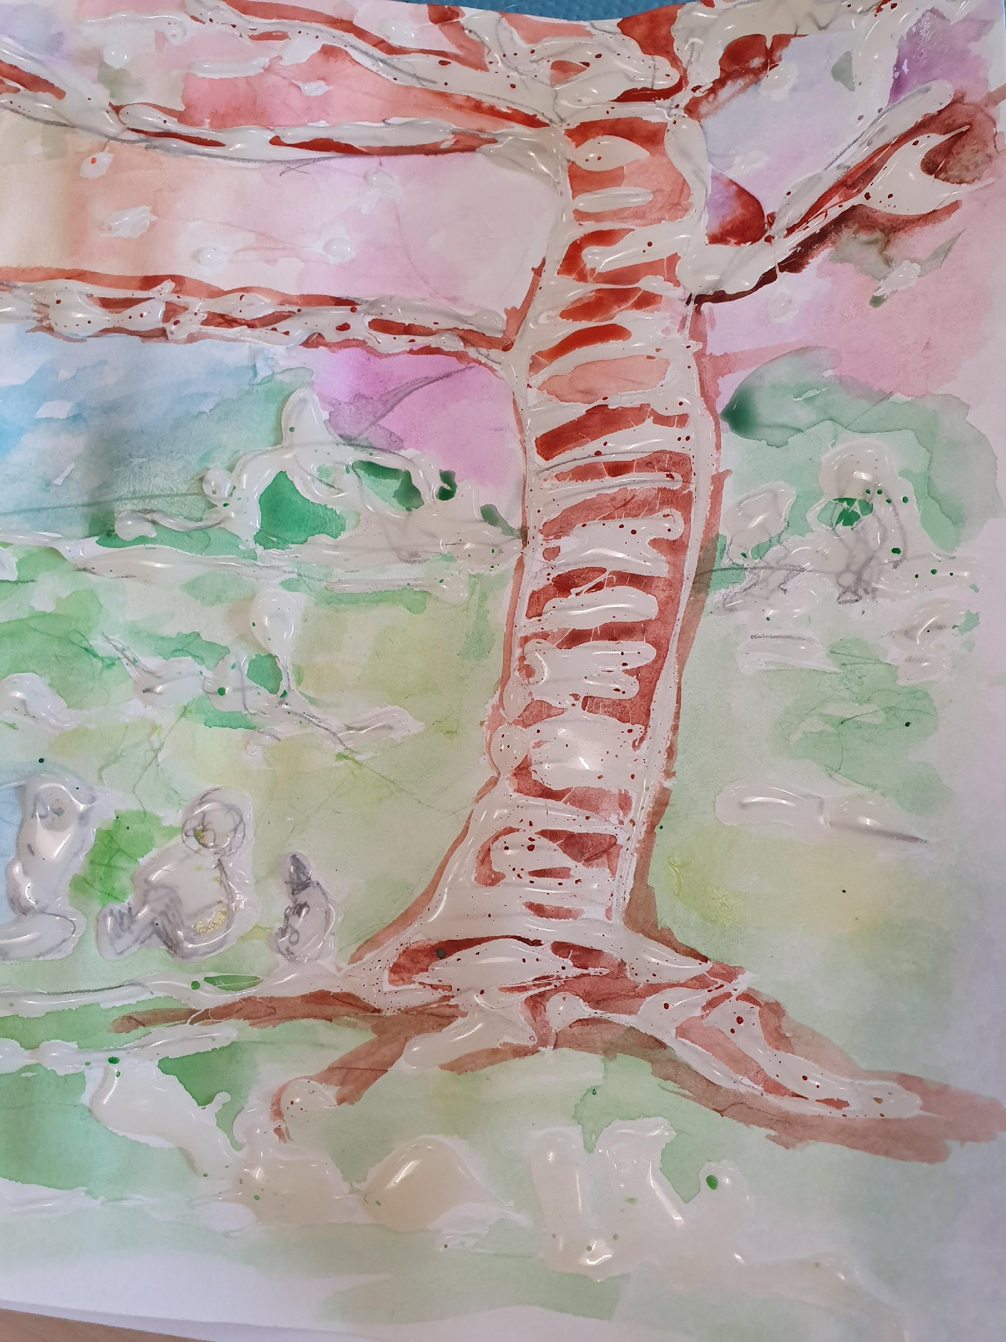 | LI: to evaluate and reflect on the learning journey  All children to complete two post-it notes each. The first one, they are to self-assess their own piece of work by identifying their successes and next steps. Then they can peer-assess their partner’s artwork by remarking on their successes and providing them a specific next step.  Identify through discussion what the children enjoyed doing with their art and why they enjoyed this.
Science  Throughout the term, set up a wormery/ant home etc. and children can start the lesson by observing what has happened or what has changed each week. | LI to classify and compare things that are living, dead or never alive  Hook: 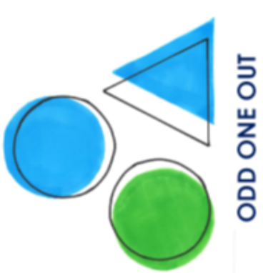 – have three objects on tables/board and chn to use sentence stems to explain OOO  e.g. plant, wooden pencil/object and something plastic.  Introduce terms – Living/dead/never alive – what do we think this means?  https://www.youtube.com/watch?v=b7rMHNaB548  What do living things do?  What is the difference between dead and non-living?  Can you identify things that are living, dead and non-living?  Activity  Chn to go to on a treasure hunt to the forest school and playground. Give children a bag and they collect different items . Chn to sort them into categories chn can have table in books or as context..    A leaf goes into the ‘never alive’ section because it doesn’t grow. | LI to identify living and non-living things in a habitat.    Why do you live here?  Explain animals choose a place to live because it gives them everything they need to survive. What might these things be? Shelter, warmth/cool, food etc.  What other habitats can you think of? Where might other animals live?  Share images of other habitats including micro-habitats (explain the meaning)  What animals might live in these habitats?  Activity – in books -  Tour of the school/local area – what lives in our area? Look for evidence of animals e.g. fox holes etc.  What non-living things are there which make it suitable for the animals?  . | LI To identify and describe a microhabitat.    What do we think a microhabitat is?  A small habitat (micro) that is different to the habitats around it.  It is a habitat for extremely small creatures such as woodlice.  A small part of a habitat is a microhabitat. A microhabitat has its own conditions of temperature and light, and its own characteristic species. Microhabitats include the shady area under a tree and the underside of a rock in a stream.  Share examples of microhabitats from different areas (pond, rockpool etc)  Activity – in books -  Children to find an area of the school/forest school, use a hula-hoop as a quadrat and carefully look around the quadrat to spot which living things they can see (plants and animals), and what non living things they can see. Children can be taught to use pooters too.  https://www.twinkl.co.uk/resource/t-t-3619-tree-leaf-identification-display-posters  https://www.twinkl.co.uk/resource/t-t-3616-woodland-word-mat  https://www.rbkc.gov.uk/PDF/Minbeasts%20pack.pdf | LI to use what I know to make a prediction  What is a prediction?  Explain and give examples – What do you predict the weather will be like tomorrow? What lessons do you rhink you will do tomorrow? Etc. Ask chn to justify it using what they already know.  Where do woodlice like to live? How do you know?  Explain that we are going to test whether our ideas are correct or not.  How can we do this?  Explain the chamber investigation – split a box with a lid into 4 using cardboard.Make holes in cardboard for woodlice to move through. Change the conditions of each quarter, damp, damp and covered (leaves), dry, dry and covered etc.  Put woodlice inside and return to the box after a week – where are the woodlice living?  Activity – in books –  Children can draw a diagram of the box.  Children to make a prediction and explain why. | LI: To research different habitats and their features  Research different habitats and animals that live there/why  Revisit the woodlice experiment. What have we discovered? Why have they chosen to live there?  Then research the different habitat types. (desert/Antarctica/rainforest/jungle/cave) | LI: to identify food chains  Discuss food in habitats. What might creatures in this habitat eat? What usually comes at the bottom on the food chain?  Activity: children to draw a food chain  What might a human’s food chain look like? | LI: To design a new habitat  Design habitat for new animal at the zoo and justify reasons  Hook – letter from zoo asking for help to design a new habitat.  Choose animals they have researched – how will you make sure it has everything they need? What will they need to eat using the food chain? What will you NOT include in your habitat?
PE: Outdoor | LI: To understand the expectations in PE  Recap importance of getting changed with children. How to behave outside etc. What do we do when we change into our PE kit? Where do we put our things etc.  Show children clips of different jump styles – long jump, triple jump, jumping in puddles etc. Explain we’ll be learning how to jump this half term. Children can play some jumping games on playground as a pre-assessment | LI: To identify the features of a good jump.  Show videos of normal jumping. What do you notice about their bodies? Can we make any steps to success for this?  Children to practice jumping. Have hoops set out. Children to jump between hoops using a two footed land. Hoops further apart for increased challenge. | LI: To perform a two footed jump in a range of scenarios  Different stations set up around the playground.  -jumping on spot  -jumping through hoops  Jumping side to side over the jump mat | LI: To coach my partner  Rehearse with children how to give someone feedback.  Partner children up. Put rubber strips/hurdles between children. Model how to jump from side to side. I still need to do the same STS but this time I also need to swing my hips to change my direction. Children give each other feedback to improve jumping | LI: To perform a range of jumps  Show videos of triple jumps. What do we need to do with our bodies?  Children to practice with partners and continue to coach each other. | LI: To perform a range of jumps  Show videos of long jumps. What do we need to do with our bodies?  Children to practice with partners and continue to coach each other. | LI: To perform a range of jumps in an obstacle course  Children to create their own obstacle courses using equipment for the different teams. What equipment will you use? How will they jump through the course?  Children to complete each others obstacle courses.
PE: Indoor | LI: To understand the expectations in PE  Recap importance of getting changed with children. How to behave inside etc. What do we do when we change into our PE kit? Where do we put our things etc.  Show children clips of different dances. How are they moving, what levels are they using, how fast, how slow etc. | LI: To move in time to a beat  Activity:  Focus on levels and different parts of chns bodies  Listen to x3 types of music with different tempos.  Chn to move bodies how they feel matches to the music  This music has a ____ tempo. It makes me want to move ____. | LI: To generate movements in line with a theme  Using the characters from the book, link to the music e.g. this sad piece could be horse when…  This excited piece could be when the mole…  Children generate routine movements for their parts of the music. | LI: To create transitions between sequences  Activity:  Creating transitions between different parts of the music. What is a transition? How can we link the ideas? Can we use the themes in the text to help us?  Children to create their transition movements and share with class. | LI: To choreograph a routine in time to music  Activity:  Children to create and rehearse their dances using the transitions from the week previously. Ensure using levels, turns, beats etc.  Groups/WC | LI: To choreograph a routine in time to music  Activity:  Children to create and rehearse their dances using the transitions from the week previously. Ensure using levels, turns, beats etc.  Groups/WC | LI: to perform a choreographed dance  Activity:  Perform dance  Children to give peer feedback. I like it when you…  You moved me when…

