Spellings
Use the ‘Look, say, cover, write, check’ method to practice these words containing the letter string ‘tial’ ‘cial’ each day.

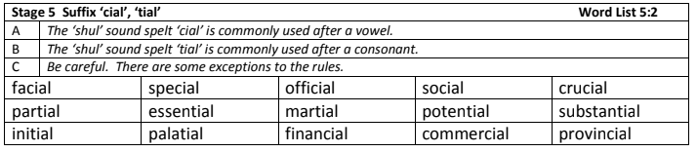
Challenge: Can you identify the meaning of these words and find synonyms and antonyms of each one?

English
In English this week, the children have published their narratives and looked at how to edit and improve their writing. This half term, they have learnt a variety of language and structural features to use in a narrative to engage the reader.

- Can you edit and improve the short paragraph below, using some of the language features that you have learnt? Remember to keep to the correct tense: present tense.

As I walk into the park, I see a man. He is wearing a black mask and it frightens me. I don’t know what to do. He is coming closer. I stand waiting. He walks past and says, “Thank you.” I am relieved.

Language features: descriptive and figurative language, show not tell, repetition, dialogue, varied sentence openers, punctuation for effect.
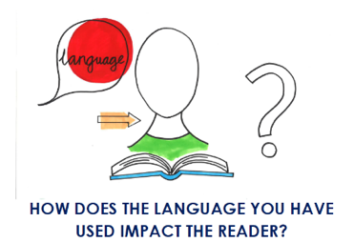
- Reflection: Can you reflect on how your language choices have affected the reader?

I used the word/phrase ____________ to make the reader feel __________________________________.

Maths
In Maths, we have consolidated our understanding of multiplication and division. We have applied our methods to a range of contexts. Complete the calculations below using the formal written methods for multiplication and division.

- Mrs. Callaghan gives three of her children a calculation each.
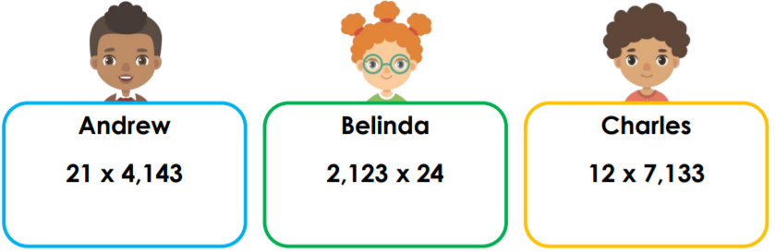
Which pupil has the smallest answer?

- A bakery sells boxes of cupcakes. There are 16 cupcakes in a box. Last year, the bakery sold 1,521 boxes. How many cupcakes did they sell?

The bakery also sells muffins with sprinkles on the top. In one month, they used 2,138 sprinkles. How many sprinkles will they use in the whole year?

- True or false?

Flowers are sold in trays of 12. The school needs 2,450 flowers to plant in the reception play area. The school caretaker thinks 204 trays will be enough.

- Jacob and Amelia are using short division to solve 6,728 ÷ 16.
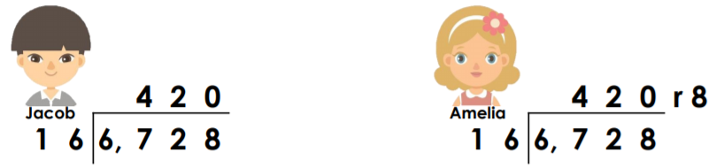
Who do you agree with? Prove it.

Reading
Remember to read for at least 30 minutes every day. Can you record any comments, questions or new and exciting words you have read in your reading journals?

Times Tables
This half term our times tables foci are our 2, 4 and 8 times table, Can you test yourselves and see how many you know when setting yourself a 2 minute timer? Do you notice any patterns with these times tables?
If you would like to challenge yourself daily, take these ‘Daily 10’ tests on:
https://www.topmarks.co.uk/maths-games/daily10

