Spellings
Use the ‘Look, say, cover, write, check’ method to practice these homophones.
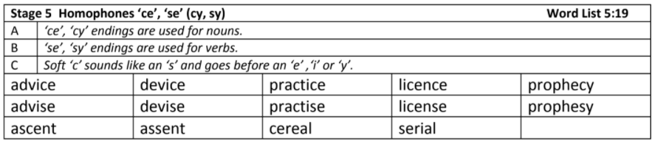
Challenge: Can you identify the meaning of these words and find synonyms and antonyms of each one?
English
In English this week, the children have been introduced to their new text, Trash by Andy Mulligan.They have read the first three chapters of the book, sequenced key events and answered questions in the role of the protagonists. Read the extract below and evaluate the author’s impact.
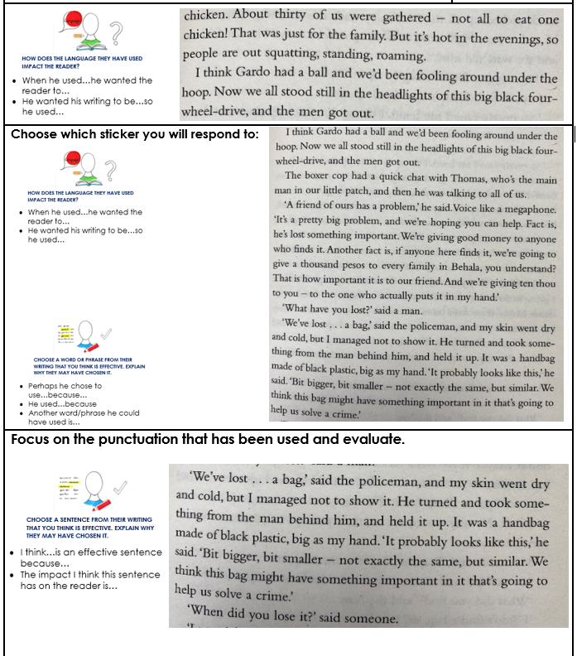

Maths
In Maths, the children have been looking at fractions. they have been simplifying fractions, converting mixed numbers to improper fractions and visa versa and adding and subtracting fractions.
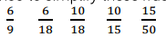
- Simplify the following fractions:

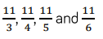
- Convert these improper fractions into mixed numbers:
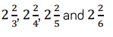

- Convert these mixed numbers into improper fractions:

- Solve the following calculations:
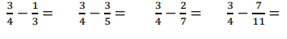
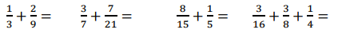
Solve the following calculations:

- On Friday, Ron walks 5/6k to school, 3/4km to the shops and 4/5km home. How far does he walk altogether?

- Eva has a full tin of paint. She uses ⅓ of the tin on Friday, 1/21 on Saturday and 2/7 on sunday. How much paint does she have left?

Reading
Remember to read for at least 30 minutes every day. Can you record any comments, questions or new and exciting words you have read in your reading journals?

Times Tables
This half term our times tables foci are our 2, 4 and 8 times table, Can you test yourselves and see how many you know when setting yourself a 2 minute timer? Do you notice any patterns with these times tables?
If you would like to challenge yourself daily, take these ‘Daily 10’ tests on:
https://www.topmarks.co.uk/maths-games/daily10

