Spellings
Use the ‘Look, say, cover, write, check’ method to practice these words containing the prefixes non-, ill- and co-.
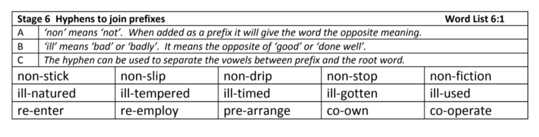
Challenge: Can you identify the meaning of these words and find synonyms and antonyms of each one?
English
This week, the children have learned to use dialogue to show conversations between characters and advance the plot . Create a conversation between Raphael and Gardo when they are sifting through the trash and discover the wallet. Remember to include adverbs to describe how the characters are speaking; synonyms for said; facial expressions and body language of characters and actions.
LI: To use dialogue and description to advance the plot | 
- Demonstrate an increased awareness of the character’s voice through carefully selected vocabulary
- Open and close spoken words with inverted commas
- Begin each line of speech with a capital letter
- Include punctuation inside the inverted commas
- Use an appropriate speech verb to report who has spoken
- Begin a new line for a new speaker

Write the conversation between Gardo and Raphael. Remember to include the key events from the text.


Ensure you advance the plot of the narrative by including further description and show not tell; this should describe how the speaker acts when speaking and how the person they are talking to responds.
Consider: body language, facial expressions, tone of voice, actions
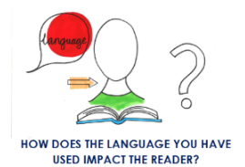
Why should we include a balance of dialogue and
description within our narratives? What is the effect
on the reader?
Maths
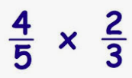
This week in Maths, children have multiplied fractions by fractions. Use your learning to complete the questions below.
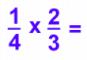
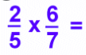

- Match the calculations to the correct answers.
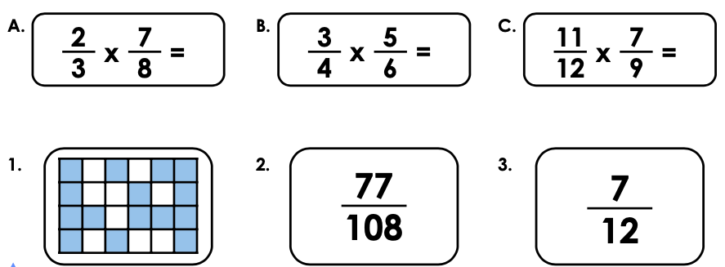

- Choose the correct number cards to complete the calculation below. Each number card can only be used once.
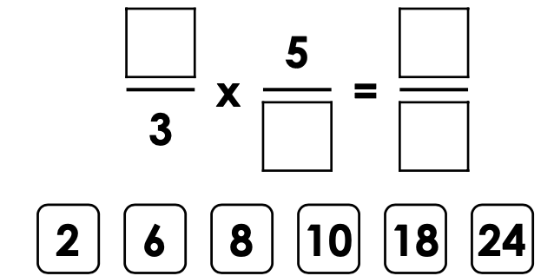

Reading

Remember to read for at least 30 minutes every day. Can you record any comments, questions or new and exciting words you have read in your reading journals?

Times Tables
This half term our times tables foci are our 2, 4 and 8 times table, Can you test yourselves and see how many you know when setting yourself a 2 minute timer? Do you notice any patterns with these times tables?
If you would like to challenge yourself daily, take these ‘Daily 10’ tests on:
https://www.topmarks.co.uk/maths-games/daily10

