Spellings
Use the ‘Look, say, cover, write, check’ method to practice these
homophones.
 | Attempt 1 | Attempt 2 | Attempt 3 | Attempt 4
isle
aisle
aloud
allowed
their
there
they’re
herd
heard
past
passed
Challenge: Can you write a sentence that uses each word?

English
This term, in English, we have been writing a narrative based on our core text: The Boy, The Mole, The Fox and The Horse. We have been focusing on improving sentences by adding adverbial phrases and noun phrases. Can you up-level these five sentences by adding adjectives and an adverbial phrase to each sentence?

Example - The fox crept through the snow.
As the shadows of his surroundings started to stretch across the white blanket, the cunning, wise fox crept through the snow.

The trees stood still.
Mole scurried across the grass.
The sun set.
The wind blew.
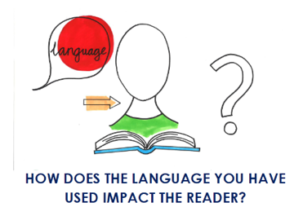
The boy walked through the snow.

- Reflection: Can you reflect on how your language choices have affected the reader?

I used the word/phrase ____________ to make the reader feel ___________________.
Maths
In maths we have been focusing on place value and decimals. Can you solve the 2 number riddles and then create two of your own.

1) What is the number?
•The number has four digits.
•The thousands digit is the same as 18 divided by 2.
•The hundreds digit is the same as 90 divided by 10.
• The ones digit is the same as 3x3.
• The tens digit is the same as 100-91.

2) What is the number?
• The number has five digits.
• The ones digit is an even number that is bigger than 6 but smaller than 9.
• The ten thousand digit is the same as 800 divided by 100.
• The hundreds digit is the same as 2 x 2 x 2.
• The tens digit is half of 10.
• The thousands digit is the same as 50 - 20 - 20 - 5.

3) Complete the number line.
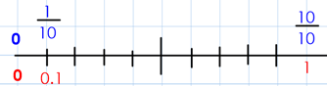
4 ) Write these numbers in ascending order.
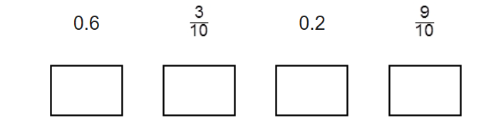

Reading
Remember to read for at least 30 minutes every day. Can you record any comments, questions or new and exciting words you have read?

Times Tables
This half term our times tables focus are our 6 and 12 times table, Can you test yourselves and see how many you know when setting yourself a 2 minute timer? If you would like to challenge yourself daily, take these ‘Daily 10’ tests on: https://www.topmarks.co.uk/maths-games/daily10

