Spellings
Use the ‘Look, say, cover, write, check’ method to practice these
words ending in -ent.
 | Attempt 1 | Attempt 2 | Attempt 3 | Attempt 4
ancient
confident
excellent
frequent
different
recent
convenient
accident
experiment
environment
Challenge: Can you write a sentence that uses each word?

English
This week we have started studying our new book ‘A long walk to water’. One task we took on was to create questions that were effective. We worked hard to create open ended questions that would give us as much information as possible if answered well.
Can you create 10 questions based on the two photos below?
Use these sentence stems to help you…

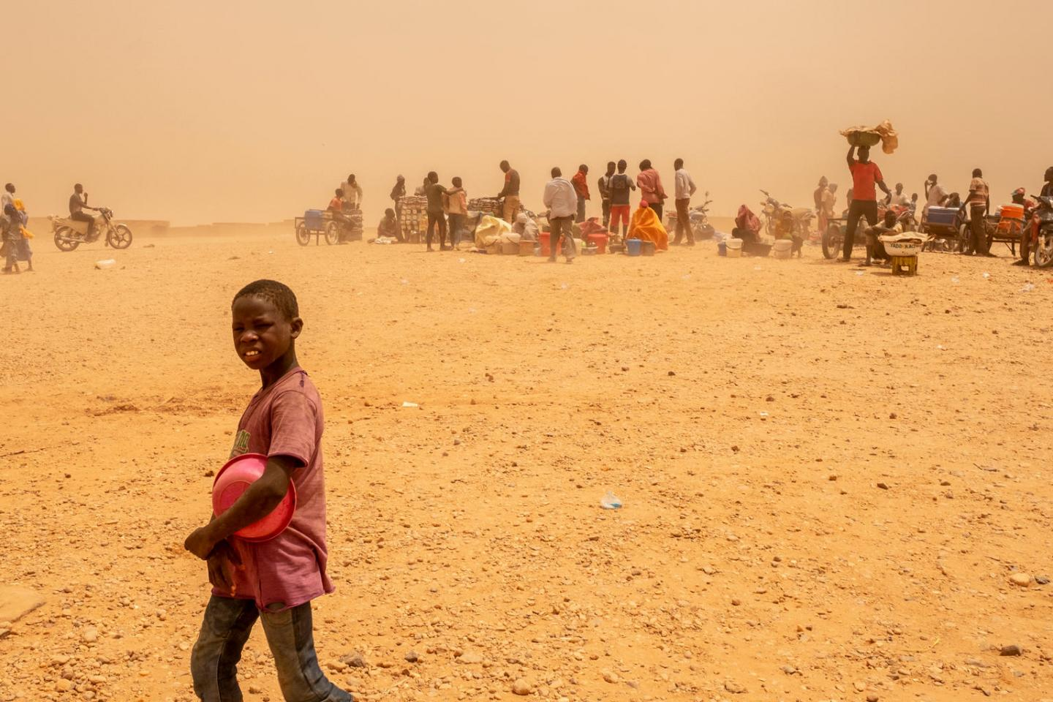
Who…
What...
Where…
Why...
When...

Maths
Our focus this week in maths has been on fractions; we have learnt how to calculate fractions of amounts, equivalent fractions and compare and order fractions.

- Eva uses the models and her multiplication and division skills to find equivalent fractions. Use this method to find equivalent fractions to ⅔, ¾ and 4/4 where the denominator is 16.
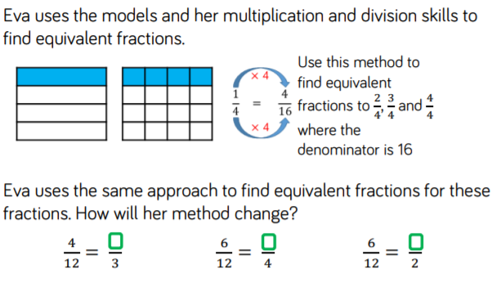
- Eva uses the same approach to find equivalent fractions for these fractions. How will her method change?
- Sarah wants to shade ¾ of this shape.
She has shaded 2 triangles.
How many more triangles must she shade so that is shaded?
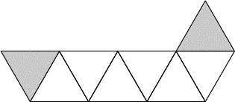
- Sarah has a bag of 24 marbles. ⅓ of the marbles are red.
How many marbles are red?
- Write these numbers in order starting with the smallest.
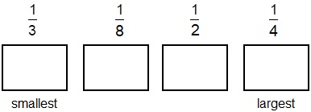
- Which shape below is shaded ¾ grey? Put a ring round the correct one.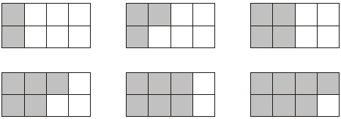
Reading
Remember to read for at least 30 minutes every day. Can you record any comments, questions or new and exciting words you have read?

Times Tables
This half term our times tables focus are our 6 and 12 times table, Can you test yourselves and see how many you know when setting yourself a 2 minute timer? If you would like to challenge yourself daily, take these ‘Daily 10’ tests on: https://www.topmarks.co.uk/maths-games/daily10

