Spellings
Practice spelling these year 4 common exception words using look, cover, write and check method.

Look | Cover | Write | Check
through
different
disappear
difficult
describe
1.Use the word in a sentence.
2.How many words can you fit into one sentence?
English
This week, children have been learning about the importance of editing and up leveling their writing. Can you edit and up level the paragraph below?
in a blink of an igh, the boy looked up and realised he was lost. All he see was trees lurking over him. The tree branches was long like the river nile. Qietly he walked through the forest. Rusty leaves dancing all around him lifting up the dirt of the forest. All of a sudden he could feel goose bumps climbing up his spine as he herd birds screeching above his head. The sky was full of crows. The forest was like a scary house.
Task 2
In preparation for next term, could you think of a super hero that has had a positive impact on you? and bring along a photo of your chosen hero?

Maths

This week in maths, children have been looking at negative numbers and using such knowledge to solve problems.

Can you complete these problems involving negative numbers ?
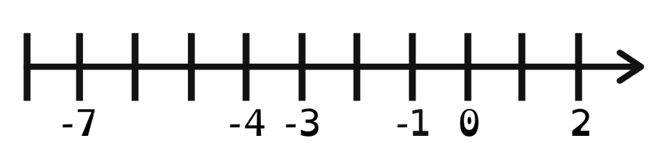
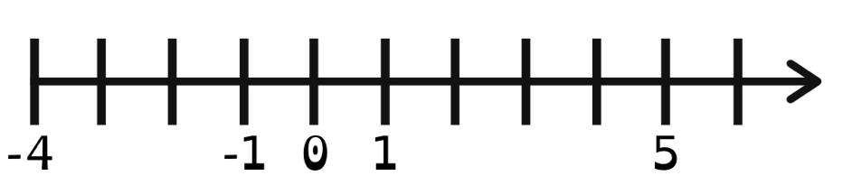
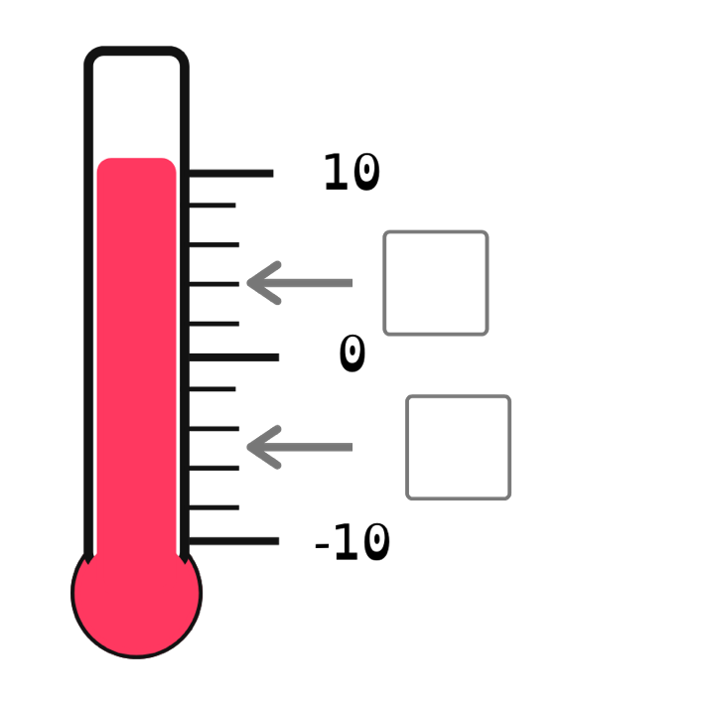
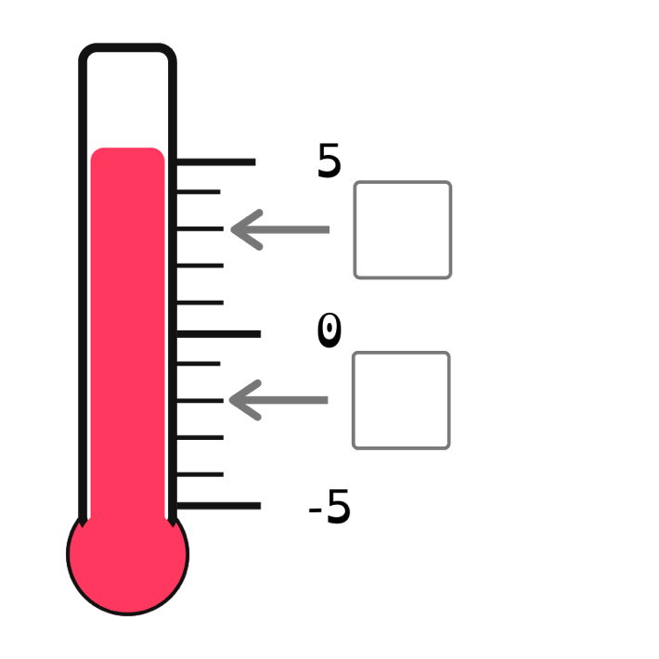
What would the 9th and 11th numbers be based on the sequences below?
1st | 2nd | 3rd | 4th | 5th | 6th | 7th | 8th
20 | 15 | 10 | 5 | 0 | -5 | -10 | -15
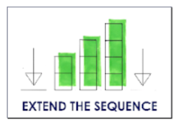
Can you spot the mistake in these number sequences?
a) 2, 0, 0, −2, −4
b) 1, −2, −4, −6, −8
c) 5, 0, −5, −10, −20
Explain how you found the mistake and convince me you are correct.

Reading
This term in reading, we have been learning about different reading strategies such as inferencing and evaluating to answer questions based on a text. Using such knowledge can you apply taught strategies to answer questions.

LI: to use a variety of reading strategies to answer questions on a text | 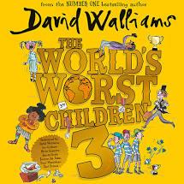
- Read the text and questions carefully
- Skim and scan the text, looking for key words
- Apply the relevant reading strategy
- Check you have answered the question fully
Needless to say. Mother hated having tricks played on her. Her son showed no mercy. It was because her reaction to his pranks was the greatest that Hank dreamed up devilish tricks to play on her.
The boy would think of the next day’s pranks while enjoying his nightly bath. Mother always moaned that he spent far too much time in there. Every evening after her son had been in the bath for over an hour, she would pound on the bathroom door.
BUNG! BUNG! BUNG!
“Hank, come out! If you stay in that bath a second longer, my boy, you will end up withered like a prune!”

Answer the following questions with a full sentence:
Q1: What did the author mean by “you will end up withered like a prune!”? How does it link to spending too long in a bath?
Q2: What individual words suggest that the mother Is annoyed at the amount of time the boy spends in the bathroom? Why?
Q3: Why does the author use the word “devilish” to describe the boy’s tricks?

Remember to read for at least ten minutes every day and record the books you have read in your Reading Journal. You can also make a record of new and exciting words you read in there!

Times Tables
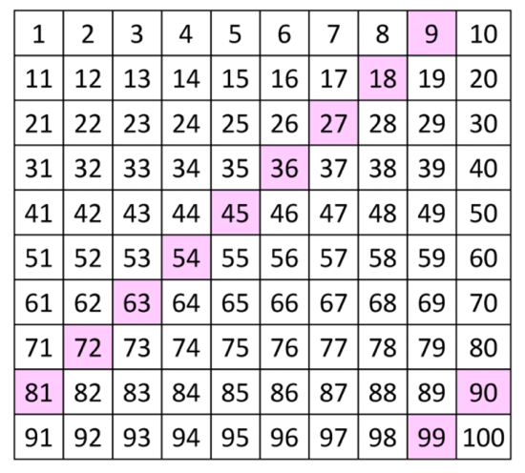
Practice your 9 times tables as much
as you can so that you can learn them off by heart.

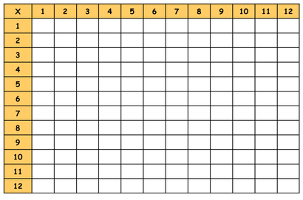
Speed challenge: Complete the blank times tables grid below. Remember to cover up the grid above.

