Medium Term Planning – Summer 2

Inspire Curriculum | Core Text  Hook | Diversity, Community & Global  Project Outcome for the Term
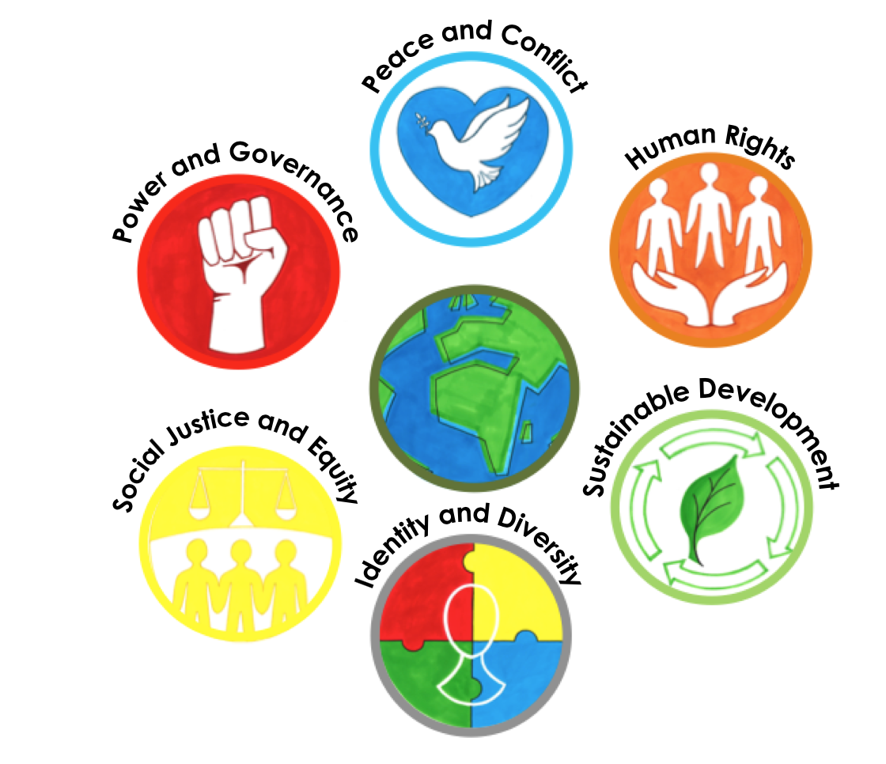 | 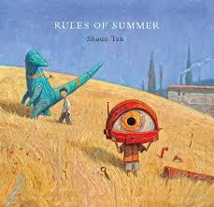  Rules of Summer by Shaun Tan | Project Outcome.  Children will create and bury a time capsule of memories to commemorate this moment in history. They will also plant a tree to give back to the community. Their therapeutic RSE curriculum will take them from acknowledging and managing their emotions to reflecting on their recent experiences. They will then look forward and plan for a future of hope.  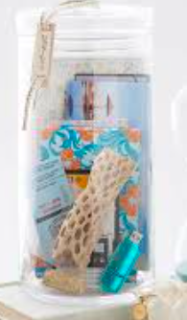
 | Art Outcome  Display idea | Trip/Visitors
 |   ‘Freedom from Lockdown’  Focus Artist - Shaun Tan.  Outcome - community landscape relief with giant marbled animals. | N/A

Diversity, Community & Global Learning Project

Highlight the global theme/themes covered this half term:

Social justice and equity
Identity and diversity
Sustainable development
Peace and conflict
Human Rights
Power and governance

Focus: What will the focus of the term be? Refer to long term plan

Summer 2
Week 1  w/c 1st June  3 days.  Weds  Thurs  Fri | Art -  LI - To explore a mood colour palette.  Starter –  Have a range of colours available and ask the children to sort them into Happy colours and Sad colours. (Could have colouring pencils to sort into two piles, pieces of coloured card, or on the Whiteboard display a colour pallet and children to write on whiteboards which side colours belong)  Discuss the choices with the chn and understand how they have grouped their colours.  Activity -    Introduce a wider range of feelings e.g. worried, low, upbeat, energised. Have children help you create a mind-map on the flipchart. Use Communication in Print images too for each emotion. Open the floor to the children about what choice of colour they would use to present - Upbeat. Model to the children how this will look in their book.    Each child has a mini pack of emotions. The children will choose one of the emotion faces and paint colour strips using shades of red, blue, and yellow/orange to represent that feeling.  Encourage children to do these a few times so that they have an emotion for each colour.    (Happy, upbeat = Yellow, Sad, worried = Blue, etc)  Key Vocab –  feeling, mood, emotion, colour palette, colour wheel  Questioning -What colour are you feeling today? Why? What situation might make you blue? red? orange?  RSE - Addressing our emotions.  LI - to ask questions.  Activity -  Chn ask questions and share their concerns about the coming weeks.  A corona - lockdown - return to school - social story is shared.  Children write their questions on a post it note and put it in a worry box.  Teacher reassures and explains through answering these worries. Brings out emotions from a box – why might someone be feeling nervous? Etc.  Vocab –  worry, concern, support, feelings, emotions.  Questioning –  How do you feel? Does anyone else feel this way ? When have you felt like this before?  What can you do to feel better?  LI - To understand changes in our routines  Activity -  Chn are taken around the building and shown, entrance and exit spots, shown how to sit in lunch hall, how to walk around with two meters distance, how to be in playground and stay two m apart, toilet procedures, changes in time we have lunch etc.  Good to be green recap. Create large piece for classroom. Recap normal rules. Add handwashing etc to green.  LI – To identify emotions might feel  Activity -  Chn place emotion faces on Zone of Regulation A3 colour grids.  Activity - in books … I felt … when. … (links with lock down overcoming trauma and adapting to new norms.)  Vocab -worry, concern, support, feelings, emotions, angry, frustrated, bored, sad, alone, giving up, nervous, anxious.  Questioning - How do you feel? Does anyone else feel this way ? When have you felt like this before?  What can you do to feel better? How can we get out of blue and into yellow/ green?
Week 2  w/c 8th June | Art  LI - To create a pencil sketch  Activity -  Walk around the playground and look out at the flats looking down on them.  Show chn images of buildings in their community. eg highrise flats.  Children create pencil sketches of buildings  Vocab - line, shape, straight, cubed, square, sketch, observe  Questioning - What shapes can you see? What lines can you see?  Art  LI - to create a sketch using mixed media  Activity -  Show chn images of buildings in their community. eg highrise flats.  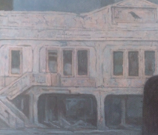    Children create sketches of buildings using charcoal and pastels.  These will be cut out and added to collage relief. Individual sketches needed - not skyline  This is onto brown parcel paper and newspaper.  Vocab - line, shape, straight, cubed, square, sketch, observe  Questioning - What shapes can you see? What lines can you see?  RSE - Managing our emotions.  LI - how to manage my emotions.  Activity -  Share some red emotions and discuss how we can calm down and move to green.  Practice some mindfulness breathing strategies. Lazy eights, finger five, candles flowers, butterfly.  Discuss time out, count to ten, yoga moves, exercise  Share some blue emotions and discus how we can get back to green.  Cuddles, ride our bikes, chat with grown up, exercise, hobby etc.  Children choose emotion in print. stick in book and write using scaffolds  When I’m …. I can ….  Vocab -worry, concern, support, feelings, emotions, angry, frustrated, bored, sad, alone, giving up, nervous, anxious, manage emotions, feel better.  Questioning - How do you feel? Does anyone else feel this way ? When have you felt like this before?  What can you do to feel better? How can we get out of blue and into yellow/ green?
Week 3  w/c 15th June | Art -  LI - to explore a mood colour palette.  Activity -  Refer back to colour strips from week one. Explore a colour wheel and discuss.  Children paint blank colour wheel and use shades of red, blue, and yellow/orange to represent feeling. Chn annotate with feeling words.  Vocab - feeling, mood, emotion, colour palette, colour wheel  Questioning.  What colour are you feeling today? Why?  What situation might make you blue? red? orange?  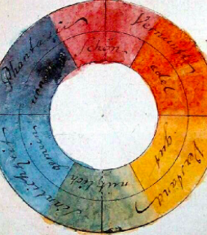  Art -  LI - to explore a mood colour palette using marbling.  Activity -  Refer back to colour strips and colour wheel. Chn choose an emotion and appropiate marbling ink. They put drops in water tray and lay varied paper on top, eg plain, parchment, newspaper. Explore effects.  Vocab - feeling, mood, emotion, colour palette, marbling,  Questioning.  What colour are you feeling today? Why?  What situation might make you blue? red? orange?    RSE Reflection and Recovery  LI - reflect on a significant event.  Activity -  Share positive community images of lockdown - clapping for NHS - food parcels - lending library - virtual learning - rainbows - cookie delivery  Explain lockdown was a moment in history and we will look back and remember this. Explain concept of time capsule.  Discuss meaning of memories. Brainstorm as a class happy memories of lockdown. eg playing with brother, baking with mum, playing in park, finding new ways of playing, eating as a family, teachers teaching on line. Chn brainstorm happy memories - positives from negatives - in books.  Vocab - memories, reflections, history  Questioning - What did you enjoy? How did you help your community ? What did you do at home?
Week 4  w/c 22nd June | Art -  LI - to explore a focus artist  Activity -  Explore pictures of Shaun Tan in talk partners. Children choose one and brainstorm around under headings. - What’s in the picture ? What emotions and mood does it make you feel ? Lead chn to notice animals feat heavily.  Vocab - Shaun Tan, illutstrations, illustrator, animals, city setting, urban landscape  Questioning.  What can you see in the picture? How does it make you feel ? What mood is the artist portraying?  Does it remind you of anything ? (links with texts) What do the pics all have in common ? (links to obscure animals)  Art -  LI - to explore a focus artist  Activity -  Explore pictures of Shaun Tan in talk partners. Picture all feat animals. Chn choose fave - cut in half and stick in book. Chn use pencils to sketch the second half of the page.  Vocab - Shaun Tan, illutstrations, illustrator, animals, city setting, urban landscape  Questioning.  What can you see in the picture? How does it make you feel ? What mood is the artist portraying?  Does it remind you of anything ? (links with texts) What do the pics all have in common ? (links to obscure animals)  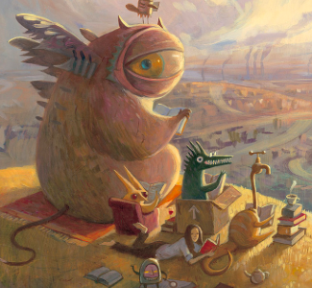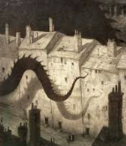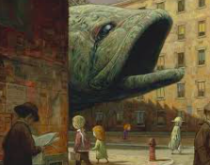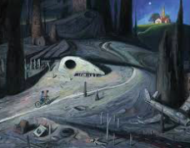  RSE Reflection and Recovery  LI - reflect on a significant event.  Activity -  Brainstorm with children ‘Why we love Woodhill’ These will form messages of hope for Sept.  eg, teachers who help us learn, playing maths rockstars, playing on the playground, fish and chips on a friday, going swimming, visiting the care home etc.  Chn brainstorm around a sch logo in their book.  Vocab - memories, reflections, history, hope, promise, love,  Questioning - Why do you love Woodhill ? Which people are special to you? What can’t you wait to do in Sept?
Week 5  w/c 29th June | Art -  LI - to sketch an animal using a chosen media.  Activity -  Introduce final outcome pic by Shaun Tan. Share pictures of animal and what they might represent, a bird - freedom, lion - courage, rabbit - pet homelife. Chn draw an animal that represents they’re mood - leaving lockdown - adapting to new norms - representing freedom . Teacher to have card stencils for LA chn to draw around. Chn to fill an A4 page and choose their own media.  Vocab - Shaun Tan, animals, hope, freedom, courage, resilience, strength,  Questioning.  Which animals represent hope, courage, resilence etc.. ?  Which animal might represent your current mood? Why ?  Art -  LI - to create an animal relief.  Activity -  Chn draw their animal onto marbling paper. Chn can choose marbling colour based on links with emotion Teacher to have card stencils for LA chn to draw around. Chn to fill an A4 page  Vocab - Shaun Tan, animals, hope, freedom, courage, resilience, strength,  Questioning.  Which animals represent hope, courage, resilence, freedom, family, home etc.. ?  Which animal might represent your current mood? Why ? Which colour will you use to represent your animal ? Why ?  RSE Reflection and Recovery  LI - reflect on a significant event.  Activity -  Opportunity for chn to write positive lock down memories on cartridge using special pens. these will go in the time capsule. Chn also write captions of ‘Why Woodhill’ on black card strips with metallic pens, hole punched with ribbon. These will go in a communal space as part of our celebration of hope for Sept.
Week 6  w/c 6th July | Art -  LI - to create a waterwash background  Activity -  Show chn images of night time sky. Chn to paint A4 night time sky water wash using water colours. Teacher mosel adding water to create darkness to light.  -group to work with teacher on cardboard relief buildings to use on a display centre canvas.  Vocab - Shaun Tan, night time, water wash, shade, dark, light    LI - to create a collage  Activity -  Chn to cut out, layer and stick buildings they sketched in Wk 2. Add their marbled animal cut out.  Children add embellished pieces, eg trees and windows - cut from coloured card. Chn use chalk or pastel effects to add details on windows, buildings and stars and moon in sky.  - group to work with teacher on cardboard relief buildings to use on a display centre canvas.  Vocab - Shaun Tan, cityscape, layers, foreground, background, collage.  RSE Outcome - Giving back to the Community.  Children plant tree and create and bury time capsule under tree.  - A group can also arrange fake branches in a decorative pot inside a communal space and tie messages of hope onto it using ribbon.
Week 7  w/c 13th July | Art X 1 lesson this week.  LI - to reflect on our work  Children share pieces and use peer evaluation to feedback using scaffolds below.  I can see your animal is …  Why did you choose this animal ..  This is similar / different to me because … ?  I chose this animal …. to represent.  Chn write captions for display.  ‘ The colour …. makes me think of …. ‘  ‘ I was ….. (colour) now I am …. (colour …) because…  My animal is …. to represent the value of ….  RSE - Moving on. x 2 lesson this week.  LI - to reflect on the year  Activity -  Chn write a letter in two parts - reflections & goals - to the new teacher to introduce themselves and share goals and reflections.  This year I was successful at ….  I had to overcome the challenge of …  I enjoy …  My friends are …  Questioning.  What success did you have this year ? What do you enjoy learning in class? What challenges? How did you overcome these?  Vocab success, challenge, learning, future, reflections, goals, targets, hopes, worries.  LI - to set targets for the future  Chn continue letter focusing on target setting and worries.  I want to get better at .. and ..  I hope to …  I am worried about …

 | Week 1 | Week 2 | Week 3 | Week 4 | Week 5 | Week 6 | Week 7
Whole Class Reading | Making links between texts. Using phonics.  Where the Wild Things Are | Making links with real life experiences. Using phonics.  The Colour Monster, | Making links with real life experiences. Using phonics.  After The Fall | Making links with real life experiences. Using phonics.  Here we are - Oliver Jeffers | Predictions. Using phonics.  The book of kind. | Clarifying. Using phonics.  How to heal a broken wing | Clarifying. Using phonics.  How to heal a broken wing
P.E  Infant Agility   | LI: To understand how to perform the correct running technique  Intro: How can we keep ourselves healthy? Why is it so important?  Activity:  Sprint race Using your arms to make your legs move quicker, look in the direction you are running, standing upright and changing direction.  Treasure chest.  The Teacher splits the class into groups and locates them in an area around 3 different Treasure chest in the middle. Children run out one at a time and collect treasure from the middle demonstrating their running and changing direction technique from the previous activity. Children may only collect one piece of treasure at a time and return it to their area.  Get the chn to identify and reflect on their own strengths in their performance and what they could do next time.  Equipment:  Bean bags  Cones  Small balls (  these can be colour coded to make it easier) | LI: To develop techniques to throw a ball with accuracy  Activity: Chest pass: Find a wall space and chest push the ball against the wall. Highlight any good practice: Create the ‘W’, step in and push the ball in the direction of where the ball needs to go.  Shot Put: Using small soft balls, tennis balls or bean bags. Model the technique to chn - hand near the shoulder, bending knees, and pushing forward. Give chn the chance to practise using the standing stance.  What else can we do to make the ball go further?  Develop the use of leaning back slightly, using a run up, side stepping and seeing if this pushes the ball/ beanbag further.  Use a tape measure and cones to measure the chn’s distance and see if they can beat their distance.  Equipment:  Netballs  Basketballs  Tennis balls  Cones  Lesson 2:  LI: To explore ways of using feet to control a ball  Activity:  Football control: Each pupil moves around inside the grid trying to keep the ball as close to them as possible. Encourage pupils to keep their head up instead of looking at the ground. Every minute hold your hand into the air and ask the pupils to shout out the number on your fingers.  Allow pupils to use both feet and encourage gentle touches so the ball sticks to their feet.  See if pupils can turn in any direction using different parts of their feet. Then shout out different parts of the body EG Knee and the pupils need to stop the ball with that body part.  Treasure chest: Split the class into small teams at each corner of the grid. Put all the balls in the centre of the grid in 4 separate bundles. Pupils have to run to the hoop and use their feet to get the ball back to their corner. Only 1 person can go at a time and also can only take 1 ball at time.  Equipment:  Footballs  Small soft balls  Cones | LI: To incorporate different balances into a routine  Activity: Discuss with pupils what we mean by balancing and what parts of the body can assist us when performing balances e.g. arms  Let pupils go off and explore different ways of balancing, go around and ask pupils what part of the body they are using to balance.  Then try and get pupils to perform a stretched balance and a curled balance, discuss different body parts that can be used.  Allow pupils to explore different balances such as balancing on backs, tummies, sides, bottoms etc  Describe what PATCH and POINT balances are. A point balance is using small body parts such as feet, hands, head or knees. Patch balances use large body parts such as legs, back, stomach.  Pupils to run about and perform either a point or patch balance when called out.  Put everything learnt into a set sequence. Pupils need to perform sequences to the class and then the class needs to give feedback.  How did your peer sequence their moves? What did you think of their performance?  Equipment: Chalk  Cones  Lesson 2:  LI: Understand different ways to balance  Activity: The teacher plays a range of music and informs students to move in a range of ways. For example, Running, Skipping, hopping etc. When the teacher stops the music, students have to stop and hold a balance of their choice for 10 seconds.  What makes a good balance? Who can stand on one leg?  Complete the same task as previous, but students are only ever to balance on one leg. When the music stops the first person to fall out of the balance is out, until there is a winner. Encourage pupils to try and balance on each leg, not just the same leg each time. Arms should be out to the side, tummies sucked in, head up and eyes should focus on something in front of them to help them balance.  Stork Test: Each pupil to balance on one leg with hands on hips. Time how long each pupil can hold the balance for. Repeat if necessary and see if they can beat their time.  Which balance was the easiest? Why is balancing challenging?  Equipment:  Chalk Sound system/CD player | LI: To develop the technique to jump effectively  Activity:  The “Bean” warm-up. (runner bean, broadbean, baked bean, etc)  Using a large skipping rope, encourage students to walk/run up to the skipping rope and perform a jump to get past the skipping rope. Develop: Skipping rope starts moving across the floor, and then half swing into a full swing for progression. Introduce different games: Jump in, half turn & then out, jump in at the same time as your partner etc. Which body parts do you use to jump?  Wall jump: Standing next to a wall, with chalk in one hand that is raised up,how high can the child jump? As the child jumps, using the chalk to mark on the wall how high they could jump. Repeat several times to see which is their highest jump. (Teacher to model this first so chn understand how to jump and mark)  Equipment: skipping ropes  Chalk and cones  Lesson 2:  LI: To develop the technique to jump effectively  3 activities set up to practice different types of jumping: High jump, long jump and quick jump  Jump the mountain  Use a long skipping rope, with a person on each end holding it slightly above the ground. Children line up in front of the rope and jump over one at a time. After all have made the jump over, the rope is raised slightly and again everyone jumps over the rope. Steadily raise the rope so that it's higher and more challenging to jump over. (Important: It's very important that the rope is held loosely so that if a child does hit the rope they don't trip.)  Action jumping  Two people turn a long rope and one person jumps in. The turners call out actions (like "touch your nose" or "jump on one leg") for the jumper to complete while jumping. They keep shouting out actions until the jumper makes a mistake. Then the person who called out the action gets to be the next jumper.  *Depending on chn’s ability, use the rope either along the ground like a snake, or swing round for the child to jump through.  Jump the river  This game is similar to "jump the mountain", but instead of trying to jump high, the goal is to jump further and further distances. Start with two long skipping ropes, with a holder at each end keeping the ropes at ground level and about 6" apart (the "river"). Children line up in front of the rope and jump over one at a time. Slowly widen the distance between the ropes to make the jump more challenging. *To help children who cannot jump as far, make one end of the "river" skinnier by holding the rope handles on that side closer together. Have more advanced jumpers jump on the wide end.  Equipment: skipping ropes | LI: Recap lesson of all 4 agility skills  Activity: Run: Set out cones, 10 metres apart. The pupils are to run as fast as they can to the cones and back: to complete 4 lengths (40m). Encourage long steps, use of arms and to look ahead.  Throw: Have a start area marked out with cones, with the tape measure laid out with the 0m at the start area. Pupils stand in the start area, and using a chest push technique throw the ball as far as they can. Concentrate on elbows up, finger tips pointing towards each other and to push through the ball.  Balance: Practice the stork balance, encouraging pupils to look at something ahead, slightly bend the standing knee and tummy sucked in. Record the times for each pupil.  Jumping: Encourage pupils to complete as many jumps as possible in 15 seconds over a speed bounce or an appropriate object. Look for feet together, bending knees and using the arms top drive up.  Equipment: Cones. Measuring tapes Speed jump stand / Cones. Netball/ soft balls  Lesson 2:  LI: To develop techniques to throwing  Warm-up: traffic lights  Javelin Using foam javelins. The teacher introduces the correct grip and stance when throwing a Javelin : Stand facing the direction of the throw, hold the Javelin back behind the body, palm of the hand facing the sky, feet apart with the opposite foot from the throwing arm out in front of the body.  Allow pupils to have a go at throwing the javelin again, trying to bet their distances from before.  The teacher can then teach the students what they need to do with their bodies when they release the Javelin: move the body forward as the arm comes forward, release the javelin as the hand moves past the head and follow through with the arm in the direction of the throw.  Has the distance you can throw your javelin increased over the lesson?  Target Throw: The aim of the activity is to score as many points as possible. The teacher marks out a number of different areas which are worth a range of different points. One person in each group could be nominated to be official scorer and their job is to remember their teams score by using their memory or white boards and pens. Once everyone has had a go, the official scorer works out how many points their team scored.  How have you shown this Character skill today?  Equipment:  foam javelins. Cones. tApe measure | LI: Recap lesson of all 4 agility skills  Activity:  Timed/distance challenge - use stop-watches and chn to record their times for each activity. What can you do differently to increase… ?  Run: Set out cones, 10 metres apart. The pupils are to run as fast as they can to the cones and back: to complete 4 lengths (40m). Encourage long steps, use of arms and to look ahead. Record the times for each pupil.  Throw: Have a start area marked out with cones, with the tape measure laid out with the 0m at the start area. Pupils stand in the start area, and using a chest push technique throw the ball as far as they can. Concentrate on elbows up, finger tips pointing towards each other and to push through the ball. Record the distance for each pupil.  Balance: Practice the stork balance, encouraging pupils to look at something ahead, slightly bend the standing knee and tummy sucked in. Record the times for each pupil.  Jumping: Encourage pupils to complete as many jumps as possible in 15 seconds over a speed bounce or an appropriate object. Look for feet together, bending knees and using the arms top drive up. Record the number of jumps completed.  How did you encourage and support your peers in today's activities?  Equipment: Cones. Measuring tapes Speed jump stand / Cones. Netball/ soft balls Stop-watches  Lesson 2:  LI: To explore ways to control a ball  Basketball bouncing: Using basketballs, have the chn use one hand to control the ball.  Begin by 1 person dribbling up to a cone and back again then giving the ball to the next person. Then only allow pupils to dribble with their strong hand. Encourage pupils to keep their heads up and make sure the ball is not directly in front of them causing them to trip over the ball.  Then only allow pupils to dribble with their strong hand. Encourage pupils to keep their heads up and make sure the ball is not directly in front of them causing them to trip over the ball.  Add more cones, pupils move in and out of the cones keeping the ball under control. After each group has had 3 turns, turn into a race to see which group can get every member through the race the quickest.  Equipment: Basketballs Cones | LI: To show resilience when competing against my peers  Activity:  Mini-sports day within your class.  Have a range of the terms activities set out for chn to compete in.  *Egg and spoon  * Beanbag balance  *Chest pass throw  *Shot Put and Javelin  *Speed bouncing  *Mini-long jump  *football dribbling  2 chn on each station so some competitiveness. Give the chn 2 minutes of each station.  Finish the sports day event with sprint races.  Discuss with the chn their effort, motivation and resilience over the events that they took part in.  Equipment: Cones. Measuring tapes Speed jump stand / Cones. Netball/ soft balls Stop-watches basketballs or netballs speed bounce jump footballs. Bean bags hoops eggs and spoons

English

Week 1  w/c 1st June | Week 2  w/c 8th June | Week 3  w/c 15th June | Week 4  w/c 22nd June | Week 5  w/c 29th June | Week 6  w/c 6th July | Week 7  w/c 13th July
Daily phonics – phase 5  Phonics assess children in class to find gap sounds using most recent screening | Daily phonics – phase 5 | Daily phonics – phase 5  Split digraph focus | Daily phonics – phase 5 | Daily phonics – phase 5 | Daily phonics – phase 5  Split digraph focus | Daily phonics – phase 5
LI: To discuss and explore the concept of rules.  Discussions with children about rules. What are rules? Where do we have rules? Why do we have rules? Who makes the rules. Children to explore rules in different contexts.  LI: To develop our own rules  Children to develop their own rules for the classroom.  LI: To create a game and a set of rules.  Children to take part in games, teacher to share the rules. Why was it important to follow the rules? If we didn’t have rules what would the impact be? Then children to use PE equipment to develop a game. Generating rules for their game.  LI: To explore how we can apply character skills to our lives  What character skills have we used during lockdown/over the past few weeks?  What character skills can we apply to school in the next 6 weeks? | Hook: To explore the theme of a text.  Reveal the title of the story to the children. reintroduce the word ‘rules’ and recap learning. What do we think the book may be about?  Children given envelope with chopped up words. Children can create their own rules using the words from the text. Can share with peers.  LI: To sequence pictures to create a story.  Reveal pictures from the story. Children to sequence them and orally retell the story.  LI: To use picture clues to create rules  Children given key images from the book. From given sentence starters, children to make up rules for each picture.  LI: To generate questions  Children given key images from the book. From given question stems children to generate questions they have about the picture.  LI: To use picture clues to create predictions  Predictions before and after in books.  I think that the characters have seen a monster because they are running away. I predict that they will find a net to capture the monster. | LI: To generate vocabulary to describe a character’s emotions  Vocabulary generating for different emotions. Look at images and describe how the character is feeling. Generate new vocabulary to make a word bank  Petrified, scared, nervous, anxious etc.  LI: To explore how a character’s emotions change throughout a story  Emotions graph for characters. Children to discuss how characters feel at different points in story and then create emotion graph.  LI: To justify how a character is feeling  Freeze frames for story so far. How is the little brother feeling? How is the older brother feeling? Orally speaking in past tense. Sentence stems:  I felt … when…  Reflection: What rules could have helped the characters  LI: To describe how a character is feeling Children stick in their freeze frame pictures from the last lesson and add captions in role.  When I saw the giant lizard I felt petrified because I thought it might eat me.  LI: To reflect on similarities between my own life and a text  Reflection lesson: When have you felt like… How did you overcome it?  I have felt like the boy when…  To overcome this I… | LI: To identify the present and past tense  Children to have present and past tense words they sort into a t-chart. Discuss differences between present and past tense.  LI: To edit sentences into the past tense  Children to have present tense sentences. Stick into book and edit into past tense below.  LI: To generate new descriptive vocabulary  Generating new vocabulary. New words in envelopes and children to try and match to the picture they think it matches too. Then clarify words together as a class, creating word banks.  LI: To generate descriptive noun phrases  Generating noun phrases for rabbit picture, lizard picture and the fruit picture e.g. shadowy buildings, dark corners. Uses senses grid with picture in the middle.  LI: To describe a setting using noun phrases  Simple sentences using the noun phrases alongside the picture.  I can see shadowy buildings.  I can hear slithering tails. | LI: To describe a setting using conjunctions  Sentence starters and conjunctions to extend.  All around me, I could see towering buildings and shadowy alleyways. As I listened I heard the rustle of trees and snapping twigs. Etc.  LI: To create a setting description  Write the description of the setting using conjunctions and sentence starters.  LI: To edit and evaluate our writing  1st half of lesson: Editing focus. Responding to green boxes, editing for capitals etc. 2nd half: English stickers – how were you successful? Why did you choose this word?  LI: To identify features of good texts  Look at good model and bad model of final outcome. What features does each one have? Which do we prefer and why?  LI: To edit and improve a piece of writing  Children look again at the good example from yesterday. What makes it good? Create writer’s toolkit. Then edit the poor piece of text using the writer’s toolkit. | LI: To innovate a story map  Children to innovate the predrawn story map of the final outcome.  LI: To orally retell my story map  Children to redraw their own version of the story. Retell outloud to their friends.  LI: To write the beginning of my story  Children write first section of their writing. CT to green box and encourage editing.  LI: To write the problem in my story  Children write second section of their writing. CT to green box and encourage editing.  LI: To write the ending of my story  Children write final section of their writing. CT to green box and encourage editing. | LI: To perform and share my writing  Children to share their stories with the rest of the class. Film their readings.  LI: To evaluate my writing  Children to reflect on what they enjoyed about their stories. What character skills did they use in their writing? How were they successful? Etc.

 | Week 1  w/c 2nd June | Week 2  w/c 8th June | Week 3  w/c 15th June | Week 4  w/c 22nd June | Week 5  w/c 29th June | Week 6  w/c  6th July | Week 7  w/c13th July
Stages:  Pre-assessment  Fluency  Reasoning  Application  Outcome  Reflection & Evaluation | Focus for the week:  Place value to 100 | Focus for the week:  Place value to 100 | Focus for the week:  Place value to 100  Addition – 1 digit plus 2 digit | Focus for the week:  Addition – 1 digit plus 2 digit  Subtraction | Focus for the week:  Subtraction  Multiplication – 2, 5 and 10 | Focus for the week:  Multiplication – 2, 5 and 10 | Focus for the week:  Multiplication – 2, 5 and 10
 | Arithmetic focus:  Counting forwards and backwards to 100.  100 Square splat game  Wednesday settle in with routines – start learning on Thursday  Pre-assessment  LI: to recognise numbers up to 100  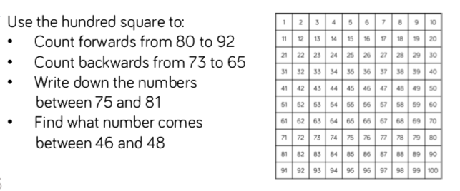  Have a 100 square and explore it for the first time counting forwards and backwards in different ways with the questions provided  And play number bingo  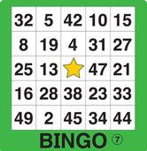  This is a hook lesson and an assessment for the teachers. Children will come in and play bingo. Each will have a number card and they have to identify numbers that are being called out. Ask some trickier questions like I have 3 tens and 2 ones etc.  Fluency:  Number tracks from 50 -100 in a variation of ways alongside more counting games focus particularly on crossing tens boundaries and saying 16 and 60 differently etc | Arithmetic focus:  Counting forwards and backwards to 100.  100 Square splat game  Fluency:  LI: To represent the place value of numbers to 100  NCETM materials 1.9 teaching point 2 & 5  Children have done this lesson already up to 50 – edit the slides and numbers so can do 50 -100 – use numicon or diennes to build 2 digit numbers up to 100 – use sentence Stem outloud ‘This is 56 because it has 5 tens and 6 ones’ (context)  Fluency:  LI: To represent the place value of numbers to 100 (in books)  Starter- revise how to partition numbers.  Chn to choose number cards between 1-100 and have to represent with diennes. Use start with the answer stcker and give them the diennes representation and they have to work out what the number is. Or draw it along with varied white rose questions  I have represented the number 30. Do you agree?  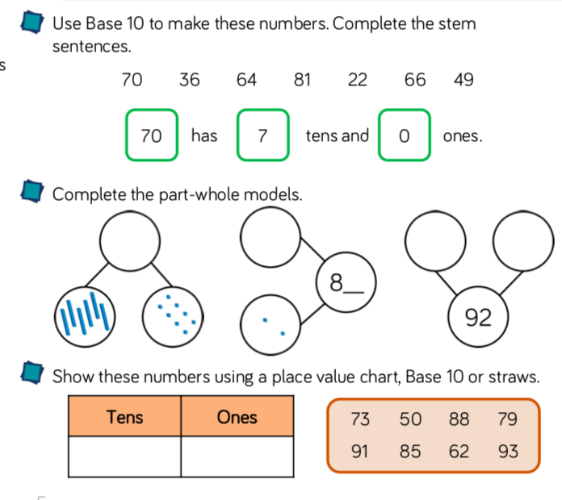  Fluency  LI: To understand that numbers have a place on a numberline.  NCETM 1.9 teaching point 3. 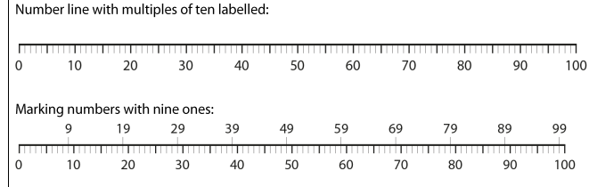  Going a bit deeper than just number tracks and use string beads like in materials (context)  Reasoning/  Application:  LI: To apply my knowledge of place value to 100  Chn to be given range of odd one out questions and explain it sticker. They can group the numbers by tens, ones, size, odd or even but need to justify it.  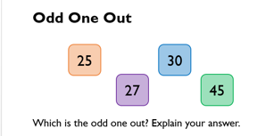  ___ is the odd one out because.. (lows circle and orally say why)  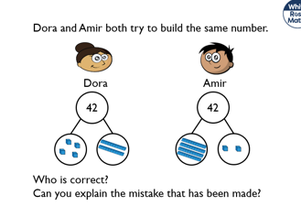  have 2 questions to respond to and find the error/prove.  Focus on one or 2 of these types of problems  Application:  LI: To compare numbers to 100  NCETM materials 1.9 all of teaching point 4 – children use diennes or numicon to compare 2 numbers for (cardinal) Children use number lines to compare 2 numbers (ordinal) using sentence stems…  I know that 24 is less than 75 because … | Arithmetic focus:  Number bonds within 5  Application:  LI: To compare numbers to 100  Applying what children did yesterday but varied in books like in the materials from yesterday using symbols and language < > =  LI: To order numbers to 100  Varied fluency on whiterose to order 3 numbers up to 100  Application:  LI: To find one more or one less than a number (maybe into separate 2 lesson)  Numbers up to 100 – use of hundred squares to support – particular attention to crossing 10s  Outcome Reflection & Evaluation  LI: to partition and compare 2 digit numbers  Context: Fruit smoothie shop  Children will be given a variety of fruit that will represent either 10’s or 1’s.  Banana’s will be 10  Apples, strawberries and blueberries will be 1 (for example)  There will be a smoothie menu with specific amounts that children must make by partitioning the fruit as they represent the numbers.    They will then compare the amounts in accordance to the partitioned number and children to decide which is a higher or lower, more or less etc.  Pre- Assessment:  LI: To assess our addition knowledge.  What do you know about addition? Model addend+addend=sum.  Chn to label number sentences- addend and sums. As a class create a vocabulary bank to add to maths wall. Give examples of addition we’ve already learned. Counting on and adding by 10 (making 10 first and then counting on the rest (recap this with 20 frames) | Arithmetic focus:  Number bonds to 10 and 20 ..patterns  Fluency  LI: To add numbers within 20  Children use concrete materials such as numicon to support (30 frames) to support adding a 2 digit and a one digit  Example 18 + 5 =  (context)  Fluency  LI: To add numbers within 20  Varied fluency within books – use of equipment like numicon to help them solve  _+_=18  Reasoning  LI: to reason about addition Error spotters with incorrect sums for numicon pictures etc when adding 2 digit and one digit  Application:  LI: To create a word problem involving addition  Chn to use F/T/N boards and create their own number sentence stories and orally read the sentence amnd draw it out. First I had … cubes. Then I added … more. Now I have….  Pre- Assessment:  LI: To assess our subtraction knowledge.  What do you know about addition? Model minuend – subtrahend = difference  Chn to label number sentences- addend and sums. As a class create a vocabulary bank to add to maths wall. Give examples of addition we’ve already learned. Counting back and asubtracting through 10 (subtract to 10 first and then counting back the rest (recap this with 20 frames) | Arithmetic focus:  Addition subtraction using 20 frames – subitise the answer  Fluency  LI: To subtract numbers within 20  Children use concrete materials such as dienes or 20 frames and counters to support subtracting a 2 digit and a one digit  Example 18 - 5 =  (context)  Fluency  LI: To subtract numbers within 20  Varied fluency within books – use of equipment like 20 frame to solve  18 – 5 = ____  Outcome/ Reflection and Evaluation:  LI: To apply my knowledge of addition and subtraction  Sort them out -  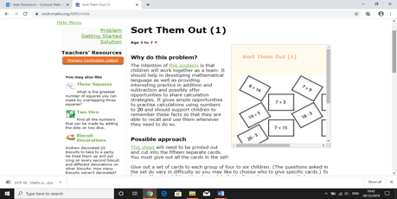  https://nrich.maths.org/6885  Each child to decide and present their ideas to rest of the class. Class discussion to evaluate the strategy used.  it I….  Use the NCETM Materials 2.1 alonside all of MUltiplicaiton linking to coins and money)  Fluency  LI: To count in tens  Children to use numicon to count in tens. They can put their objects into groups of ten then start to learn their ten times table by matching the number of objects with the numbers on their 100 square.  What do you notice about all the numbers in the 10 times table?  What’s the same, what’s different?  Fluency  LI: To count in tens.  Children will answer a variety of fluency questions for counting in tens using pictures of objects that can be grouped into ten, e.g. flowers, birds etc. using resources from the previous lesson to help them. Children could move into abstract repeated addition number sentences:  10 + 10 + 10 = 30  Draw it sticker. E.g. Can you draw 4 groups of ten? Children could draw circles with dots or draw jumps on a number line. | Arithmetic focus:  Counting in 5s/10s patterns  LI: To make equal groups  Plates and objects – equal vs unequal – making equal groups of 2 5 and 10 (Context)  LI: To add equal groups (varied in books WR  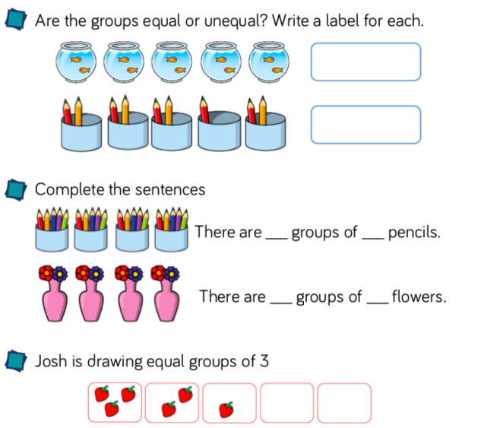  LI: To add equal groups using concrete equipment  Recording repeated addition (Context)  LI: To add equal groups  Using varied fluency and reasoning questions from white rose recording repeated addition number sentences  Fluency  LI: To create arrays using concrete objects.  Children will practice making arrays using either counters/cubes or other accessible equipment. They can choose any number of cubes to start off with and explore how many rows and columns they will need to make arrays for the 2s, 5s and 10 times tables.  Once children have practiced making arrays, they can begin to record repeated addition number sentences for them.  2 + 2 + 2 = | Arithmetic focus:  Counting in 2s  Fluency  LI: TO link arrays with repeated addition  Matching activity? Array to repeated addition  LI: To record arrays for the 2, 5 and 10 times table.  Use of pictorial images for children to find the product …intro language of finding the product  Children to draw array from times table but record as repeated addition  Reasoning  LI: To use my knowledge of repeated addition to spot errors  Error spotter sticker and finding the mistakes within arrays. (unequal groups too many etc.  Fluency/ Reasoning  To recognise patterns for the 2 times table.  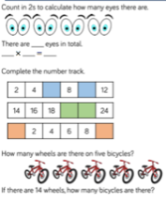  Fluency/ Reasoning  LI: To recognise patterns for the 5 times table.

