Spelling
Can you find all the statutory spelling words in the word search below?
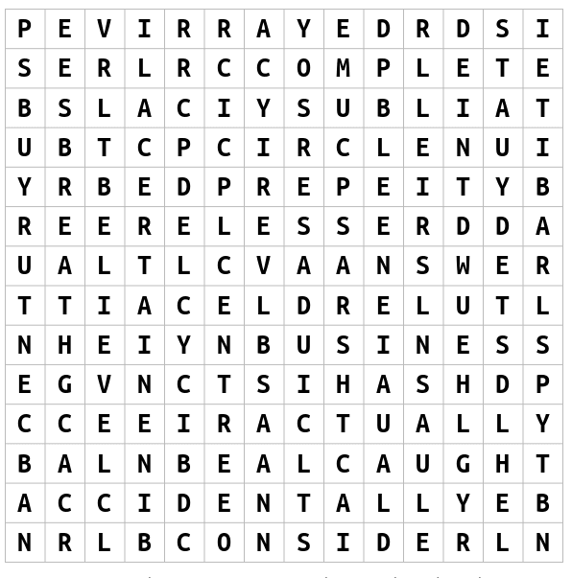
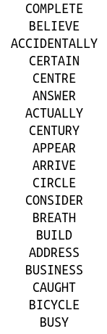

Challenge: Now practice spelling these words by first looking at the word, then covering the word and finally writing it.

English
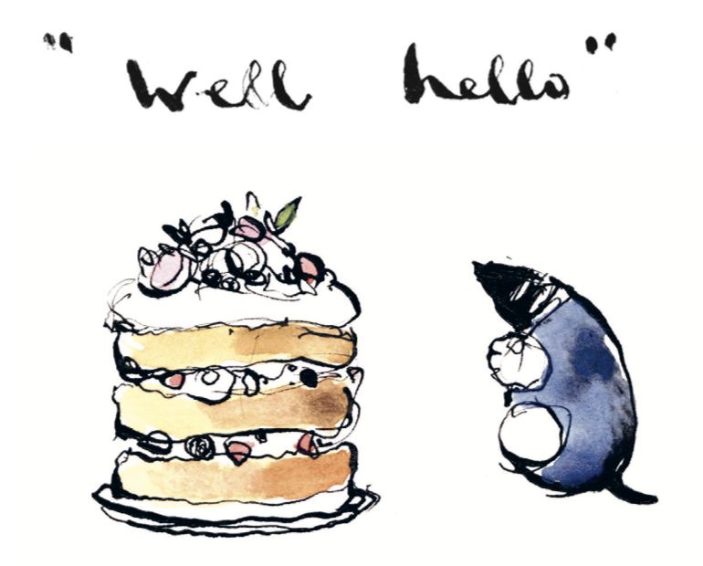
Think of 5 - 7 adjectives describing cake and write them down. Now imagine you are the mole in the story, write a small paragraph seeing how many of these words you can use to describe your love of cake.
Think about:
- choosing some long and short words
- what the word means
- how else you could use the word in a sentence

Check:
- capital letters and full stops
- your spelling
- that you have used some interesting adjectives

Extra challenge: See if you can use 3 of the words we found in our word
search to add to your paragraph as well.
Maths
It is our end of term class party and your teacher ordered pizzas for everyone to enjoy but oh no, they are cut up in different numbers of slices. Can you help your teacher?
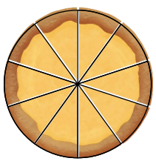
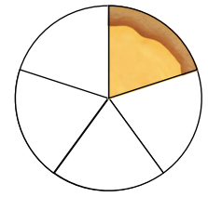
If 5 children shared a pizza cut into 10 slices, how many slices will each child get? Write your answer as a fraction

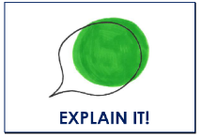
Sara ate ⅖ of one of the pizzas. Amalia said she had less than the 5 other children, do you agree? Explain your answer.

Challenge: Can you draw two ways we can equally share a pizza between 4 learners and shade how many slices each learner will get?
Times Tables
We have been practicing our 2, 4 and 8 times tables this term. Can you complete the multiplication wheels below?
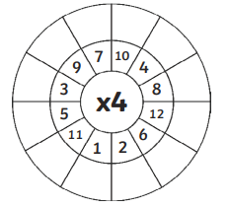
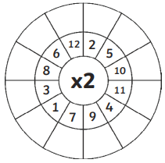
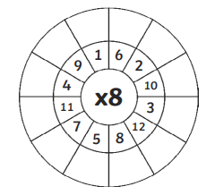

What can you notice about the 2, 4 and 8 times tables? Could we use the 2 times tables to help us with our 4 times tables and the 4 times tables to help us with our 8 times tables?
Challenge: Can you practice your 4 and 8 times tables on your fingers?

Reading
Remember to read for at least 30 minutes every day. Can you record any comments, questions or new and exciting words you have read?

