Spellings
Use the ‘Look, say, cover, write, check’ method to practice these words from the year 2 spelling list each day.

 | Attempt 1 | Attempt 2 | Attempt 3 | Attempt 4
after
again
any
bath
beautiful

Challenge: Can you identify the meaning of these words and find write a sentence using each one?
Phonics

ch ee er oi ue

Use the videos below to learn more about these sounds.
Ch - https://www.youtube.com/watch?v=mGSFG37LewA

Ee - https://www.youtube.com/watch?v=du3incCU6Xc

Er - https://www.youtube.com/watch?v=Taa3ANEyN_Y

Oi - https://www.youtube.com/watch?v=Z-0wWdE-Ezg

Ue - https://www.youtube.com/watch?v=fLrAGcK26s4

Can you now make a list of or draw pictures of any more words you can think of which contain these sounds?

Treasure Hunt

How many objects around your home can you find with these sounds?
You may also use the website below to play some fun, educational phonics games:
https://www.phonicsplay.co.uk/

English
In English this week, we have been writing a descriptive third person recount of our core text “The Boy, The Mole, The Fox and The Horse” using verbs, adverbs and expanded noun phrases with exciting adjectives.

Using the table of vocabulary below can you write a short recount using descriptive language.
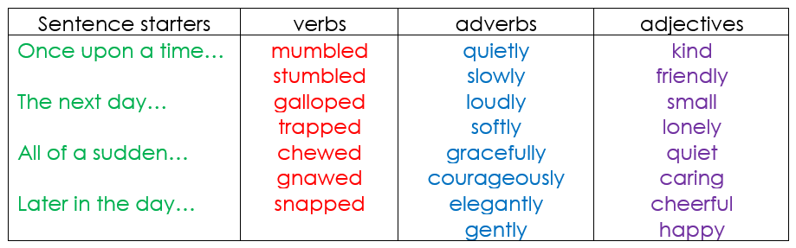

Maths
In Maths, we have been making connections between number bonds in preparation for addition and subtraction next half term. We looked at similarities and differences and discussed patterns in the sequences.

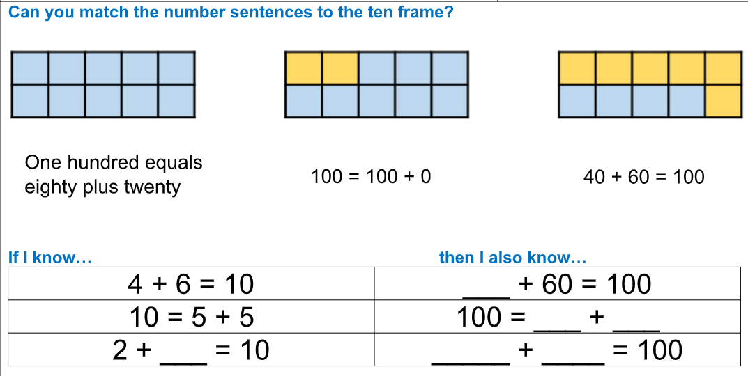
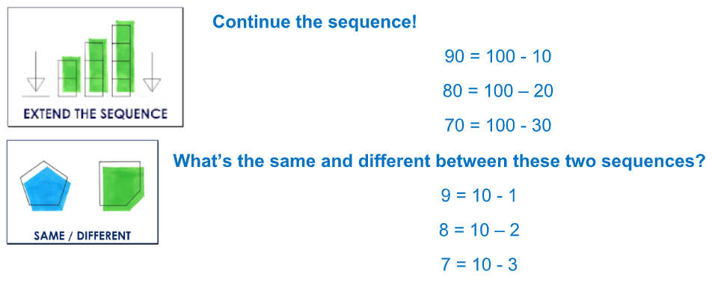

Reading
Remember to read for at least 30 minutes every day. Can you record any comments, questions or new and exciting words you have read?

