Spellings
Use the ‘Look, say, cover, write, check’ method to practice these words from the year 2 spelling list each day.

 | Attempt 1 | Attempt 2 | Attempt 3 | Attempt 4
because
behind
child
children
Christmas

Challenge: Can you identify the meaning of these words and find write a sentence using each one?
Phonics

igh qu th oa sh

Use the videos below to learn more about these sounds.
Igh - https://www.youtube.com/watch?v=3UVtOaeBIDg

Qu - https://www.youtube.com/watch?v=JpyASJYqlKs

Th - https://www.youtube.com/watch?v=7f74GArsWis&t=4s

Oa - https://www.youtube.com/watch?v=M8nGaspuWAQ

Sh - https://www.youtube.com/watch?v=7gBsGxhdt2E&t=120s

Can you now make a list of or draw pictures of any more words you can think of which contain these sounds?

Treasure Hunt

How many objects around your home can you find with these sounds?
You may also use the website below to play some fun, educational phonics games:
https://www.phonicsplay.co.uk/

English
In English this week, we used our core text for this half term, “Happiness is a Watermelon on Your Head”, to look at what makes a piece of writing good. We looked at the punctuation, grammar and spelling.

Look at the sentences below and rewrite them correcting any mistakes in the spelling, grammar or punctuation.

there are dancing leaves IN thegarden where miss jolly plays music becos they sway in time to the music
sweet music glidez threw The treesas miss jolly shares her joyful sounds with her bore
hapines is when we smileand do al the fun fings that make us larf?

Maths
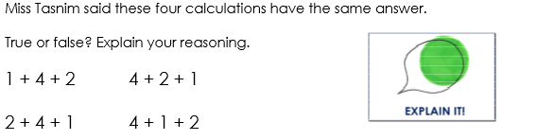
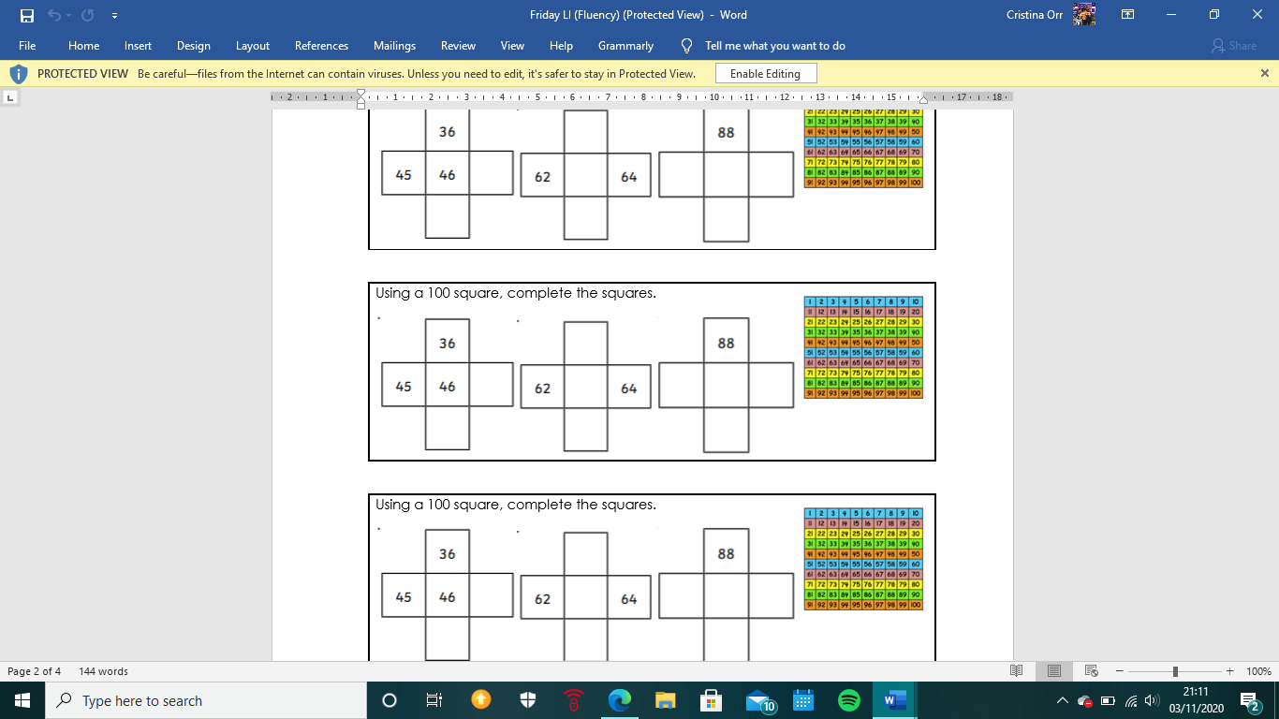
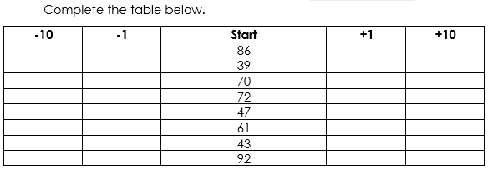
In Maths, we have been looking at finding one more and one less of any given number, then moving to ten more and ten less. This will prepare us for the addition and subtraction that we will be covering this half term.

Reading
Remember to read for at least 30 minutes every day. Can you record any comments, questions or new and exciting words you have read?

