Medium Term Planning – Summer 2

Inspire Curriculum | Core Text  Hook
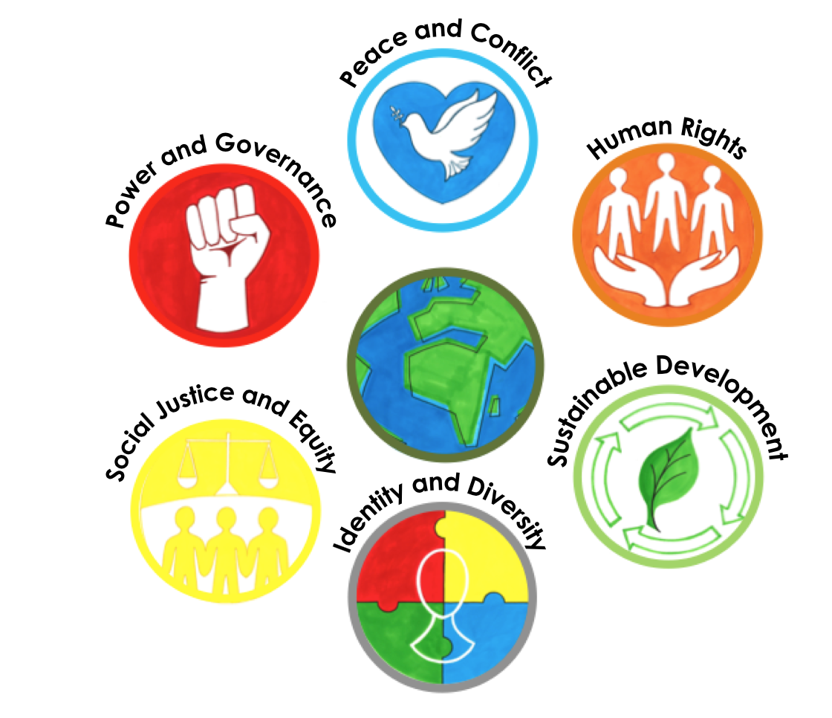 | 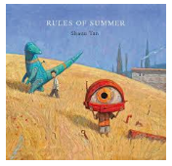  Rules of Summer by Shaun Tan
Art Outcome
Display idea

When life gives you lemons…
Children will use the style of Shaun Tan’s art (textured paintings & crosshatching) to compare to that of Van Gogh. They will then take inspiration from the food picture in the Rules of Summer book. The food focus is a lemon to coincide with the message that when life gives you lemons, make lemonade. This phrase will be used to encourage optimism and a positive can-do attitude in the face of adversity or misfortune. Lemons suggest sourness or difficulty in life; making lemonade is turning them into something positive or desirable.
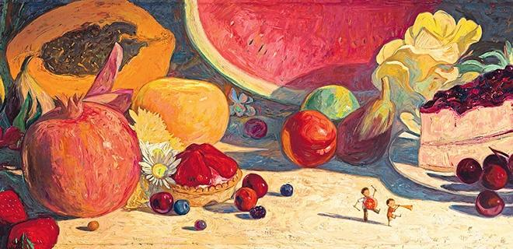
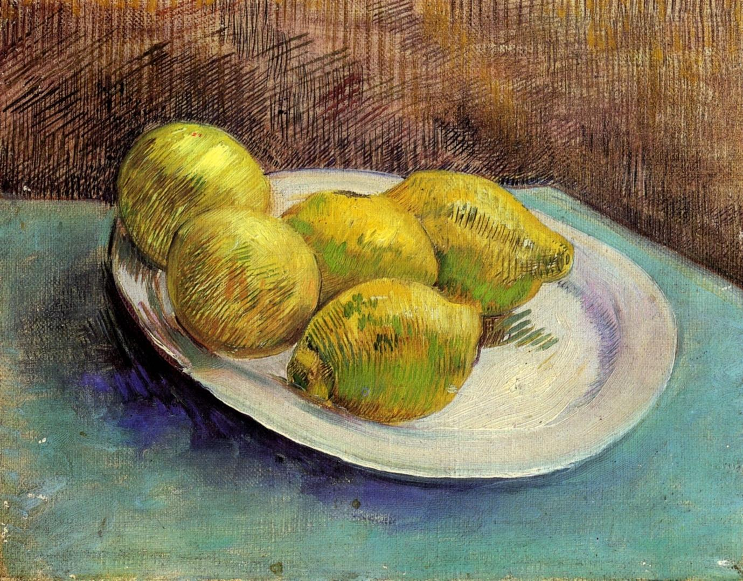

Diversity, Community & Global Learning Project

Summer 2
Week 1  w/c 1st June  (01.06.20 INSET) | Exploring  Hook lesson:  Make lemonade to introduce the learning topic and open the conversation around the pandemic.  Chn to describe the taste of the lemon initially (sour, bitter) and then relate to initial feelings when faced with a difficulty. What do people do to make lemons taste nicer and have a more pleasant taste. This analogy can be used to explain how in life when faced with hardship, people make changes to endure the hardship  Science (Year 2 KPI)  LI: to understand how good hygiene is important in preventing infections and illnesses  Chn will conduct two scientific experiments where they will investigate the impact of hand washing on the spread of small and microscopic particles. Chn will need washing up liquid, glitter (or cocoa powder) and shallow dishes. The scientific skill the children will be focussing in will be predicting and observing. Chn to be supported using sentence frames and scaffolds.  https://www.livinglifeandlearning.com/glitter-germ-experiment.html  Key questions:  What is a germ? How do they get on your hands? How do you get them off? Why do I need to wash my hands? What does a germ look like? Are all germs bad? The term "germs" refers to the microscopic bacteria, viruses, and fungi that can cause disease.  Key knowledge:  Virus (say: VY-rus) need to be inside living cells to grow and reproduce. Most viruses can't survive very long if they're not inside a living thing like a plant, animal, or person. Whatever a virus lives in is called its host. When viruses get inside people's bodies, they can spread and make people sick. Viruses cause chickenpox, measles, flu, and many other diseases. Because some viruses can live for a short time on something like a doorknob or countertop, be sure to wash your hands regularly!  Remember the words that germs fear — soap and water. Washing your hands well and often is the best way to beat these tiny warriors. Wash your hands every time you cough or sneeze, before you eat or prepare foods, after you use the bathroom, after you touch animals and pets, after you play outside, and after you visit a sick relative or friend.  
Week 2  w/c 8th June | Exploring  Science  LI: to understand what nutrients we need to be healthy  Chn will be focussing on the working scientifically skills of classifying and grouping.  Food contains a range of different nutrients – carbohydrates (including sugars), protein, vitamins, minerals, fats, sugars, water – and fibre that are needed by the body to stay healthy. A piece of food will often provide a range of nutrients.  https://www.bbc.co.uk/bitesize/clips/ztr3cdm  Key Questions:  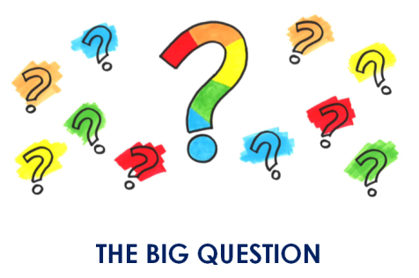  Why do we need a balanced diet? What happens to our bodies if we don’t have a balanced diet? Which diets around the world are renowned for being ‘healthy’? What is our ‘immune system’ and how does it related to the food we eat? Children to make connections between a balanced diet containing all the nutrients, minerals and vitamins necessary for our bodies to help us fight infections and illnesses.  https://thekidshouldseethis.com/post/how-does-your-immune-system-work-ted-ed  History  LI: to understand the impact of significant people  Children will be studying the life and impact of Florence Nightingale & Mary Seacole linked to the opening of temporary hospitals around the country in response to the pandemic. Why are they called ‘Nightingale/Seacole’ hospitals? What was so significant about her life?  https://www.natgeokids.com/uk/discover/history/general-history/florence-nightingale/  The children can then compare the life and achievements of Florence Nightingale with Mary Seacole  https://www.natgeokids.com/uk/discover/history/general-history/mary-seacole/  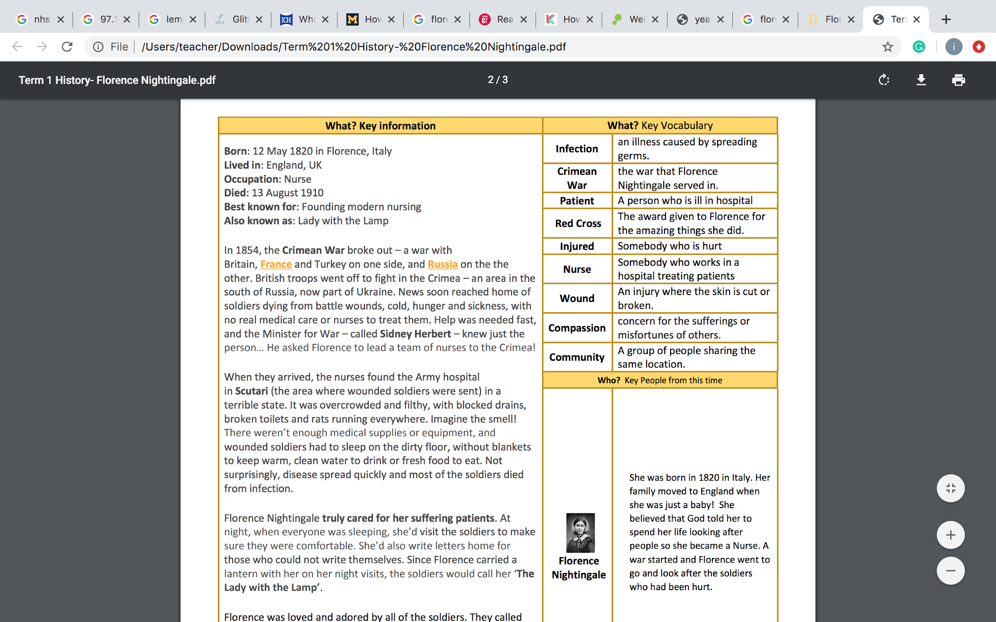
Week 3  w/15th June | Exploring  LI: to recognize significant events  Chn will investigate a range of significant events that have affected large parts of the world. Range could include: 2004 Tsunami, Australian bush fires, Coronavirus pandemic 2020  Children to look at a map of the world and demarcate the countries affected by each major event, recapping the different continents of the world and the oceans. Which major event has affected the most amount of countries? Children to use sentence stems to explain their findings.  I think that.... affected the most amount of people because I can see that...  I think that .... affected the least amount of people because I know that...  Science (year 4 KPI)  LI: to describe the simple functions of the basic parts of the digestive system in humans  Children will be learning about the passage of food throughout the body, learning about how nutrients are absorbed and the function of the different nutrients.  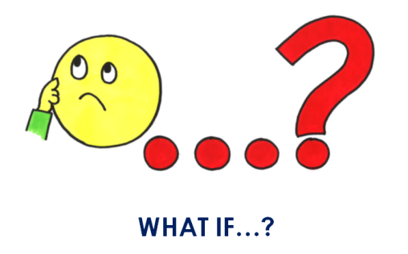  Key question: What happens if we become deficient in any of the nutrients? Link back immunity and balanced diets
Week 4  w/c 22nd June | Deepening  LI: to understand the impact of national cooperation  Children will build on their learning of the events looked at last lesson to dive deep into how communities have collaborated to face an issue. Over 750,000 people responded to the government request for support from the community.  Key questions:  Why do you think so many people responded? What inspired them to become volunteers? Have you got any experience either at home or school where you have volunteered your time to do something you felt strongly about?  What things do you think people were volunteering to do?
Week 5  w/c 29th June | Deepening  LI: to understand how groups of people work together  Children will look at examples where people have formed groups and movements with the aim of supporting communities through a difficult time. Examples to include the NHS volunteer responders’ effort.  
Week 6  w/c 6th July | Planning and delivering  Children to use laptops to create PowerPoints with their edited English learning journeys (refer to computing skills for using PowerPoint). Children to select appropriate music for the slideshow that captures the tone of the writing and the themes of the book.  If children are presenting option 1 or 2 (see next lesson) they would use this time to plan and orally rehearse their presentations.
Week 7  w/c 13th July | Evaluating  Celebration of learning  LI: to celebrate and recognize achievements  The children will be celebrating their learning this half term by sharing their outcomes in some form of presentation, this would be dependent on resources available.  Option 1: Oral presentation – Children can stand and present their outcomes, by using the oracy skills to read their diary entry out loud and their art outcome. The teacher can record and take pictures of the children’s presentations.  Option 2: Vlog presentation – Children will share their vlog which is where they will record themselves, using oracy skills to read their diary entry and show their art outcomes.  Option 3 (preferably older children): Power Point presentation – Children will present their outcomes using ICT and oracy skills after collating their vlog, pictures from their learning journey over the course of the half term and their Art outcome. The PowerPoint can include appropriate complimentary music.  The presentation of outcomes will be shared across the school, parents and the wider community, on social media platforms (permissions permitting) such as your schools YouTube channel, twitter, school website and/or emailed.  The two main character skills they will be focusing on are Integrity (pride) and Relationships (communication).    Reflection postcard  Children to reflect on the learning over the half term with a focus on their useful learning mistakes. Children to use the scaffolds on the postcards and articulate when they have encountered useful learning mistakes and how those were overcome.  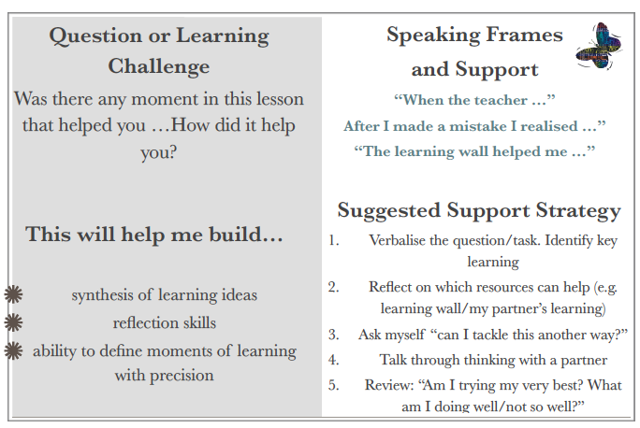  Detail about where  Skills where to present  Oracy  All curriculum- learning in lock down  Personal experience and also wider

 | Week 1  Wb 1st June | Week 2  WB 8th June | Week 3  WB 15th June | Week 4  WB 22nd June | Week 5  WB 29th June | Week 6  WB 6th July | Week 7  WB 13th July
PSHE | Exploring different types of emotions.  Class discussion around different types of emotions and feelings. Children to identify emotions that they know or have felt and to discuss how they are feeling today.  Discussion around changes in school with social distancing etc. How is this making them feel? Explain reasoning and importance of new measures. | Exploring the difference between opinion and fact.  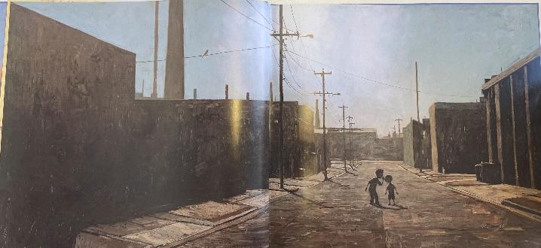  Hook: What is happening in the picture? – Sharing secrets/rumours  Discuss rumours/fake news about Coronavirus and how they make us feel. Chn can write thoughts and questions to then discuss. | What is worry?  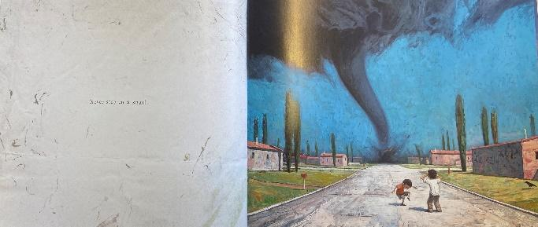  Hook: What emotions are being felt in this picture?  Resources: Please see activity sheet in emotional support folder for items required to make Worry Box  Powerpoint to be played explaining what worry is and how it makes us feel.  Introduction to the fight, flight, freeze response.  Activity is making a worry box. | What is the fight, flight and freeze response?  Last week we saw the introduction to the fight,  flight,  freeze response.  This week's activity is thinking about how this affects our body and how our body reacts to different emotions  Full teacher notes are on resources.  Practice: Finger breathing  Activity: see resources in folder | The Anger Iceberg/My Anger triggers  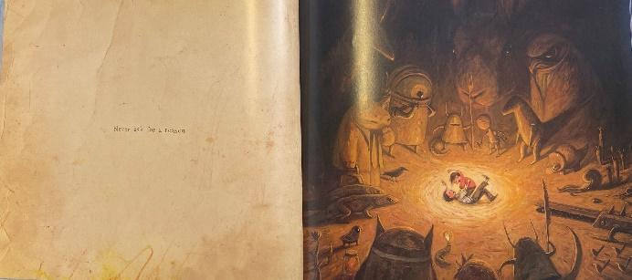  Hook: What emotions are being felt in this picture?  Resources: Scissors and glue  Last week we looked at the flight, fight, freeze response. This week we will be looking at anger. How we react when we are angry and what our particular triggers are.  Remind the children that anger is a normal human emotion and we all feel anger from time to time. It is OK to feel angry, but it is not OK to hurt ourselves, others or things.  By looking closely at what makes us angry and how we then react we can start to understand this emotion better. With better understanding comes better control.  Explain that anger is like an iceberg, only part of it is visible. There are always supporting emotions/events to the anger that we see on top. Use the first activity sheet and get children to explore what could be underneath their anger.  The ‘my triggers’ activity asks the children to think of specific triggers to them. Get them to write in the box what their triggers are then they cut out and stick the relating emoji to their trigger chart.  This is an ideal way for children to understand that anger is always caused by something else and that sometimes if we are aware of our triggers we may be able to avoid them. | Coping strategies for anxiety and anger  This week is mostly about practicing what we have already learnt.  Attached is another breathing technique that is really good at calming us down.  Get the children to sit calmly and quietly. Play some calming meditative background music. Dim the lights and practice the new breathing technique.  Remember to SNIFF THE FLOWER, BLOW OUT THE CANDLE  Ask the children afterwards how it made them feel.  Another really effective technique when dealing with anxiety/panic attacks is the grounding exercise.  Firstly, talk about worry/anxiety. Ask the children if they can remember what anxiety does to our body and how it makes our bodies react?  Now practice the grounding exercise.  All resources and teacher notes in folder | My emotions toolkit  Resources: Glue and scissors  This week is all about recapping what you have learnt and reminding the children they are now more able and more confident to talk about their feelings.  They have learnt coping skills in the form of breathing techniques as well as the other emotional/relaxation/mindfulness/relationship work they have been doing the past 6 weeks.  The children can create their own emotional tool box. They need to cut out a feeling and stick it down. Then cut out two coping strategies that helps them when they are feeling this way.  Teacher notes are in resources in folder.

Art – Vocabulary  Interpretation  Texture  Cross hatching | Starter activity:  Watch clip of Shaun Tan  Discuss: What inspires you?  LI: To analyze an artist  Activity:  Children to have a look at Shan Tans work, discuss the surrealism and fantasy within his pictures using the talk about art example.  Children will then use pictures to create a mood board of his work.  Children should talk through mood boards, giving the teacher the opportunity to discuss interpretation. | Starter activity:  Show children art work by Van Gogh.  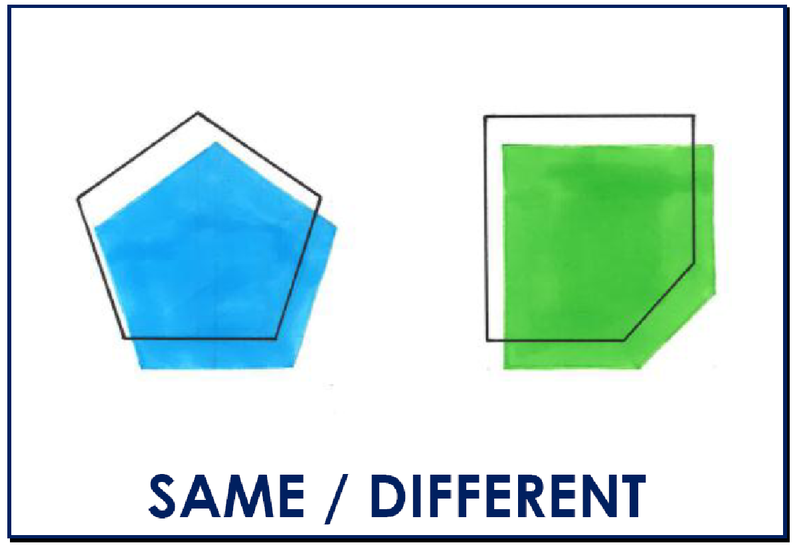  LI: To identify different sketching techniques  Activity1:  Children to recap techniques using patch tests (example below). Discuss what techniques are visible in Tan’s artwork.  How can you show light and dark spots with each technique?  Activity 2:  Children will then discuss light source, identifying where there will be a shadow and cast shadow. Children to either draw a lemon shape or use a template and complete shading, labelling the light source, shadow and cast shadow. | LI: To apply sketching techniques  Activity:  Children will create an incidental piece of art using graphite pencils and oil pastels.  Children will be looking at contrast in colours to make things stand out. Highlighting the techniques learnt so far.  Using this picture from the book as inspiration:  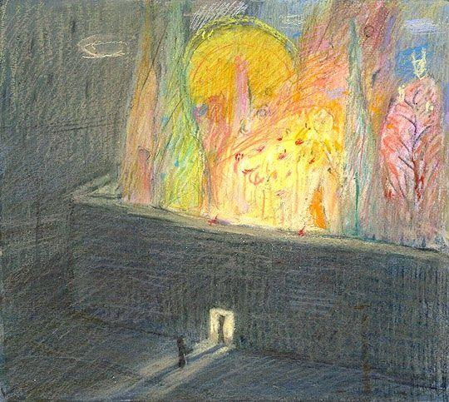  Discussion points:  What shapes can you see?  How has the direction of hatching impacted the picture?  Where are the sources of light?  How can you this be transferred to the lemon picture? | Starter activity:  The circle game.  On a printed sheet of circles, the children will have 20 minutes to create as many pictures as possible.  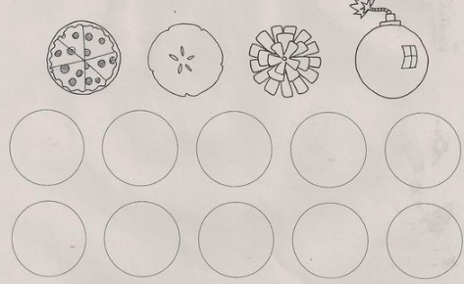  LI: To create a textured background  Activity:  Children will create the backgrounds to their artwork. All outcomes should highlight a different technique that shows texture. | Starter activity:  Finish the picture.  Give children a piece of paper with a swirl on, then give them 10 minutes to draw anything that comes into their imagination.  Give children the opportunity to explain their drawings.  LI: To create an individual outcome  Activity:  Children to finish off their art pieces by now adding the lemon.  Children should be focusing on creating their lemon thinking about the light source and shadow. | Starter activity:  Children to draw two vertical lines. Then the swirls. Colouring in the alternate shapes talking about contrasting.    LI: To evaluate an outcome  Activity:  Children will showcase their individual outcomes. They will evaluate their use of texture and light/shadow

Lesson 1

Starter
https://www.scholastic.com/teachers/videos/teaching-content/shaun-tan-interview-tan-his-inspiration-becoming-artist/

Resource for the linked artist
http://www.shauntan.net

Activity examples
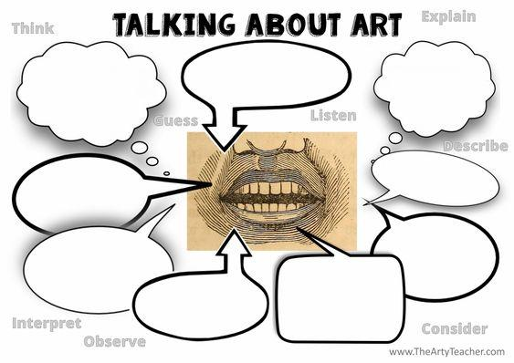

Lesson 2
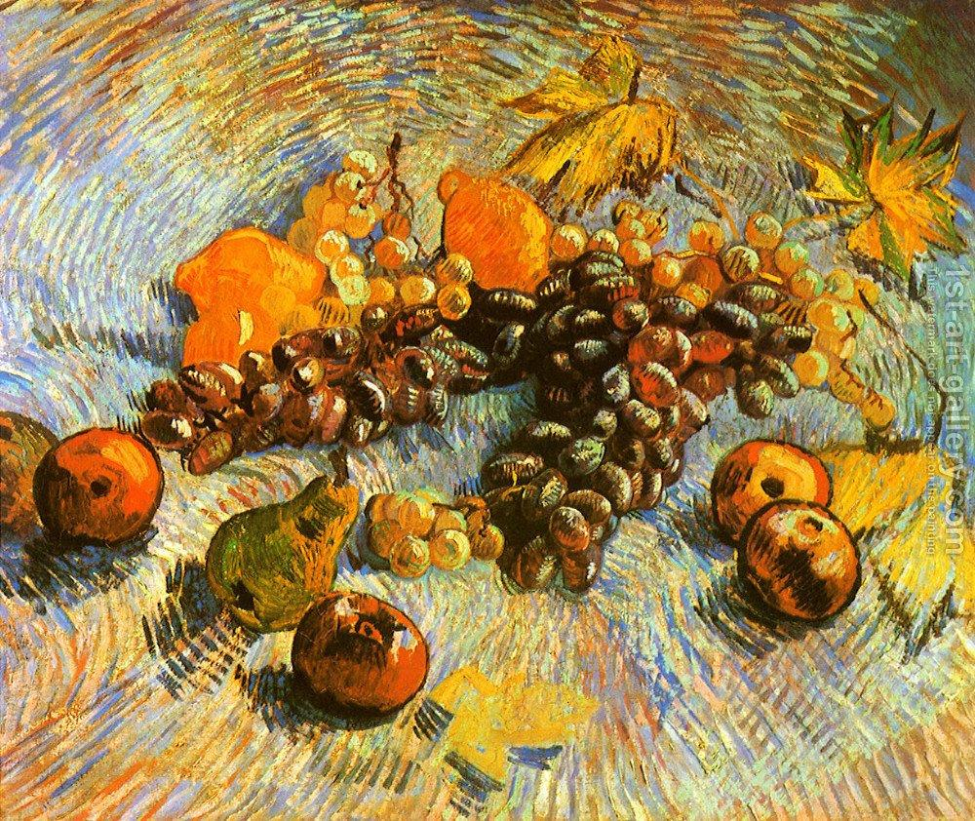
Example images to compare Tan and Van Gogh’s work (enlarge pictures for detail)
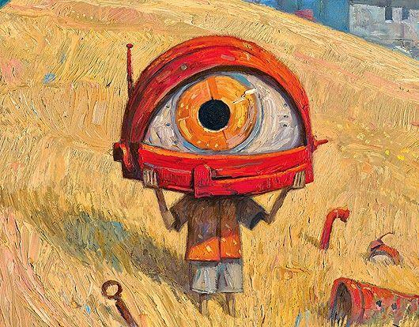
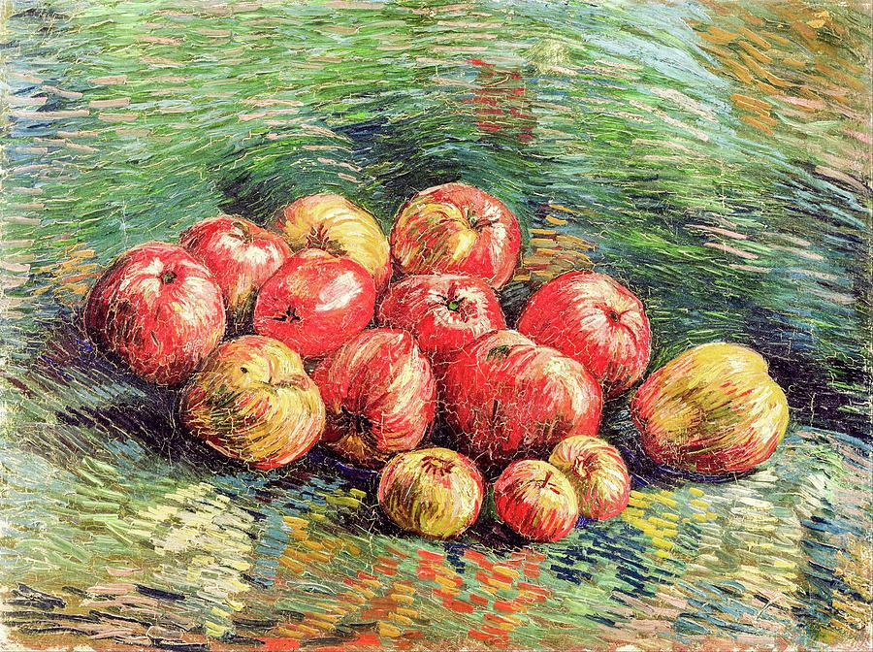

Activity 1 Activity 2:

Lesson 3
Example steps to guide children through the incidental drawing

1. Draw outline of lemon
2. Use yellow to lightly fill, leaving a section white for the light source.
3. Create texture & shadow on the lemon using green and orange
4. Highlight using white
5. Use background colour to create cast shadow
6. Draw a line horizontally to break the page and create the wall line.
7. Crosshatch horizontally on the top half and then diagonally on the bottom half.

Lesson 4 & 5
Choose an art outcome and identify the way in which you can create a textured background for lesson 4 and then creating the lemon/s as the feature.

Example backgrounds – where possible older children should apply their skill of crosshatching using acrylic and a scraper.
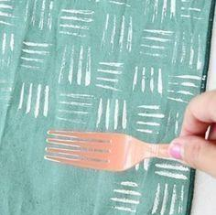
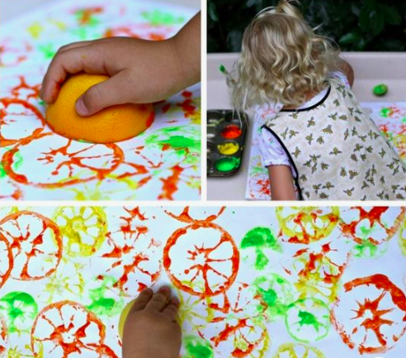

Example outcomes – consider a contrast in colours to the yellow of the lemons.

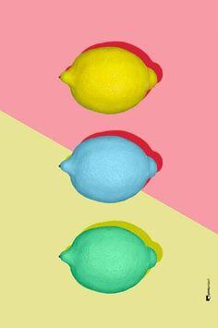

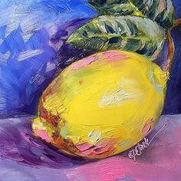

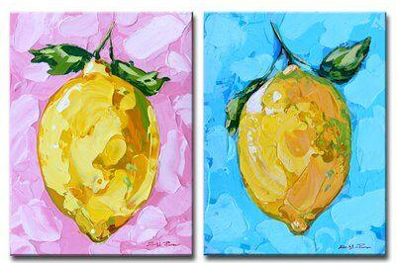

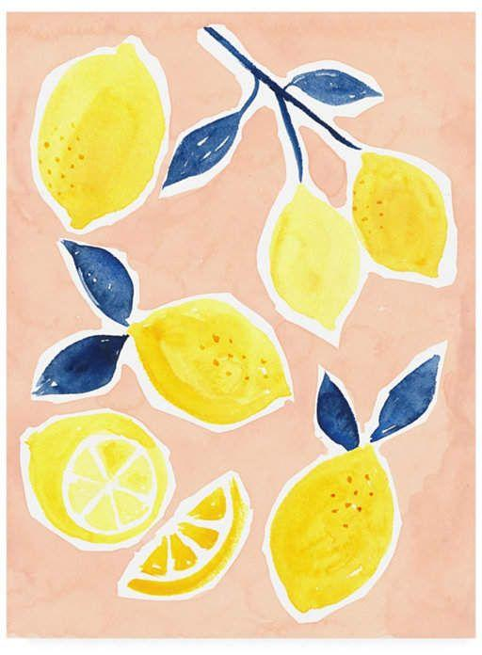

English

Week 1  Wb 1st June | Week 2  WB 8th June | Week 3  WB 15th June | Week 4  WB 22nd June | Week 5  WB 29th June | Week 6  WB 6th July | Week 7  WB 13th July
SPaG Focus:  Word types  Identifying in sentences | SPaG Focus:  Suffixes | SPaG Focus:  Prefixes | SPaG Focus:  Extending sentence ranges using different conjunctions. specific | SPaG Focus:  Year group specific | SPaG Focus:  Year group specific | SPaG Focus:  Year group specific
Hook: ‘When life gives you lemons make lemonade’ Will be combined with curriculum hook –refer to both  Chn to have opportunity to make lemonade. Begin with providing lemons Have a taste, describe flavours etc. Then create lemonade and now taste. Explore theme that when given something in life we can make something better come of it. – Link to current situation.  Predictions – share large images of books, chn to consider what is happening based on pics, what can they infer? What might the story be about.  Role play  Acting out the pictures within the story. What is your interpretation? Create freeze frames. What do the pictures symbolize?  Reflect on the impact of rules in everyday life.  Reflection on the rules we have in life. Do we like all the rules we have? But why might they be needed? How have our rules changed recently?  (blurb from the text)  “Never break the rules especially if you don’t understand them”  Reflection: Is it ok to break the rules? (circle time discussion)  Looking at the rules in the story – which image matches which rule?  Matching rules to the pictures. Take directly from book.  Pick one image and rule and justify why they matched the rule and picture together. Considering the messages within the images and what they symbolise. | Explore the concept of rules.  Begin with mind map your rules that we have  Why are rules important? Which rules do you follow that you don’t like… what is its purpose/ benefit…  How have these new rules made you feel?  Now that chn have immersed into the story we are going to take one of these rules and images and write a descriptive piece of writing.  Generating vocab using vocab wheel. Adjectives, nouns, verbs and adverbs. Based on image below. Use senses to help explore vocabulary.  What might I smell, taste, feel, see, hear?  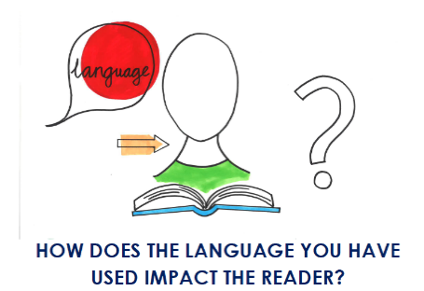  Reflection: Which words create a high impact on the reader? How do we want them to feel?  Incidental Write – Image description  Rule: “Always know the way home”  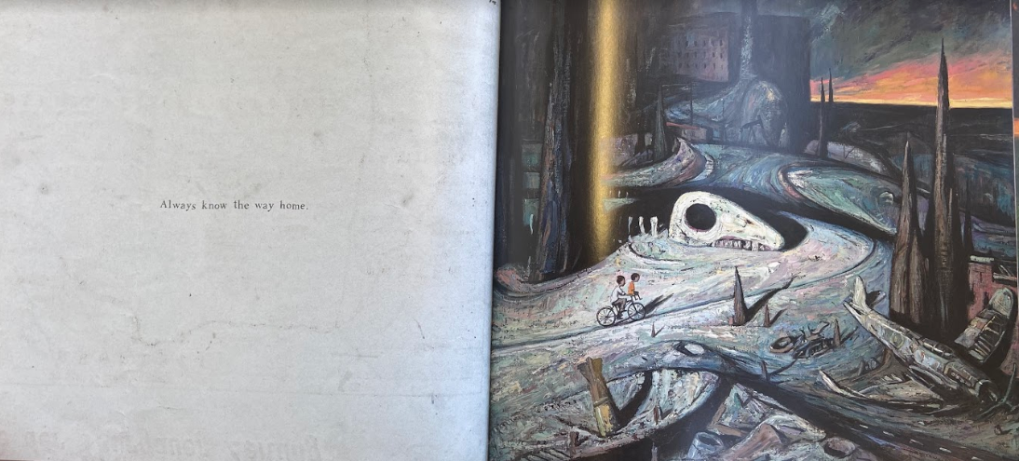  Using the image above, chn will create a descriptive piece of writing exploring the image and creating a vivid image for their reader.  Vocabulary generated day before to support writing process.  Looking at the features of a diary entry, (WMG)  Can look at comparing a vlog and diary entry. Why might people vlog nowadays rather than write in a diary? | Consider the significant events that will take place in their own diary entry. (Sequencing their events)  Sentence starter “The day I…….”  to create repetition.  Chn reflect on some of the significant things that have happened to them over this period of time. Using the last day of school before lockdown as starting point.  E.g.  “The day I baked a cake with mum”  “The day I left the house”  “The day I did my learning in my pyjamas.”  “I day I became creative”  “The day I became a gardener”  “The day I learned to cook pizza”  “The day mum/dad taught me to…”  “The day I clapped for the NHS”  Using this sentence starter as a base the chn will then explore that day/ event in further detail including feelings, thoughts, learning that happened, what it meant to them, why is was significant.  Final reflection to end diary with scaffold “What I learnt this summer…” E.g. the importance of patience, gratitude, love, kindness, hope. Chn to explore how this time has deepened their understanding and thinking of the world and as a human. E.g. a new view and understanding for the importance of NHS in our country. How precious life is and having our loved ones around us. Has this made them think differently now about certain things? What are they? How has their understanding deepened? What will they take from this experience and into life? What do they hope for the future?  This lesson will then be used as their base to plan their diary entries (wk 5) from these events.  Things to consider when planning…  - How did this event make them feel?  - What did they do?  - Who was they with?  - What happened?  - Good things/ bad things of the event (what went well)  Although this may take one or 2 lessons you can then begin to teach the skills lessons in next column.  Skills building will differ depending on year group but will generally include the skills listed in week 4. | All of these skills should be based on linking back to their significant events they considered in the last lesson.  Exploring feelings/emotions at different points.  - Role on the wall  - Role play  - Freeze frame  Exploring feelings/emotions at different points  - Emotions graph  - Written reflecting on each event  We want chn to acknowledge that our feelings can change on a day to day basis and that’s okay. They may want to even focus one of these days in their diary. E.g. today I felt sad and missed my friends.  Show not tell emotions  Generating sentences to engage the reader/ audience.  Explaining their actions to show feelings rather than telling us. E.g I couldn’t stop smiling or  I curled up under my blanket.  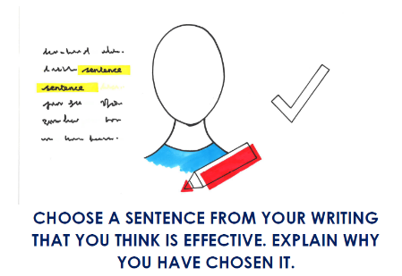  Sentence structures  - If, if, then (thinking about the consequences) E.g. If the virus hadn’t happened, If I didn’t have to stay at home, then I wouldn’t have learnt how to….  - Simple sentences to create tension.  - Time adverbials for openers  - Complex sentences using conjunctions, subordinating conjunctions whatever is appropriate for the year group.  Punctuation for effect. Listen to a vlog or diary read aloud consider when voice changes or stops. What punctuation will create that?  - Look at model and evaluate punctuation used.  - What punctuation is needed in a diary?  - Exclamation marks, full stops for short sentences.  Suspense  - Rhetorical questions  - Short sharp sentences  - Repetition to emphasise a point. | Planning diary x2  Use the key questions from ‘consider significant events’ lesson to support in planning process.  Things to consider when planning…  - How did this event make them feel?  - What did they do?  - Who was they with?  - What happened?  - Good things/ bad things of the event (what went well)  Oracy lesson  Practicing oracy skills such as tone and expression in their voice.  How can we grip an audience?  Refer to the oracy framework – physical strand. | Writing diary  Begin to write diary entry  Paragraph 1 – The last day of school before lockdown.  - What was your day like?  - How was it different to a normal day at school?  - How did you feel knowing it was your last day for a while?  Paragraph 2 and 3 if appropriate –  2 or 3 significant events.  “The day I…..”  Editing lesson  Writing final paragraph – Reflecting on this period of time  - “What I learnt this summer…”  - Hopes for the future  - Thoughts and feelings on going back to school  - What are you looking forward to the most?  - What will you miss from being at home?  Edit/ Reflect on writing  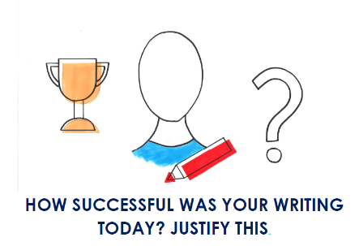  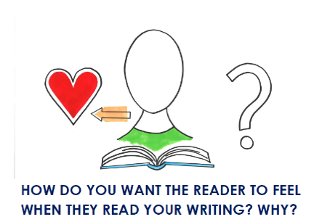 | Apply oracy skills  Chn will now create their vlog using their diary as a script.  Chn to have access to ipads/ laptops to support in the creating of the vlog.  Sharing each other’s vlogs or diary entries with class. This will link with the curriculum outcome and is an opportunity for the chn to share their reflections in whatever form that may be with each other. Options detailed within final week of curriculum learning.  Publishing -  Draft, edit, write up best.  End of Year Celebrations

